ICDS UPDATE on distribution Take Home Rations

Summary: The Ministry of Women and Child Development in its letter dated 30th Mar 2020, has issued a guidance to all states and UTs of India, to provide food security allowance as a single instalment to the extent possible, to each beneficiary, in case of non-supply of entitled quantities of food grains or meals to entitled beneficiaries. For States/UTs, which have taken steps for doorstep delivery of supplementary nutrition, necessary instructions to be given to district authorities to utilize services of anganwadi workers/helpers for such delivery of food items for continual nutrition support.

As of June 2020________________________________________________________________,
All 36 States and UTs are distributing dry rations or THR or cash entitlements to beneficiaries aged between 6 months to 36 months
All 36 States and UTs are distributing dry rations or THR or cash entitlements to Pregnant and Lactating women
All 36 States and UTs are distributing dry rations or THR or cash entitlements in lieu of Hot Cooked Meals to children aged between 3 years to 6 years

Source of data : Published newspaper articles, official media reports and phone calls to respective state government officials.

Distribution of Taken Home Rations to children 6 months to 3 years
Category of States/U.Ts | Colour in the map | No. of states/UTs
Sates distributing Take Home Rations |  | 28 (Bihar is providing cash entitlement)
U.Ts distributing Take home Rations |  | 8 (Puducherry is providing cash entitlement)
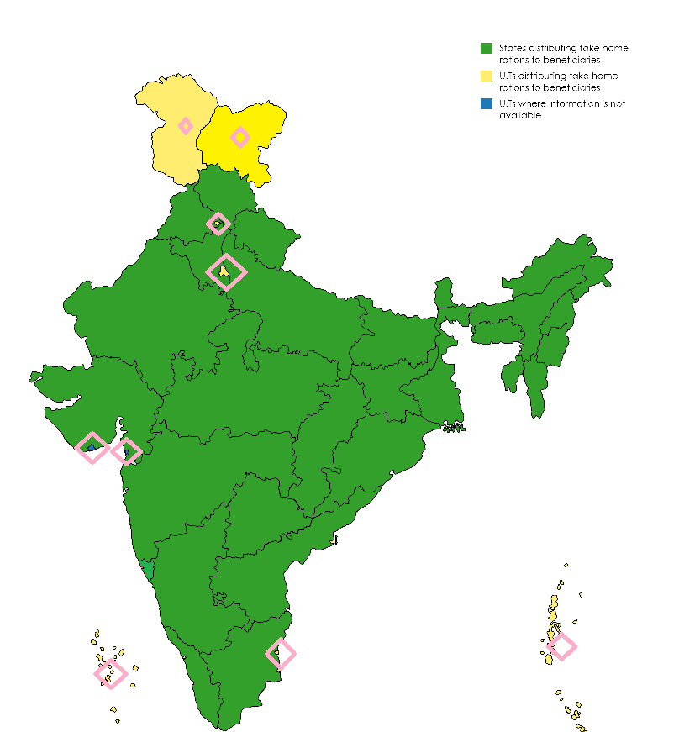

Distribution of Taken Home Rations to Pregnant and Lactating Women

Category of States/U.Ts | Colour in the map | No. of states/UTs
Sates distributing Take Home Rations |  | 28 (Bihar is providing cash entitlement)
U.Ts distributing Take home Rations |  | 8 (Puducherry is providing cash entitlement)
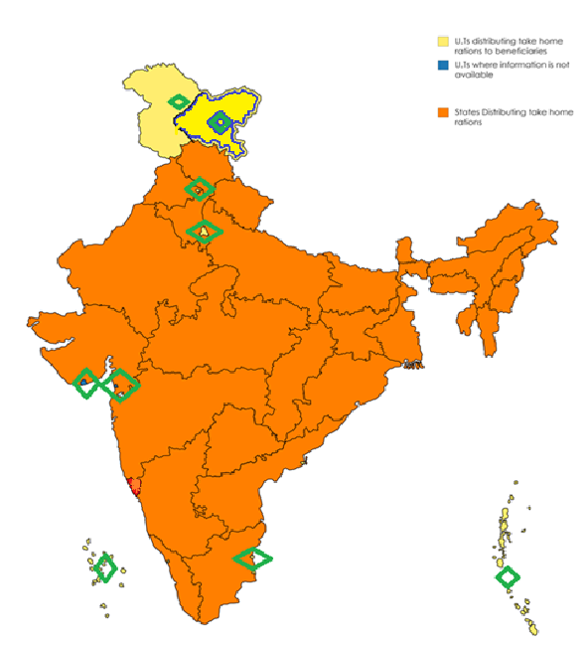

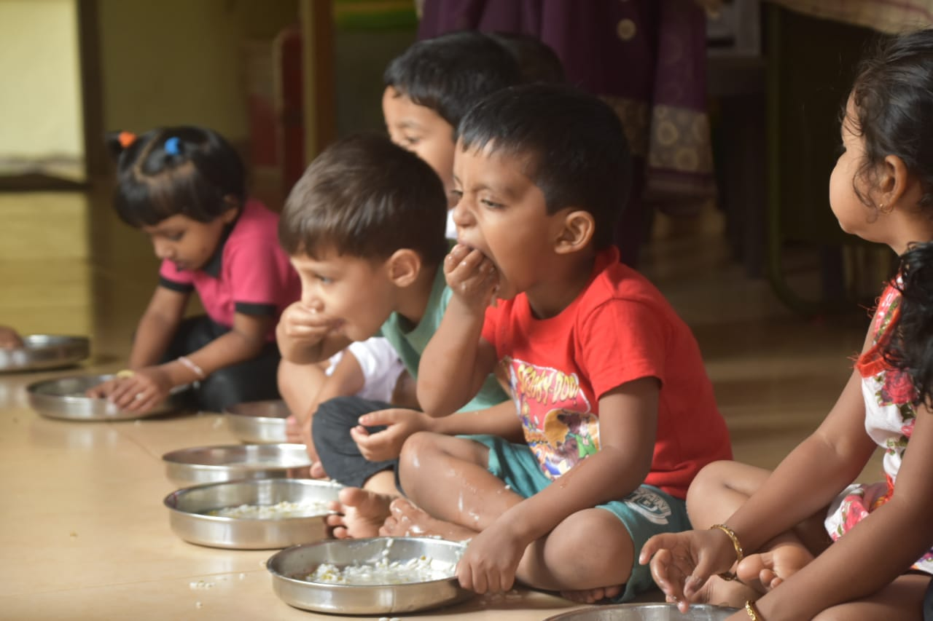
Distribution of Taken Home Rations to children between 3 years to 6 years
Category of States/U.Ts | Colour in the map | No. of states/UTs
Sates distributing Take Home Rations |  | 28 (Bihar is providing cash entitlement)
U.Ts distributing Take home Rations |  | 8 (Puducherry is providing cash entitlement)
