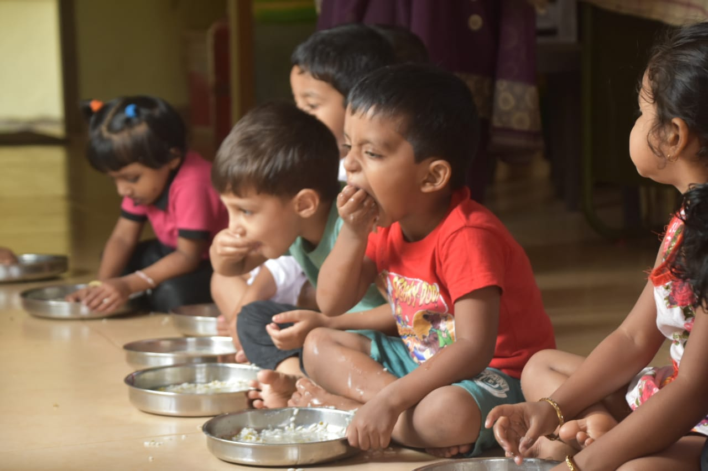
ICDS scheme in India – Tracking state government response during the Global Coronavirus (n-CoV) -Pandemic- Update till 15thMay, 2020

Photo Credits: WFP/Rafi.P
In the photograph: Children from the anganwadi centre in Thaliparamba block, Kannur consume fortified meals. WFP in collaboration with the Department of Women and Child Development, Govt. of Kerala has undertaken a pilot project on ‘fortification of rice served in hot cooked meals” which covers the entire Thaliparamba Block.
Background: Launched in 1975, The Integrated Child Development Service (ICDS) Scheme is the foremost symbol of country’s commitment to its children and pregnant/nursing mothers, as a response to the challenge of providing pre-school non formal education on one hand and breaking the viscous cycle of malnutrition, morbidity, reduced learning capacity and mortality on the other. The beneficiaries under the scheme are children in the age group of 0-6 years, pregnant women and lactating mothers. ICDS is a centrally sponsored scheme implemented by state governments and union territories. The supplementary nutrition component of ICDS aims at bridging the gap between the Recommended Dietary Allowance (RDA) and the Average Daily Intake (ADI) of children and pregnant and lactating women. Under the revised Nutritional and Feeding norms which have been made effective from February 2009, State Governments/UTs have been requested to provide 300 days of supplementary food to the beneficiaries in a year which would entail giving more than one meal to the children from 3-6 years who visit AWCs. This includes morning snacks in the form of milk/banana/egg/seasonal fruits/micro-nutrient fortified food followed by a hot cooked meal (HCM). For children below 3 years of age, pregnant and lactating mothers, Take Home Rations (THRs) in the form of pre-mixes/ready-to-eat food are provided. Besides, for severely underweight children in the age group of 6 months to 6 years, additional food items in the form of micronutrient fortified food and/or energy dense food as THR is provided.

Summary: The Ministry of Women and Child Development in its letter dated 30th Mar 2020, has issued a guidance to all states and UTs of India, to provide food security allowance as a single instalment to the extent possible, to each beneficiary, in case of non-supply of entitled quantities of food grains or meals to entitled beneficiaries. For States/UTs, which have taken steps for doorstep delivery of supplementary nutrition, necessary instructions to be given to district authorities to utilize services of anganwadi workers/helpers for such delivery of food items for continual nutrition support.

As of May 2020________________________________________________________________,
35 States and UTs have started distribution of dry rations or THR to beneficiaries aged between 6 months to 36 months
35 States and UTs have started distribution of Dry Ration/ THR to Pregnant and Lactating women
35 States and UTs have started distribution of dry rations/THR in lieu of Hot Cooked Meals to children aged between 3 years to 6 years: However, in Bihar cash allowance is transferred to the beneficiaries’ account and in Telangana, Hot Cooked Meals are provided in Anganwadis as take away food.
1 UT: Either Information is not available, or no action has been taken, for any of the three groups of beneficiaries on public forum

Distribution of Taken Home Rations to children 6 months to 3 years
Category of States/U.Ts | Colour in the map | No. of states/UTs
Sates distributing Take Home Rations |  | 28
U.Ts distributing Take home Rations |  | 7
U.Ts where no information is available |  | 1 (Dadra Nagar haveli and Daman & Diu)
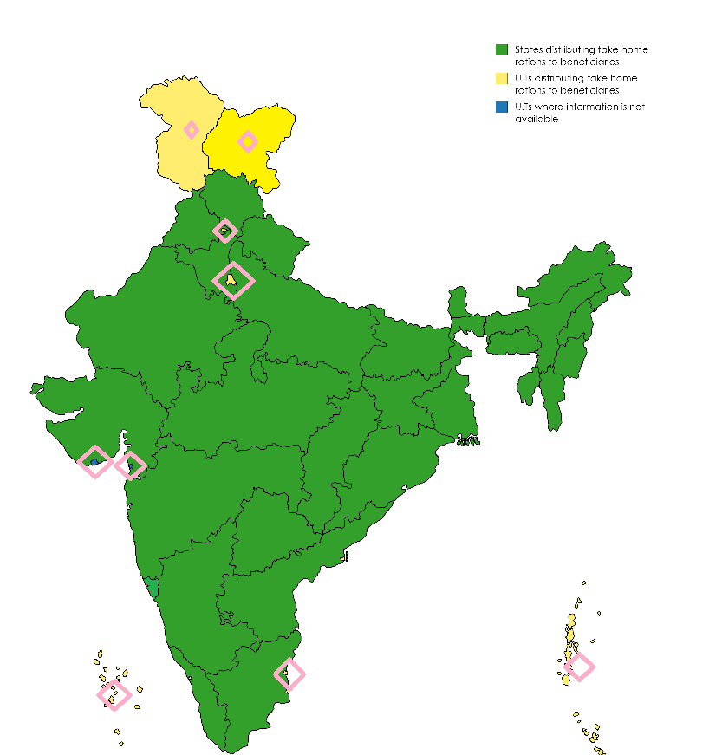

Distribution of Taken Home Rations to Pregnant and Lactating Women
Category of States/U.Ts | Colour in the map | No. of states/UTs
Sates distributing Take Home Rations |  | 28
U.Ts distributing Take home Rations |  | 7
U.Ts where no information is available |  | 1 (Dadra Nagar haveli and Daman & Diu)
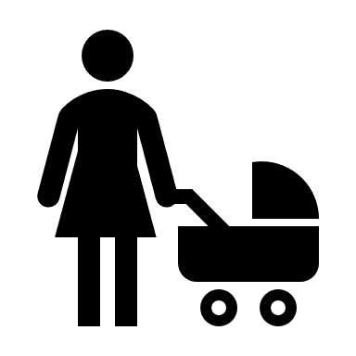
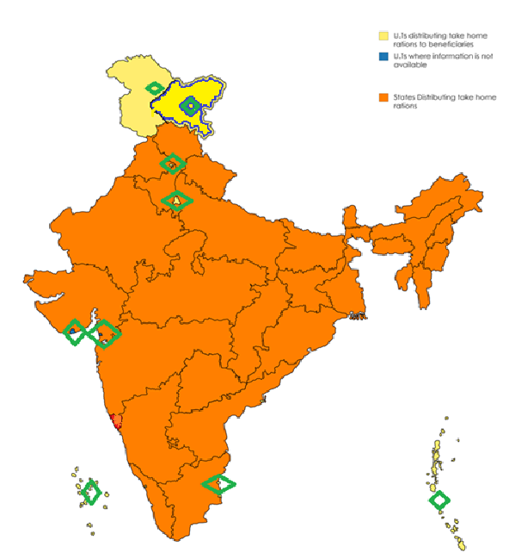

Distribution of Taken Home Rations to children between 3 years to 6 years
Category of States/U.Ts | Colour in the map | No. of states/UTs
Sates distributing Take Home Rations |  | 28 (Bihar is providing cash entitlement and Telangana is giving cooked meals)
U.Ts distributing Take home Rations |  | 7
U.Ts where no information is available |  | 1 (Dadra Nagar haveli and Daman & Diu)
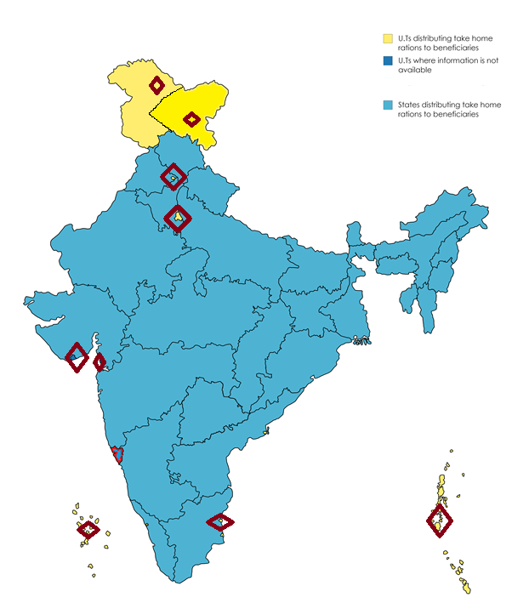

Country wide status
Measures taken by States and Union Territories Governments for the implementation of the ICDS scheme in response to COVID-19
Status Update: As on 15th May 2020
S. No | State/Union Territory | Status on distribution of THR for all the three age groups
 |  | THR for children 6-36 months of age |  | THR for pregnant/ lactating women |  | Hot cooked meals for children 3-6 years of age | Source of information
1 | Andhra Pradesh | Take Home Ration of Balamrutham 2.5 Kg /month and Eggs (daily One egg) distribution to continue for children 6-36 m of age, to be delivered at households by Anganwadi workers. |  | For pregnant and lactating women, Rice (125 g/day), Red gram Dal (30 g/day), Oil (16 g/day), 2 Eggs/day and 1.5 litres of milk will be home delivered per head (In addition, THR will also be distributed to Pregnant and Lactating women in their households Apart from regular Take Home Ration, additional nutrition (protein and millet based) is also being provided once in month to anaemic pregnant and lactating women under Bala Sanjeevani and YSR Sampurna Poshana schemes- this is a part of Tribal Sub Plan. |  | For Children 3-6 years lactating women, Rice (75 g/day), Red gram Dal (15 g/day), Oil (5 g/day), 1 Egg/day and milk to malnourished children will be home delivered per head (total estimated 8.7 lakh children) | Nutrition Specialist, UNICEF
2 | Gujarat | Children in this age group are provided 4 packets of Take Home Rations (Balshakti THR), 500 g each, home-delivered by AWWs. This arrangement was in place till 14th Apr 2020. Gujarat Cooperative Milk Marketing Federation (GCMMF) at district level is responsible for production of THR. In addition, the Govt. is also ensuring delivery of required quantity of THR to AWW by validating through OTP / ICDS CAS / images. |  | THR for P&L women was already distributed for the entire month up to 14th Apr 2020 at the start of the month. Gujarat Cooperative Milk Marketing Federation (GCMMF) at district level is responsible for production of THR. In addition, the Govt. is also ensuring delivery of required quantity of THR to AWW by validating through OTP / ICDS CAS / images |  | Children under this age group are currently not attending AWCs,Take Home Rations (Balshakti THR) are being distributed in lieu of Hot Cooked Meals as per letter from Commissioner ICDS, Gujarat. Gujarat Cooperative Milk Marketing Federation (GCMMF) at district level is responsible for production of THR. In addition, the Govt. is also ensuring delivery of required quantity of THR to AWW by validating through OTP / ICDS CAS / images | https://unicef-my.sharepoint.com/:w:/g/personal/rojohnston_unicef_org1/EUijrpv-o2lMh0hmKbFGfwABJjRnNATJAu1f9vdTHcmKLw?rtime=op9Wm6vl10g
3 | Punjab | Panjiri is being distributed to children aged 6m-3y as per entitlement. |  | Dry rations consisting of wheat, rice, powdered milk, sugar, panjiri is being provided. |  | Dry rations are being distributed in lieu of hot cooked meals. Rations consist of wheat, powdered milk, sugar, rice. | Discussion with District programme officers, Amritsar, Bhatinda
4 | Bihar | THR as dry rations is being home delivered.  Dry ration items were Rice, Dal, soybean. |  | THR as dry rations is being home delivered.  Dry ration items were Rice, Dal, soybean. |  | Cash amount for (ingredients & Conversion costs) was given to the parents of the children after the release of the funds from the Govt. | Discussion with Assistant Director (ICDS)
5 | Uttarakhand | THR (Dry rations) is being distributed to as doorstep delivery through SHGs for all beneficiaries under the scheme. |  | THR (Dry rations) is being distributed at doorstep through SHGs for all beneficiaries under the scheme. |  | THR (Dry rations) is being distributed at doorstep through SHGs for all beneficiaries under the scheme. | Official Facebook page of ICDS on 3rd April 2020
6 | Mizoram | Local task force has been created for home delivery of THR as dry ration items such as rice, pulse, oil, groundnut, chana and soy noodles packaged in plastic package and High Protein biscuits is being distributed weekly every Saturday and distribution has started from 28th March.DM has been requested to allow the vehicle for distribution of food for the beneficiaries.  THR: Energy dense Fortified food |  | Local task force has been created for home delivery of THR as dry ration items such as Rice & dal Khichri, Dal, High Protein Soy noodles, Groundnut, Motor Chana, Parantha / Puri. |  | Local task force has been created for home delivery of THR as dry ration items such as Rice, Dal, High protein Soy noodles, Groundnut, Motor chana, Wheat flour. | Discussion with Deputy Director (ICDS)
7 | Tripura | SNP food as take home rations will be provided to the guardians during home visits. Take home rations to P&L women will also be provided without disruption. |  |  |  |  | https://www.aninews.in/news/national/general-news/combating-covid-19-anganwadi-centres-to-remain-closed-in-tripura-till-march-3120200316233417/
8 | Assam | Rice, Yellow peas dal & 80g /day of Micronutrient fortified food (Panjiri)  Local procurement of these items being done by NGO's and AWW are supplying the items door to door every fortnight. |  | Rice, Yellow peas dal & 100g /day of Micronutrient fortified food (Panjiri)  Local procurement of these items being done by NGO's and AWW are supplying the items door to door every fortnight. |  | HCM is replaced by dry rations which includes Rice, Yellow peas dal, Soya granules, oil, double fortified salt.  Local procurement of these items being done by NGO's and AWW are supplying the items door to door every fortnight. | Discussion with Joint Director (ICDS)
9 | Sikkim | THR/Dry rations is being distributed to children 6-36 months. |  | THR/dry rations being distributed to the beneficiaries of this age groups. |  | THR/dry rations being distributed to the beneficiaries. | As per MWCD Facebook page.
10 | Meghalaya | Milk, Cereal based weaning food, fortified suji, fortified seera are home delivered. |  | Fortified atta, Fortified suji, Cereal based weaning food, oil, sugar are home delivered. |  | Hot cooked meals replaced by Rice, Dal, Salt, oil, Milk are home delivered. | Discussion with Child Development Project Officer (ICDS)
11 | Nagaland | AWW are delivering foodstuff (THR) at the doorsteps of beneficiaries in Tuensang district during lockdown under Chessore ICDS project |  |  |  |  | https://www.nagalandpost.com/donations-for-needy-continue-to-pour-in-amidst-lockdown/214206.html
12 | Uttar Pradesh | Production of THR through centralized facilities is ongoing. Anganwadi workers have been directed to distribute THR through house-to-house distribution. All districts have initiated action based on the same  Distribution is being done at an interval of 15 days at home by AWW. |  | Production of THR through centralized facilities is ongoing. Anganwadi workers have been directed to distribute THR through house-to-house distribution. All districts have initiated action based on the same.  Distribution is being done at an interval of 15 days at home by AWW. |  | Distribution of THR product in lieu of hot cooked meals, home-delivered at an interval of 15 days by AWW. | Letter from CS, ICDS.
13 | Chhattisgarh | Govt. of Chhattisgarh has issued an order to continue distribution of THR (Ready to eat) product to beneficiaries as per entitlement. The anganwadi workers were tasked to deliver THR from house-to-house. All districts have started distribution as per the order |  | Govt. of Chhattisgarh has issued an order to continue distribution of THR (Ready to eat) product to beneficiaries as per entitlement. The anganwadi workers were tasked to deliver THR from house-to-house. All districts have started distribution as per the order.  Ready to eat THR is being provided to P&L women in lieu of hot cooked meals, at 900 g / week / woman |  | For Children 3y – 6y, the state govt. has issued guidance to distribute THR (Read to eat product) in lieu of hot cooked meals as per entitlement i.e 125 g / day entitlement (Packaging size of THR is 750 g). | https://unicef-my.sharepoint.com/:w:/g/personal/rojohnston_unicef_org1/EUijrpv-o2lMh0hmKbFGfwABJjRnNATJAu1f9vdTHcmKLw?rtime=op9Wm6vl10g
14 | Telangana | Balamrutham: 2.5kg packet for and Eggs: 8 eggs.  No. of children (7 m-3 Years) Distributed THR- 884326 during, the COVID-19 lockdown period in two spells (from 23-03-2020 to 20-04-2020)  Special care and supervised feeding of 7 months -3yrs severely malnourished Children per day:  Rice: 37.5g.  Dal: 7.5g  Oil:7.5 g  Egg: Daily One  Milk: 100ml |  | Rice: 150g  Dal: 30g  Oil:16g  Milk: 200ml  Egg: Daily One |  | Rice: 75g  Dal: 15g  Oil: 5g  Egg: Daily One  Snacks: 20g  Special care and supervised feeding of 3yrs -6yr severely malnourished Children per day:  Rice: 75g  Dal: 15g  Oil:10g  Egg: Daily One  Snacks: 20g.  Milk: 100ml | Nutrition Specialist, UNICEF.
15 | Jharkhand | Govt. of Jharkhand has issued an order to distribute THR to beneficiaries as per entitlement. Jharkhand Livelihoods Prevention Mission has been entitled for the task. Select districts have started distribution of THR as per the order. |  | Govt. of Jharkhand has issued an order to distribute THR to beneficiaries as per entitlement. Jharkhand Livelihoods Prevention Mission has been entitled for the task. Select districts have started distribution of THR as per the order. |  | Govt. of Jharkhand has issued an order to distribute THR to beneficiaries as per entitlement. Jharkhand Livelihoods Prevention Mission has been entitled for the task. Select districts have started distribution of THR as per the order. | Nutrition Specialist, UNICEF.
16 | Maharashtra | The state govt. has issued orders to distribute dry rations in lieu of THR for children aged 6 – 36 m, the dry rations shall be sourced from Maharashtra State Cooperative Consumer Federation, Mumbai. The distribution to be done by anganwadi workers on a house-to-house basis |  | The state govt. has issued orders to distribute dry rations in lieu of THR for Pregnant and Lactating women, the dry rations shall be sourced from Maharashtra State Cooperative Consumer Federation, Mumbai. The distribution to be done by anganwadi workers on a house-to-house basis |  | The state govt. has issued orders to distribute dry rations in lieu of hot cooked meals for children 3 – 6 y of age, the dry rations shall be sourced from Maharashtra State Cooperative Consumer Federation, Mumbai. The distribution to be done by anganwadi workers on a house-to-house basis Instead of hot cooked meals. The dry rations shall consist of chana (30 g), masoor dal (28 g), rice / wheat (62 g), red chilli powder (4 g), turmeric powder (4 gm), salt (8 gm) and soybean oil (10 g) | State Govt. Consultant, WCD.
17 | Karnataka | In view on extension of lockdown Dept. of Women & Child Development has issued GO for providing THR to children from 6 months to 3 years at their households. The THR varies from district to district. (all districts of Karnataka have their own menu). |  | THR has been provided to all P & Breast-Feeding women. (Sample menu from one of the district is attached) |  | In view on extension of lockdown Dept. of Women & Child Development has issued GO for providing THR to children from 3 years to 6 years at their households. The THR varies from district to district. (all district of Karnataka have their own menu). | Nutrition Specialist, UNICEF
18 | Tamil Nadu | Dry rations consisting of rice, dal, pulses and nutritional supplements are being provided to children every 15 days. In addition, eggs are distributed to houses of under-nourished children every Wednesday by AWWs (Home-delivery) |  | Dry rations consisting of rice, dal, pulses and nutritional supplements are being provided to children every 15 days. |  | Dry rations consisting of rice, dal, pulses and nutritional supplements are being provided to children every 15 days. | https://timesofindia.indiatimes.com/city/chennai/anganwadi-workers-deliver-aid-but-at-own-risk/articleshow/75261044.cms
19 | Odisha | Entitlements in the form of chhatua, dry ration, laddoos/chikkis are given to the beneficiary groups at one go for the entire month. Eggs are distributed on a weekly basis and in case of unavailability of eggs, substitutes such as soya granules provided.  These items have been home delivered to the beneficiaries by AWWs/AWHs for the month of May 2020. |  | THR items for the month of May 2020 have been home delivered by AWW and eggs are distributed on weekly basis. |  | THR items for the month of May 2020 have been home delivered by AWW and eggs are distributed on weekly basis. | State Project Coordinator, WFP.
20 | Rajasthan | Till March 2020, THR was distributed as per the regular distribution process.  THR being distributed to both children between 6-36 months as well as to children between 3-6 years of age. Discussions on the distribution of wheat & pulses through PDS are being held and the orders will be issued once it is approved. AWW will collect dry rations from Fair Price shops and will home deliver it to the beneficiaries. |  |  |  |  | In case of unavailability of eggs, substitutes such as soya granules would be provided, without compromising on the nutrition value.
21 | Kerala | In certain areas mothers are coming and collecting the THR in the form of Amrutham, in other areas the AWWs are delivering for the entire month of May. |  | In certain areas pregnant & lactating mothers are coming and collecting the THR, in other areas, where they are not able to come, the AWWs are delivering. |  | Instead of hot cooked meals, the children are being given THR (Rice and other items) which have been distributed for May 2020. | Updates from Sr. Programme Associate (WFP).
22 | West Bengal | Dry ration is given to all the beneficiaries under the ICDS scheme. |  |  |  |  | Discussion with ICDS officials.
23 | Himachal Pradesh | The beneficiaries are given dry rations as THR for 15 day’s entitlement together and being distributed by AWW across the state. PPEs are given by state gov. to these workers. |  | The beneficiaries are given dry ratios as THR for 15 day’s entitlement together and being distributed by AWW across the state.  PPEs are given by state gov. to these workers. |  | The beneficiaries are given dry ratios as THR for 15 day’s entitlement together and being distributed by AWW across the state.  PPEs are given by state gov. to these workers. | Discussion with District Project officer  (ICDS)
24 | Madhya Pradesh | 2-3 weeks THR entitlement is given to children aged 6 – 36 months as doorstep delivery – halva, balaahar (khichdi powder) |  | 2-3 weeks THR entitlement is given to Pregnant and lactating mothers as doorstep delivery – Barfi and khichdi |  | 2-3 weeks THR entitlement is given to children 3-6 yrs. as doorstep delivery – Barfi and khichdi. | Discussion with Joint Director, WCD.
25 | Haryana | Raw home rations are distributed as per nutritional and financial norms prescribed by GoI. |  | Raw home rations are distributed as per nutritional and financial norms prescribed by GoI. |  | Raw home rations are distributed as per nutritional and financial norms prescribed by GoI. | Advisory from DWCD Haryana, dated 18th March’20.
26 | Goa | Anganwadi functionaries are distributing Take Home Rations among the beneficiaries strictly following social distancing as preventive measures against COVID-19. |  |  |  |  | As per MWCD Facebook page.
27 | Arunachal Pradesh | Distribution of Take -Home rations is happening at the home points on fortnightly or monthly basis with the help of AWW, SHG and mothers. |  | Distribution of Take- Home rations is happening at the home points on fortnightly or monthly basis with the help of AWW, SHG and mothers |  | Distribution of Take Home rations is happening at the home points on fortnightly or monthly basis with the help of AWW,SHG and mothers | Discussion with Director, ICDS.
28 | Manipur | Distribution of cooked food items has been going on in almost all the districts namely; Imphal West, Imphal East, Bishnupur, Thoubal, Kakching, Chandel, Churachandpur, Pherzawl, Kangpokpi and Noney. |  |  |  |  | http://e-pao.net/GP.asp?src=13..150420.apr20
Union Territory
1 | Lakshadweep | Anganwadi Centres has been closed till 31 March. The administration is getting the packed food delivered to each of the children weekly. This would continue till the situation improves. |  | Anganwadi Centres has been closed till 31 March. The administration is getting the packed food delivered to each of the children weekly. This would continue till the situation improves. |  | Anganwadi Centres has been closed till 31 March. The administration is getting the packed food delivered to each of the children weekly. This would continue till the situation improves. | https://www.aninews.in/news/national/general-news/anganwadi-workers-delivering-take-home-rationeven-in-lakshwadeep-ministry-of-women-and-child-development20200420152057
2 | Chandigarh | Take Home Ration’ i.e. Nutritious Weaning Food and Besan Panjiri at the doorsteps of 21000 Nos. which includes all the beneficiaries (children and P&L) of 450 Anganwadi Centres.15 days entitlement is being distributed at a time, These are prepared in 4 Kitchens and 1 Jail in the U.T, Out of 450, 58 AWCs are also distributing eggs, banana and milk. Once COVID situation subsides, this will be scaled to the remaining AWCs in the U.T.  Along with delivering SNP, AWW are also making masks for distribution in communities |  |  |  |  | Press Release of 17th April 2020.  Discussion with the consultant health and nutrition Mr. Rajeev Grewal.
3 | Puducherry | Cash entitlement has been given for 2 months covering May and June: Children – INR 9.11 per child per day, P&L mothers – 11.25 per mother per day. |  |  |  |  | Discussion with Programme officer, ICDS.
4 | Dadra & Nagar Haveli | No information available |  | No information available |  | No information available
5 | Jammu and Kashmir | Dry Rations are being distributed to the beneficiaries through Anganwadi workers. |  | Dry Rations are being distributed to the beneficiaries through Anganwadi workers. |  | Dry Rations are being distributed to the beneficiaries through Anganwadi workers. | https://www.aninews.in/news/national/general-news/anganwadi-workers-delivering-take-home-rationeven-in-lakshwadeep-ministry-of-women-and-child-development20200420152057  and  MWCD Facebook page.
6 | Ladakh | AWC beneficiaries are given their entitlements (THR/dry ration) as door- step delivery through AWW. |  |  |  |  | Discussion in the office of Additional District Development Commissioner.
7 | Daman & Diu | No information available |  | No information available |  | No information available
8 | New Delhi | On March 18, the government came with an order stating that ‘although AWC shall continue to be suspended till March 31 distribution of Supplementary Nutrition (panjiri/paushtik laddoo) shall be resumed with effect from March 19 so that nutritional supplement to beneficiaries does not get interrupted. The supplementary nutrition has been prefixed as 315 gm panjiri and 105 gm in two separate packets and 12 laddoos 330 gm in one packet respectively.  THR for six days i.e. 630g of Panjiri and 210g of groundnut is distributed door to door by AWW on weekly basis. |  |  |  |  | Discussion with CDPO, ICDS
9. | Andaman and Nicobar Islands | Dry ration of 1month instalment (May 2020) is being distributed to all beneficiaries. It consists of rice, green gram, masoor dal, Rajma, Soya chunk, oil, milk powder etc). | Dry ration of 1month instalment (May 2020) is being distributed to all beneficiaries. It consists of rice, green gram, masoor dal, Rajma, Soya chunk, oil, milk powder etc). |  | Dry ration of 1month instalment (May 2020) is being distributed to all beneficiaries. It consists of rice, green gram, masoor dal, Rajma, Soya chunk, oil, milk powder etc). |  | Discussion with Programme Officer, ICDS.

Disclaimer: The report has been generated based on published newspaper articles, official media reports and phone calls to respective state government officials.

