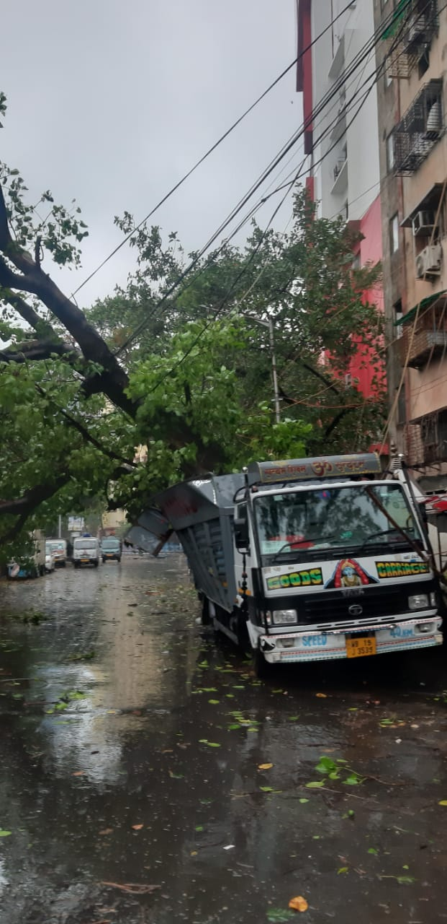
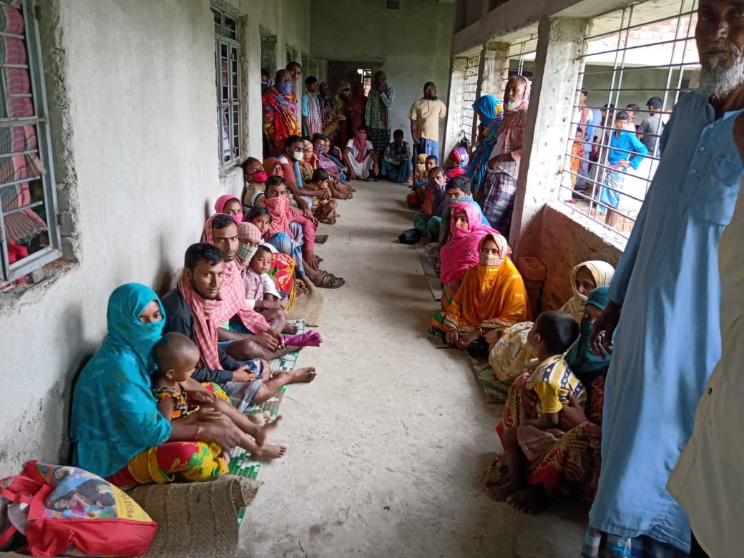
The impact of Cyclone Amphan across Kolkata

d SheltersThe impact of Cyclone Amphan across West Bengal

SITUATION IN NUMBERS
West Bengal

Cyclone Amphan 2020

Situation Report # 3

Highlights
21st May 2020 at 13.00 hrs

9 Districts affected, including 3 coastal East Midnipur, West Medinipur South 24 Parganas, North 24 Parganas, Howrah, Hooghly, Kolkata, Burdwan & Murshidabad

50.23 Million
Population affected (all nine districts)

16.57 Million Children at Risk
(all nine districts)

0.5 Million (of which Children: 0.16 M)
People evacuated from costal zones of South 24 Parganas, North 24 Parganas, West and East Medinipur district and sheltered in Cyclone/ flood shelters/ school buildings.

Source: State IAG, State Emergency Operation Centre, Dept. of Disaster Management & Civil Defence (DM&CD), Govt. of West Bengal and National Disaster Response Force (NDRF).
The Super Cyclonic Storm Amphan (pronounced as Um-Pun) on Wednesday cut a swathe through northern Odisha before bearing down on West Bengal with a wind speed of 185 kmph.
It then moved North-Northeast with a speed of 27 kmph during past 06 hours, further weakened into a Cyclonic Storm and lay Centered at 05:30 hours IST on 21 May 2020 over Bangladesh near Lat. 24.7°N and Long. 89.5°E about 270 km north-northeast of Kolkata, 150 km south of Dhubri and 110 km south-southeast of Rangpur (Bangladesh).
Cyclone Amphan killed at least 12 people and ravaged Kolkata and several parts of West Bengal as it left behind a trail of destruction by uprooting trees, destroying thousands of homes and swamping low-lying areas of the State.

Situation Overview and Humanitarian Needs
Situation Updates:
- Among the 12 dead is 13-year-old Laksmi Kumari who stepped out of her house in Raj Chowdhury Lane and a concrete chunk fell on her head. She was rushed to Howrah state general hospital and declared dead. Nurjehan Bewa a resident of Minakha in South 24 Parganas also reportedly died after a tree fell on her. Another youth was reportedly killed in Basirhat in North 24 Parganas District after a tree fell on him. A woman died at Barrackpore, North 24 Parganas after being struck in contact with electricity.
- Senior State officials said it is too early to estimate a toll on life or damage to property as the hardest hit areas are still not accessible.
- Packing heavy rain and winds with speeds of up to 190 kmph, extremely severe Cyclone Amphan slammed Digha Coast of West Bengal at 2.30 p.m. on Wednesday, triggering heavy rainfall and gusting wind in various parts of the State.
- West Bengal Chief Minister Mamata Banerjee, who was monitoring the situation at the State Secretariat Nabanna since Tuesday night, said the impact of Amphan is "worse than Coronavirus".
- The Cyclone barreled through the coastal districts of North and South 24 Paraganas of Bengal, unleashing copious rain and windstorm, blowing away thatched houses, uprooting trees, electric poles and swamping low lying towns and villages, officials said.
- Strong winds with speed up to 125 kmph per hour upturned cars in Kolkata and felled trees and electricity poles blocking important roads and intersections.
- Ground Reports coming from North and South 24 Parganas and East Midnapore said roofs of thatched houses were blown away, electric poles got twisted and hundreds of trees broken and uprooted.
- There is a massive power cut in large parts of Kolkata, North 24 Parganas and South 24 Parganas. The mobile and internet services are also down as the cyclone had damaged several communication towers.
- Streets and homes in low lying areas of Kolkata are swamped with rainwater.
- Portions of several dilapidated buildings came crashing down in Kolkata and other parts of the state.
- Embankments in Sundarban delta - a UNESCO site - were breached as the surge whipped up by the cyclone inundated several kilometers of the Island.
Leadership and coordination
- A group of senior secretaries from Government of West Bengal under the leadership of Chief Minister are actively coordinating the Government-led response coordinating all the NDRF and other responders at district and local level.
- The Government-IAG coordination at district level continues to mobilize and utilize civil society responses. IAG has already actioned its plan to conduct joint rapid needs assessment.
- Prepositioned National Disaster Response Force and other State Government responders have taken rapid action in coordination with local population to clear the roads of the fallen trees. The work is ongoing.
State Government Response
- The Chief Minister is monitoring the situation from State Control Room.
- Chief Secretary, Mr. Rajiva Sinha, mentioned during the press meeting that “It will take time for our workers to reach the affected areas. It will be only after tomorrow that proper work can begin after restoration of all road communications. There is huge loss in agriculture. We are first providing humanitarian help like food, water and shelter to those affected. Then we will think of a way to financially help or provide job avenues, so that they can stand on their feet.”
- State Emergency Operation Center (EOC) at Disaster Management & Civil Defense Department, Nabanna (with toll free no. 1070), Contact No. 033 2214 3526 is functional and monitoring the rescue and restoration work started by respective district administrations with the help of National and State Disaster Response Force (NDRF), Fire and Disaster Management Group (DMG), Civil Defence and Inter Agency Group (IAG) volunteers and local police.
- Key line departments like PWD, PHED, Health and Family Welfare, Irrigation, Power, and Fisheries have been asked to initiate the preliminary assessment, as soon as the communication channels are restored.
- Some 41 NDRF and SDRF teams are deployed in severely cyclone affected areas of Kolkata, East Medinipur, West Medinipur, North 24 Parganas and South 24 Parganas districts for rescue, relief and restoration work.
- Given the COVID-19 Pandemic, the Government has distributed more than two lakh masks among the evacuees and personal protective equipment (PPE) kits to the State Disaster Relief Force personnel, who are deployed in the vulnerable areas. North 24 Parganas and East Midnapore districts are two COVID-19 hotspot districts due to high prevalence of positive cases.
UNICEF Action
- UNICEF is closely monitoring the situation with Department of DM and CD and State IAG.
- UNICEF has supported the State Inter Agency Group (IAG) West Bengal as a key partner at state level for DRR work, in building knowledge and capacities, of both government officials and IAG members since 2016. Hence, CASA (State IAG coordinating lead agency) and Practical Action Foundation, in South 24 Parganas and KJKS (District IAG Coordinating Agency) East Medinipur, is the key DRR partner of UNICEF-KFO and are directly coordinating with District Emergency Operation Centers (EOCs) of three major Cyclone affected coastal districts.
- UNICEF Priority Sectors are also coordinating with their respective Government and CSO partners to assess the ground situation and planning for the response measures.

State and District IAG Response:
- UNICEF has active partnership with State IAG-West Bengal for supporting in Go-NGO coordination at State & District level for DRR and Emergency Preparedness and Response work.
- All the District IAGs have engaged their volunteers to support respective District Administrations in warning dissemination, evacuation, shelter management and Search & Rescue operation.
- All the participating organizations were requested to share the names of the experts to participate in the rapid assessment, if required to be deployed.
- State IAG circulated a Google Online Format among all the members of State & Districts IAGs and compiling situation updates with inputs from affected communities. These updates are being shared among all the member organizations of IAG for planning the immediate response activities.
- Cyclone preparedness advisories and video clip shared by UNICEF, were circulated through State & District IAG WhatsApp group and disseminated among the affected communities by respective members organization in their operational areas.
- District IAG members are requested to remain in touch base with District Control Room while State IAG will directly coordinate with State EOC at Nabanna.
- Ham Radio Teams are deployed in all affected Island and Costal zones to support local administration in establishing un-interrupted communication channel through Ham radio.
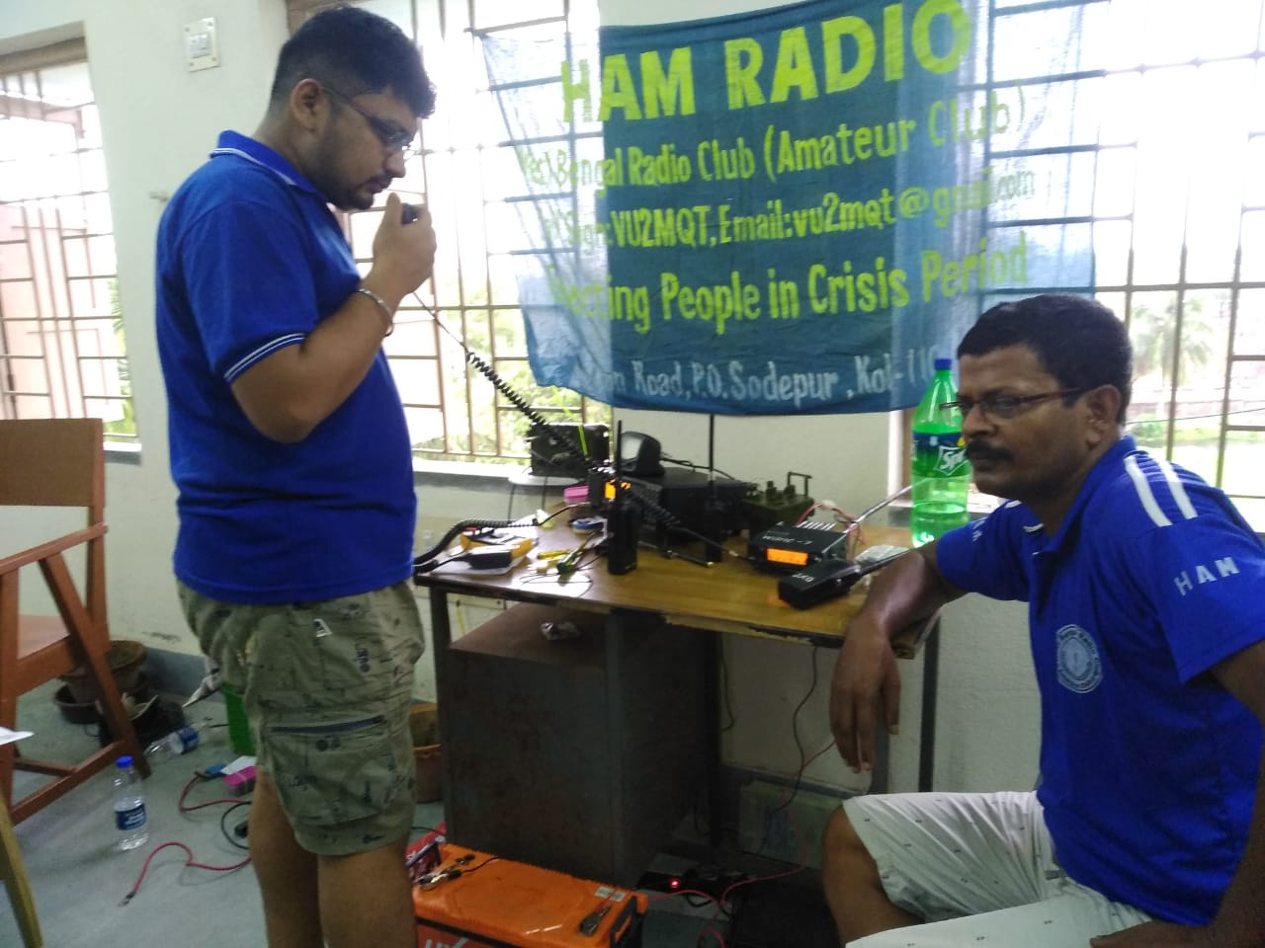
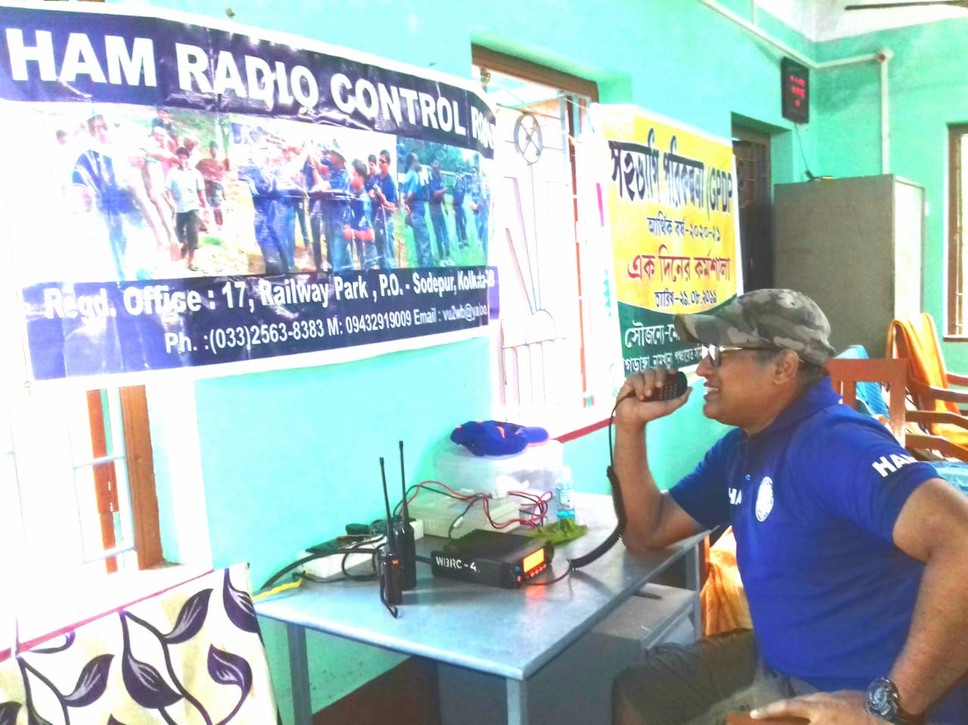

Humanitarian Strategy
Overarching UNICEF approach for the provision of life-saving interventions for cyclone affected women and children is to support service delivery by line-departments (mainstream service delivery mechanisms) and district administration wherein UNICEF partners particularly the Inter Agency Group provide on-ground implementation support. To enable this UNICEF is providing technical support and strategic advice to Government at district level. Some of the key entry points leveraged by UNICEF include:

- Volunteers mobilized and deployed through active collaboration between IAG and district administration of South 24 Parganas, North 24 Parganas and East Midnipur districts.
- Communication materials on Cyclone Preparedness and does and don’ts have been shared through the IAG volunteers up to the community level.
- Communication with communities can be established through the local volunteers to assess the immediate need and accordingly plan for the response work.
- Immediately the affected communities, both at URBAN slum and Rural Districts, to be provided with basic needs like Food, Drinking Water, Hygiene kit (keeping in view of COVID-19) etc.
Sources of Information:
- Telephonic conversation with State EOC (Emergency Operation Center), DM &CD, GoWB
- District Control Room (District EOC), East Medinipur & South 24 Parganas etc.
- State and Respective Districts IAG WhatsApp group.
- Media report

UNICEF West Bengal India

Alison Parker
Chief of Communication
UNICEF Afghanistan
Tel: +93 730727110
Email: aparker@unicef.org

Simanchal Pattnaik
Programme Officer
UNICEF West Bengal
Tel: +91 9437089446
Email : spattnaik@unicef.org

Mohammad Mohiuddin
Chief of Field Office
UNICEF West Bengal
Tel: +91 9831096706
Email: mmohiuddin@unicef.org

Who to contact for further information:

Images of impact and damage in Kolkata urban areas (Photos Shared by IAG members-West Bengal):

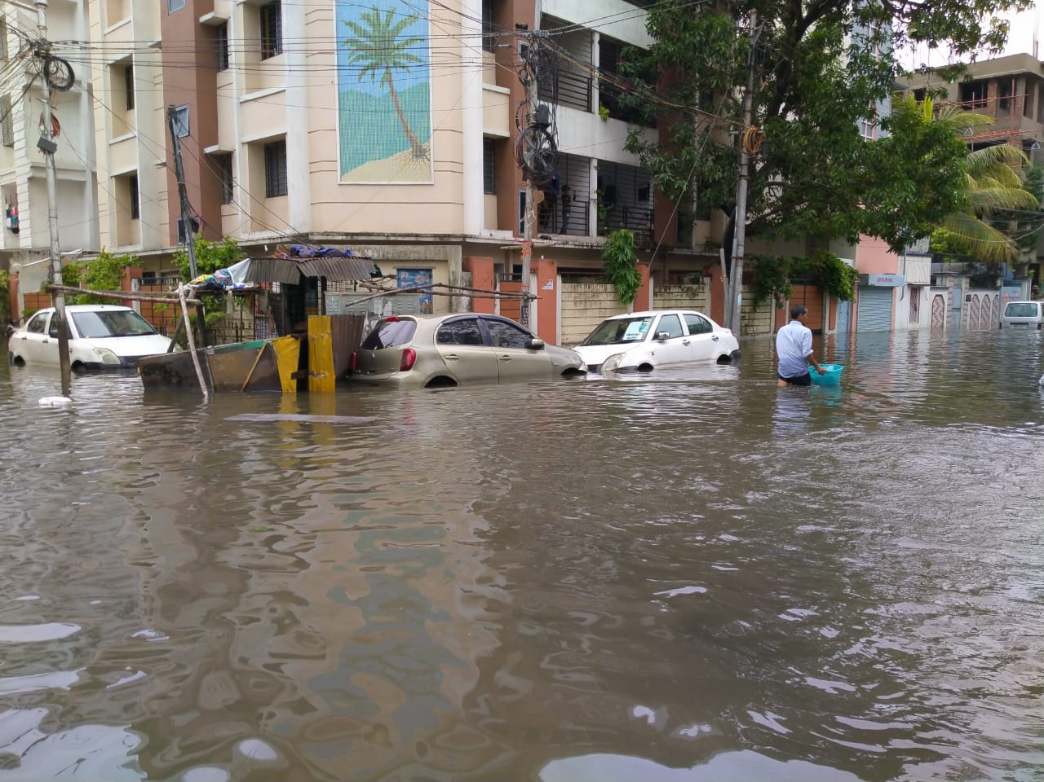
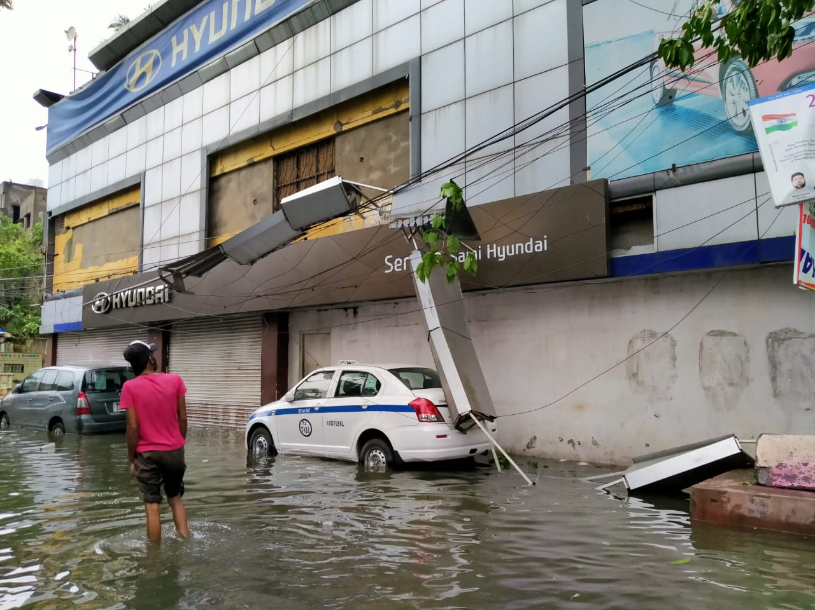
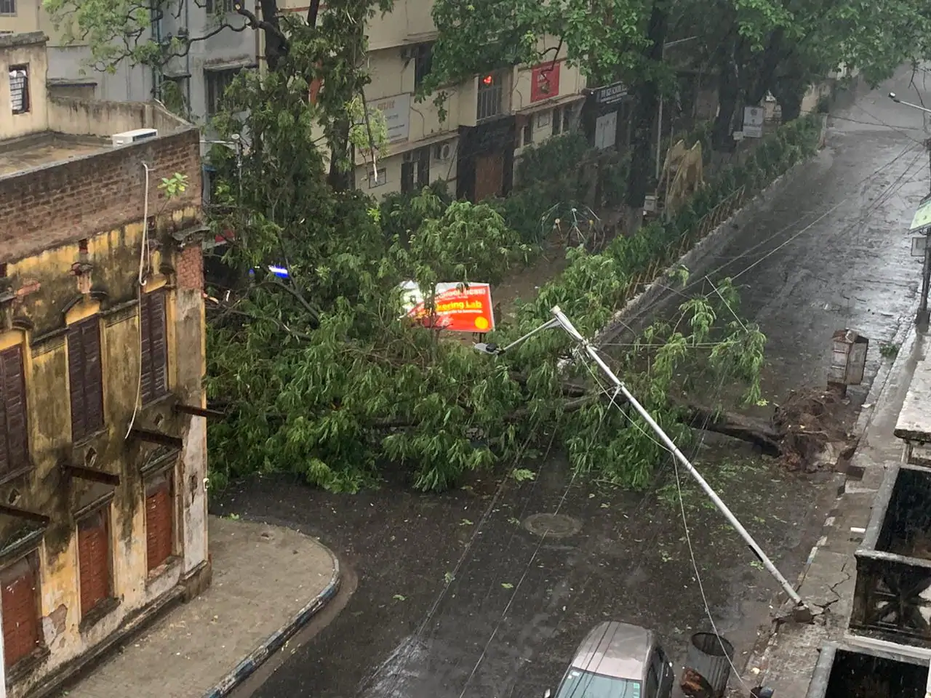
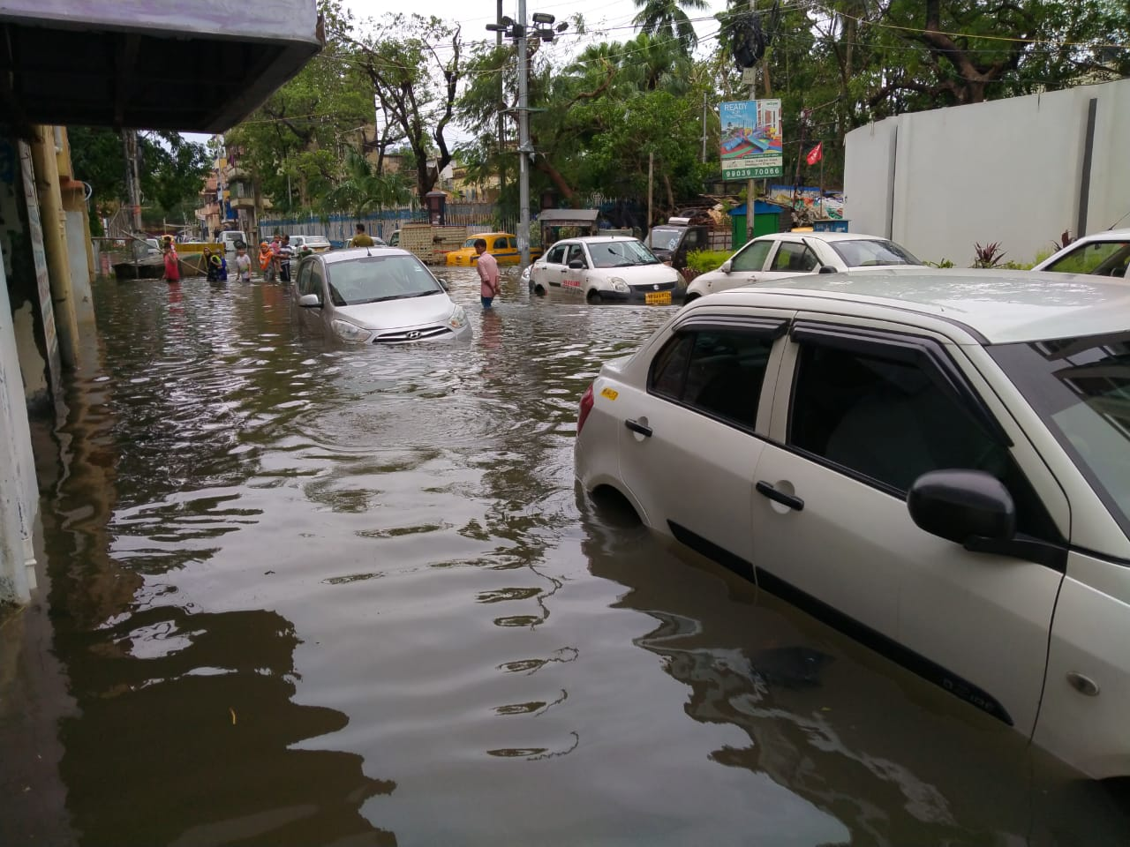
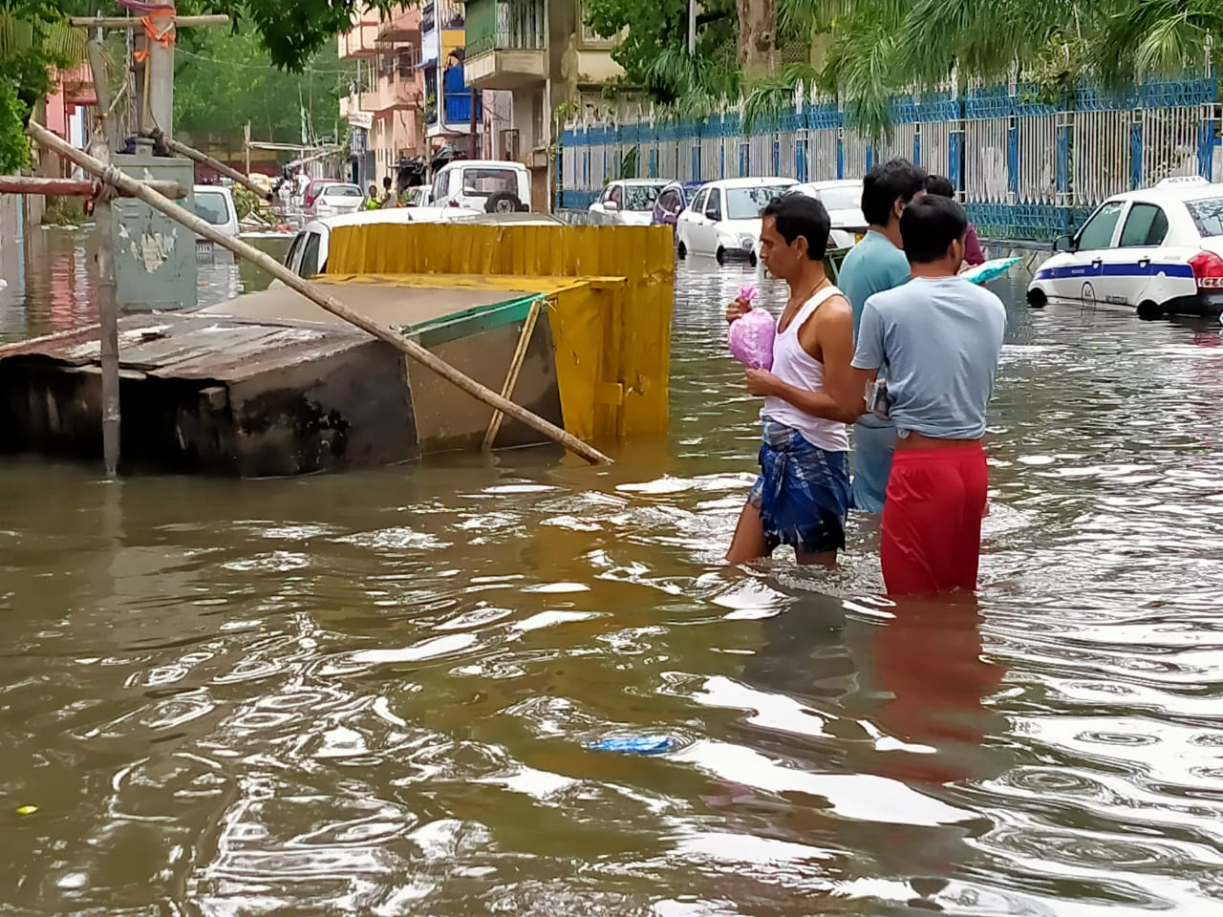
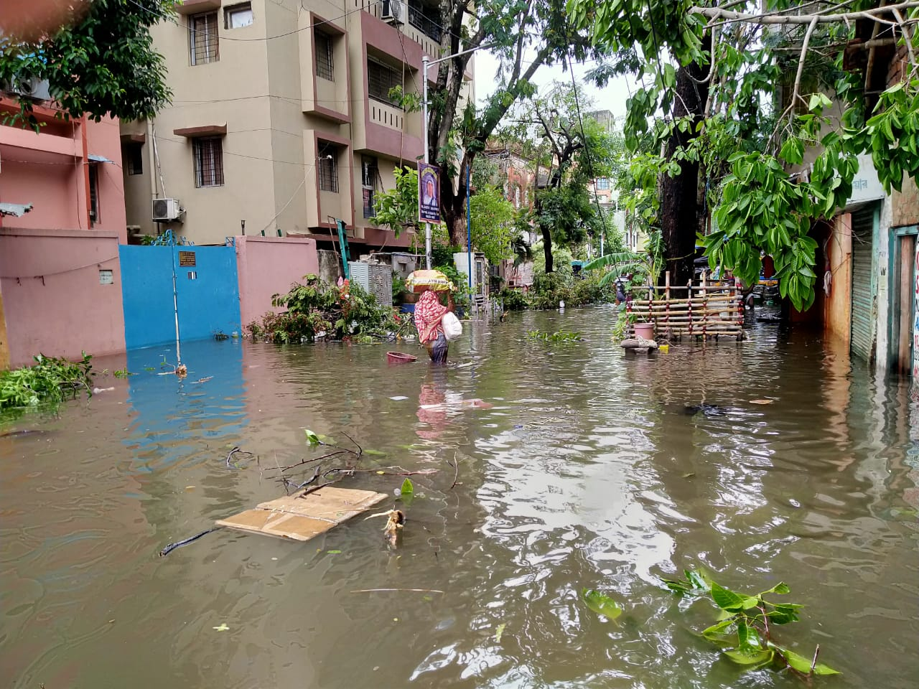

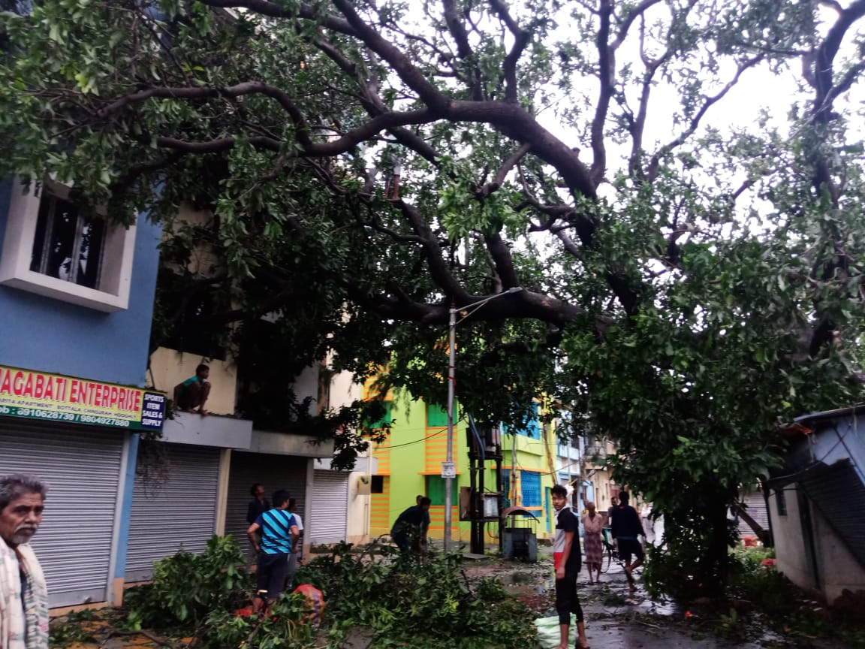
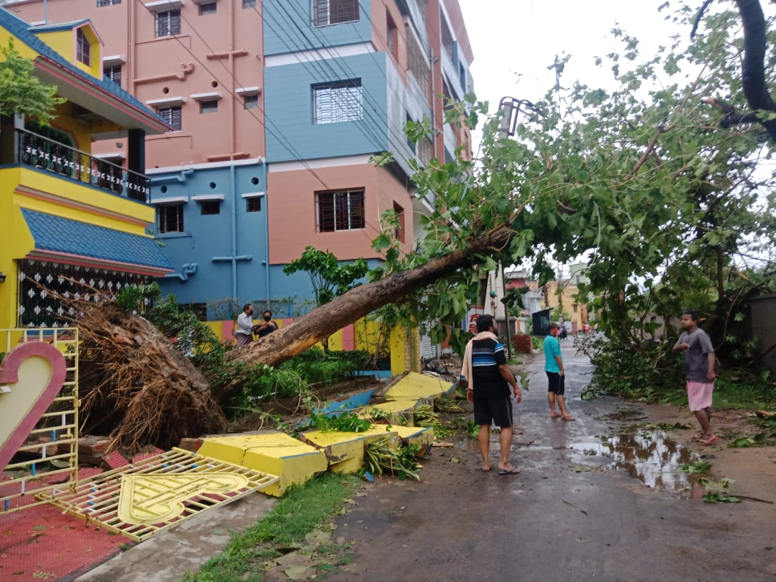
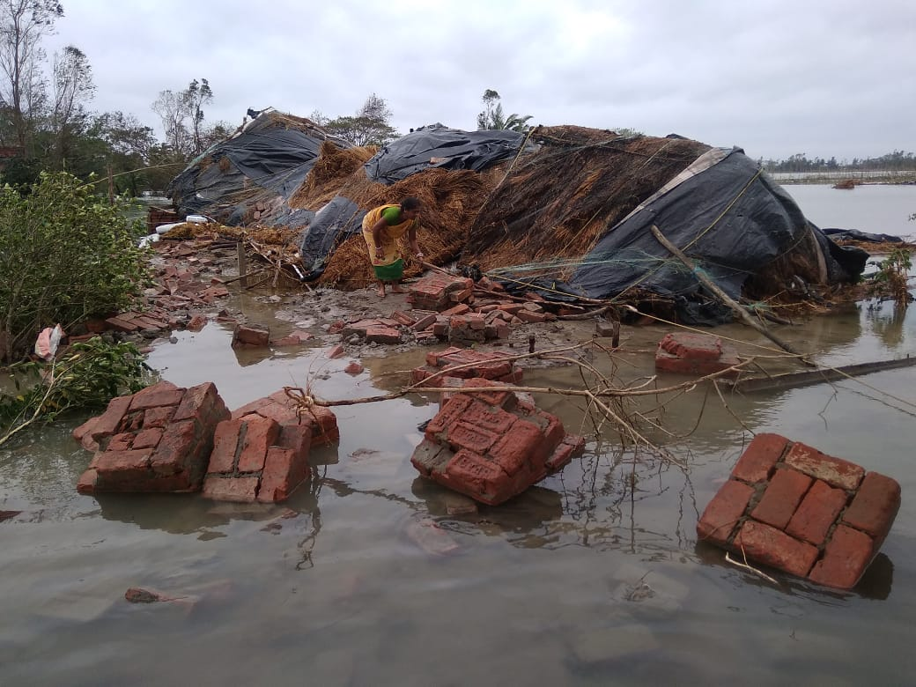
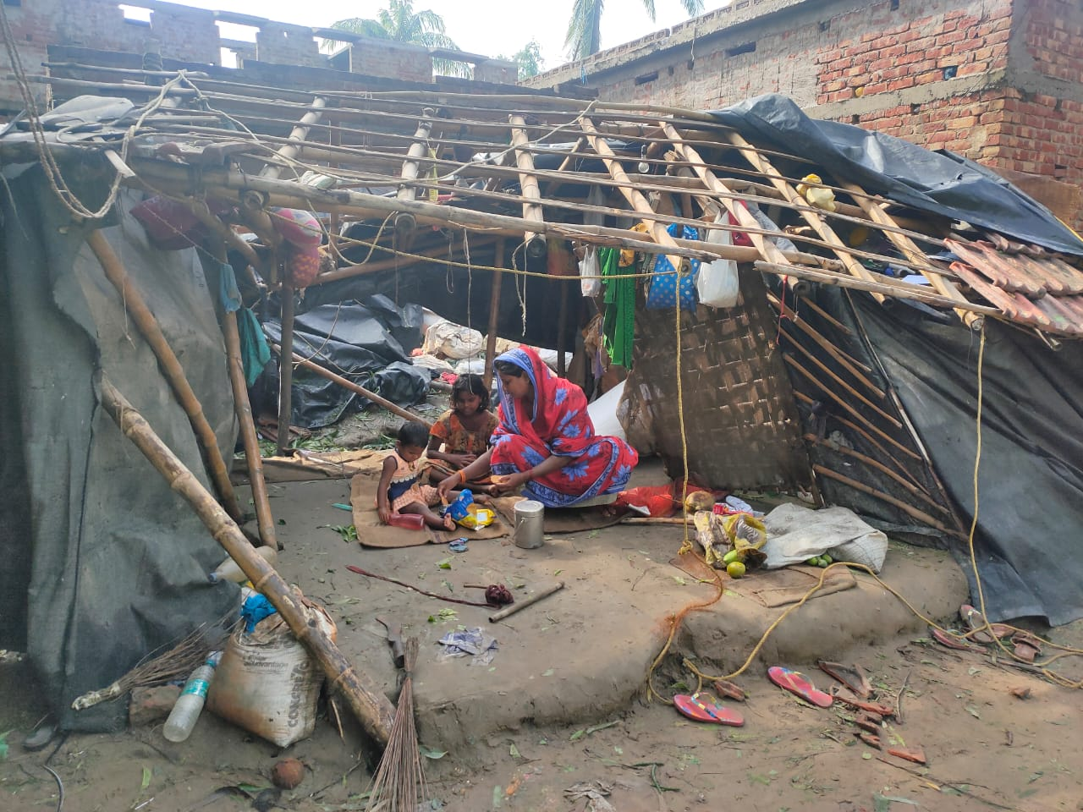
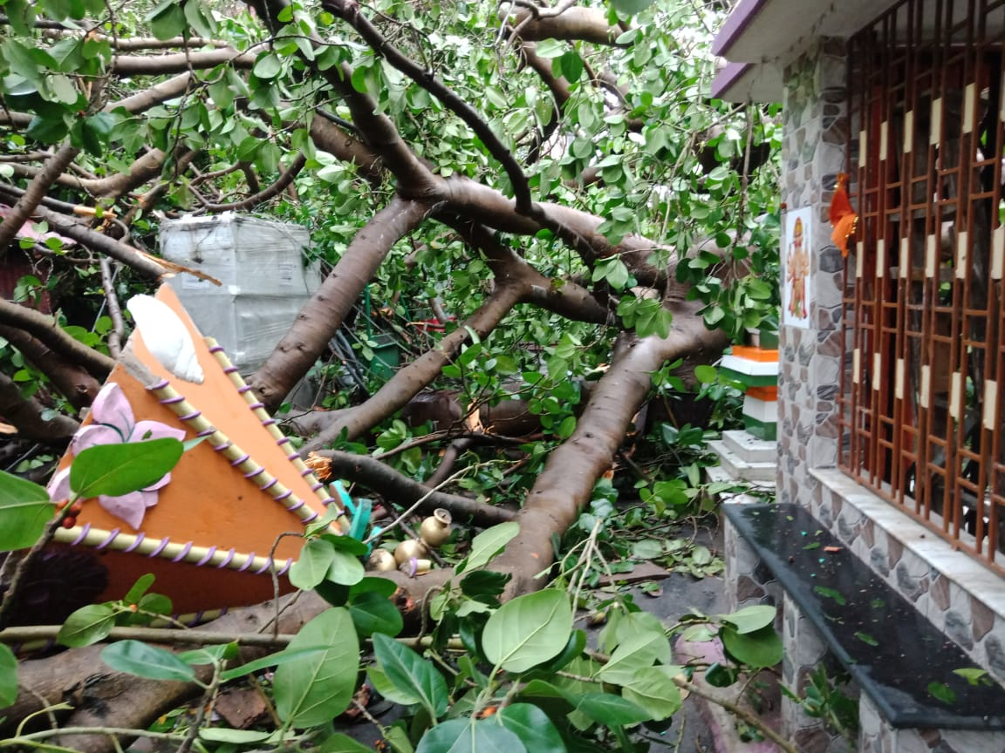
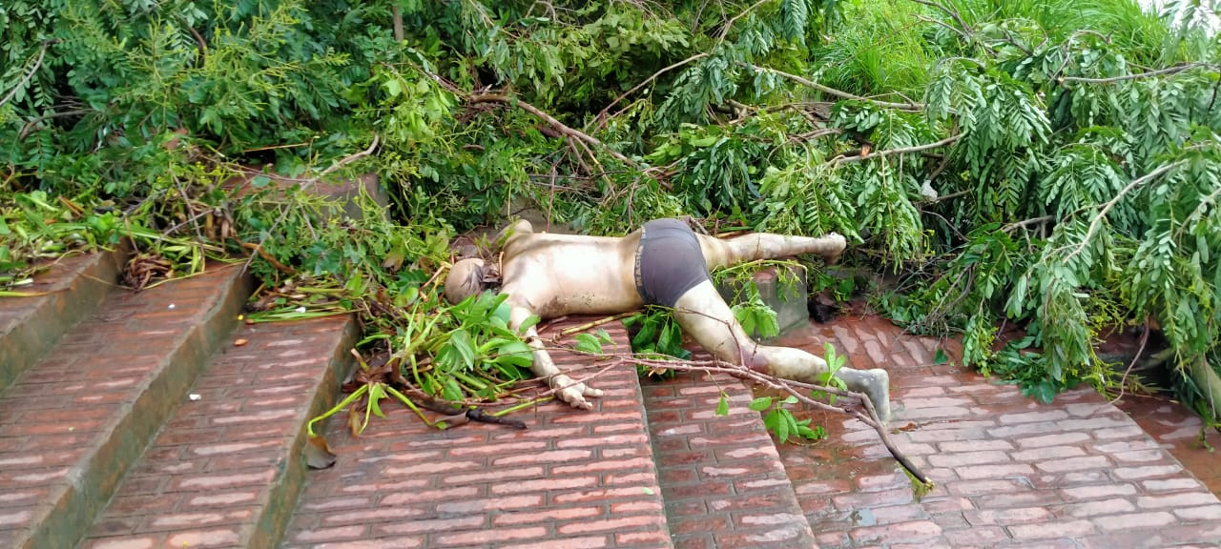
Images of impact and damage in rural areas of affected districts (South 24 Parganas, North 24 Parganas, East Medinipur, West Medinipur, Howrah, Hooghly etc. (Photos Shared by IAG members-West Bengal):

Annexure-I-IECs shared by UNICEF

