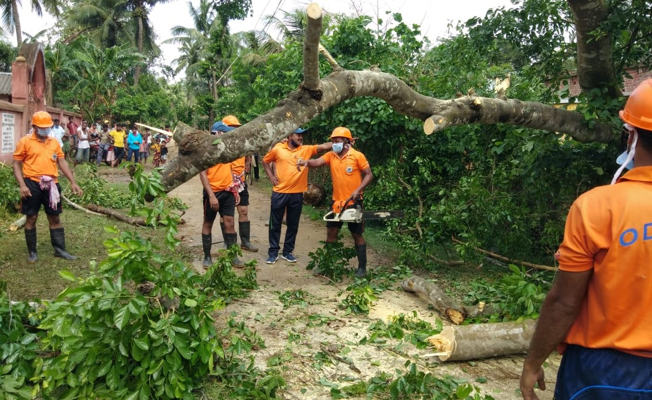
ODRAF personnel clearing a village road in Balasore
© SRC, Odisha
UNICEF Bhubaneswar,
Cyclone AMPHAN
Update # 1
Highlights

Cyclone AMPHAN is the first super cyclone in the Bay of Bengal since 1999, that made landfall in the coastal region of Odisha and West Bengal on May 20th and caused widespread damage.
- Government of Odisha took all possible initiatives, including evacuating more than two lakh population to ensure zero casualty.
- Among the 10 affected districts, Balasore, Bhadrak, Kendrapara and Jagatsinghpur districts have been heavily affected due to the cyclone, where many trees and electric poles have been uprooted resulting in disruption of road communication, electricity and tele communication.
- There is extensive damage to kutcha houses in Balasore, Bhadrak and Kendrapara districts. Boats and fishing equipments, structures of temporary street vendors, poultry farms and standing crops have been reportedly damaged in 5 districts.
- UNICEF with its consultant support at OSDMA, Bhubaneswar is coordinating with the response team.

Highlight in numbers
21st May 2020

6944 villages, 1495 GPs in 88 Blocks and 265 Wards in 22 ULBs have been affected in 10 districts

500
# houses fully damaged and 15,000 partially damaged

4.44 million
# people including approximately 1.5 million children have been affected

.85 million
livestock affected across 6,944 villages.

88
# Blocks affected across 10 districts

1 Lakh Hectare
of crop area damaged

SITUATION IN NUMBERS

Leadership and coordination
- HAM Radio was installed in Balasore and Bhadrak on war-footing to ensure emergency communication in case the general communication system fails.
- Government is focusing on rebuilding infrastructure, restoring power supply and mobile connectivity in the worst affected areas. By 10 AM on 21st May, 90% of the telephone network and 85% of the power supply had been restored.
- Chief Secretary of Government of Odisha and Special Relief Commissioner spoke to Collectors of Kendrapara, Bhadrak, Balasore & Jagatsinghpur & took stock of the situation, they ensured better coordination at the district level and governments commitment of zero-causality due to the cyclone.
State Response
- Senior IAS officers have been deputed to the district of Balasore, Bhadrak, Kendrapara & Jagatsinghpur to guide the district administration to take appropriate steps, in view of the cyclone.
- 20 teams of NDRF, 16 teams of ODRAF, over 231 teams of fire service & 100 teams of OFDC (under forest dept.) have been deployed to restore normalcy at the earliest.
- Government is yet to come with any ex-gratia announcement for the damage to livelihoods. While media coverage has spoken of a few deaths, Government of Odisha has reported no confirmed cases of human or animal casualty so far.
- 700 water tankers including lorry mounted PVC tanks & Over 300 DG sets have been kept in readiness to ensure rural water supply.

- 210 Mobile Medical Teams have been deployed in the affected areas for providing immediate medical assistance, similarly, 75 Veterinary Teams have been deployed in the affected areas for ensuring animal care.

- Odisha has offered helping hand to West Bengal to restore the relief lines, emergency communication systems water supply and electricity.
- Office of the SRC has issued instructions to the collectors of the affected districts to produce the detailed damage assessment report in 48 hours
- Government has issued instructions to the affected districts to ensure social distancing and adhering other protective measures while evacuating people and keeping them in shelters, keeping the Covid situation in view.
UNICEF Actions

- UNICEF continues to work with the office of the Special Relief Commissioner, GoO, IAG and other UN agencies. The first EMT meeting for Odisha FO took place on 20th May. Further, UNICEF sector specialists are closely monitoring the situation through local CSO partners and key Government departments. The follow up action will be based on the damage need assessment report.
Source of information:
- Government bulletins
- Media

Radhika Srivastava
CAP Specialist
UNICEF Bhubaneswar
Tel: +91 9871710646
Email:rasrivastava@unicef.org
Soumen Ray
DRR Focal Point
UNICEF Bhubaneswar
Tel: +91 7896565700
Email: sray@unicef.org

Monika Oledzka Nielsen
Chief of Field Office
UNICEF Bhubaneswar
Tel: +91 9437063979
Email: monielsen@unicef.org

Who to contact for further information:

