4/26/2020

admin

Manjari foundation

Jan Dhan Survey Report

Rajasthan

Submitted to

Rapid Community Response to Covid (RCRC)

Submitted by

Manjari Foundation

**Background:**

Over the past weeks and months, the COVID-19 pandemic has emerged as a significant and very global challenge that is creating disruption across the world. As the social distancing is the only solution to contain the spread of COVID-19, our Prime minister Shri Narendra Modi, initially on 22nd March 2020, announced 21 days lock down which is further extended till 3rd May. In view of the ongoing second phase of 19 days country wide lockdown due to corona virus outbreak which can extend further for any uncertain period, survival for marginalized & vulnerable people is going to be a challenge. To combat the challenges of this global pandemic, the Finance Minister announced various measures in order to provide relief to rural & urban worker, poor, & women, who need immediate help.

The FM also announced a separate measure of DBT under **Pradhan Mantri Garib Kalyan Yojna** under which every Jan Dhan accounts holder will get INR 500 ex gratia per month for three months.

**Objective**

Since it is important to understand the benefits of the program on the ground, a survey has been conducted in six districts of Rajasthan to understand whether

* ***The beneficiaries are getting the benefits(money) in their JD accounts***
* ***They are able to withdraw the money on time***

Abiding by the norm of social distancing, the survey was done online by google sheet.

***The survey was administered to about 3122 women who had Jandhan account, spread across the six districts of Rajasthan. Out of 3122 women, 28% respondents belong to Dholpur, 18% are from Udaipur, 17% are from Chittorgarh, 16% are from Rajsamand, 15% from Bhilwara & 6% are from Ajmer.***

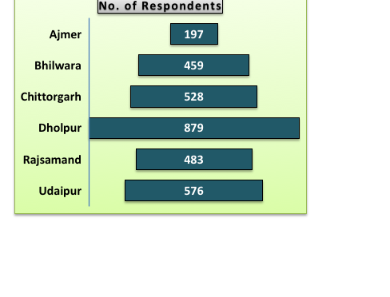

1. **Whether the Account is active?**

|  |  |  |
| --- | --- | --- |
| **Table 1** | **No. of Respondents** | **% of Respondents** |
| Inactive | 113 | 4% |
| do not know | 39 | 1% |
| Active | 2970 | 95% |

**Table 1** represents, out of 3122 women, the account of 95% women are operationalized, 4% says that accounts are not working while 1% women are not aware about the operationalization of Jandhan account.

**2.) Whether INR 500 has been credited to the account?**

|  |  |  |
| --- | --- | --- |
| **Table 2** | **No. of respondents** | **% of Respondents** |
| Amount Credited | 2324 | 78.25 |
| Not Credited | 441 | 14.85 |
| don’t know | 205 | 6.90 |

**Table 2** shows, out of 2970 women respondents, 78.25% women has received Rs 500 in their account, nearly 14.85% respondents said that they do not receive any amount, while 6.90% women are not aware if the amount is transferred in their account or not.

**3) Source of Information or mode of communication**

It is clear from table 3, that the main source of **information** about money transfer is SMS. About 1023 women got information through SMS, 546 by visiting bank, 485 from E-Mitra/E- Services while remaining women got information from other sources like newspaper, panchayat, villagers etc.

|  |  |
| --- | --- |
| SMS | 1023 |
| ATM | 10 |
| Bank correspondent visit | 179 |
| bank visit | 546 |
| E-Mitra/E-service | 485 |
| villagers | 19 |
| news paper | 18 |
| Panchayat | 43 |
| Toll Free No | 1 |

**4) Did account holders withdraw the money?**

|  |  |  |
| --- | --- | --- |
| **Table 4** | **No. of Respondents** | **% of Respondents** |
| Money Withdrawn | 1646 | 70.8 |
| Not withdrawn | 678 | 29.2 |

**Table 4** depicts that Majority of the respondents i.e. 71% of 2324 women, who were aware of the money transferred have withdrawn the money whereas 29% have still not withdrawn money.

**5) Mode of Withdrawal**

|  |  |  |
| --- | --- | --- |
| **Table 5** | **No. of Respondents** | **% of Respondents** |
| ATM | 119 | 7.23 |
| Bank | 706 | 42.89 |
| Bank Correspondent | 272 | 16.52 |
| E-MITRA | 520 | 31.59 |
| Post Office | 29 | 1.76 |

Table 5 shows that majority of women i.e. 42.89% have withdrawn money from bank, 31.59% women used E-Mitra for withdrawal, 16.52% withdrawal through bank correspondents while other a small % of women used ATM for withdrawing of money.

**6) What S/he has done with the withdrawal amount?**

|  |  |
| --- | --- |
| Agriculture | 12 |
| Grocery item | 1108 |
| Health | 3 |
| Not used | 4 |
| No response | 519 |

From the above table, it appeared that majority of respondents i.e. 1108 women has spent transferred on purchasing of grocery items, 12 women spent on agriculture & 3 on health, whereas around 519 women did not respond on what they have done with the money.