**Impact of COVID-19 on Food Systems: Perspectives from the Field**

***Edition 2 - 22 April 2020***

1. **Scope and Purpose**

This document summarises a second rapid assessment that was undertaken by the Global Alliance for Improved Nutrition (GAIN) to understand early impacts of the COVID-19 coronavirus pandemic on food systems in a set of low- and middle-income countries where GAIN works (Bangladesh, India, Pakistan, Indonesia, Mozambique, Ethiopia, Kenya, Tanzania, Rwanda, and Nigeria). A particular focus is placed on small- and medium-sized enterprises (SMEs) within the food system.

This report follows on and updates a situation report undertaken on approximately 3 April 2020. The information reported here should be interpreted with caution, as it does rely heavily on personal experience and perceptions. The information is current as of approximately 17 April 2020.

1. **Sources and Methods**

The information presented comes from a rapid assessment drawing on several sources. First, GAIN country representatives (country directors or their designees, n=10) provided input based on their experience in country via a short, structured questionnaire. Second, programme managers for the Marketplace for Nutritious Foods (MNF, a programme that provides grants and technical assistance to food system SMEs) in Kenya, Mozambique, and Rwanda collected data from all firms supported by the programme in those countries, asking about the impact of COVID-19 and associated shutdowns on their operations. This covered about 40 firms in total, producing a range of nutritious foods—e.g., poultry, fish, horticulture, and fortified cereals. Third, information was provided by representatives of the Scaling Up Nutrition (SUN) Business Network, which is co-convened by GAIN and the World Food Programme (WFP) in nine countries. In some countries, this was from high-level summaries, while three country representatives (Nigeria, Bangladesh, and Myanmar) collected information directly from firms. Finally, some secondary data and information were collected from [Euromonitor](https://www.euromonitor.com/coronavirus)’s ecommerce price and stock data (see Annex 3), [FEWS NET](https://fews.net/), [FAO Food Price Monitoring and Analysis](http://www.fao.org/giews/food-prices/food-policies/detail/en/c/1270543/), a survey of food processors by Technoserve,[1] and local and international news sources (see Annex 1).[2]

1. **Results**
   1. **Measures Taken to Control COVID-19 Spread**

The table below summarises the different measures taken to control the spread of COVID-19 in GAIN countries.[3] Since 3 April 2020, these have changed somewhat in seven of 10 countries. This includes both lightening certain measures in some countries (e.g., Kenya) to help facilitate business operations and tighter measures in other countries (e.g., Bangladesh, Tanzania) as the pandemic has worsened there. For context, the number of reported cases of COVID-19 in each country (as of 19 April 2020) is also noted, as is the average daily growth rate in cases since 1 April 2020; Fig. 1 displays the recent trend in cases in each country. Over this 2.5-week period, certain countries (Bangladesh, India, and Tanzania) have seen considerable percentage growth in COVID-19 cases, whereas others (Rwanda) have seen more modest growth. Of note, actual cases may be much higher than ‘official’ cases, due to limited testing.

**Fig. 1. Number of COVID-19 Cases in GAIN countries, 15 March – 20 April**

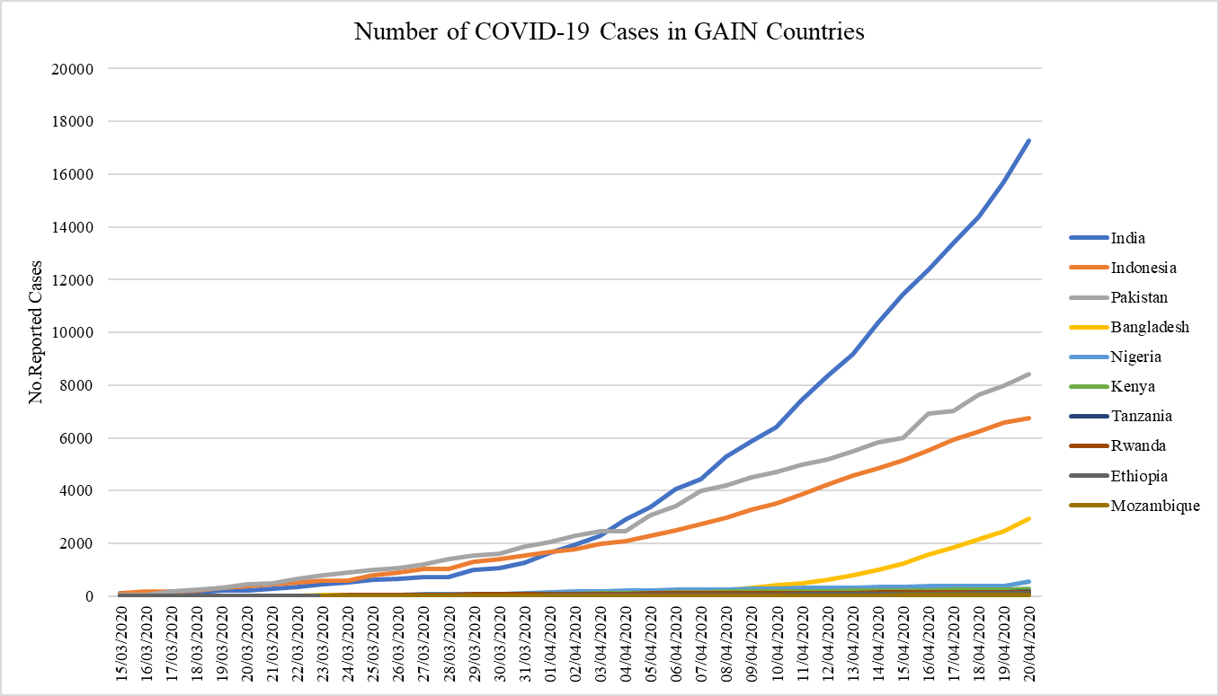

*Source: World Health Organization, https://covid19.who.int/*

**Table 1. Summary of Measures in Place to Control Spread of COVID-19**



*Notes: a dark blue-shaded cell indicates a measure has been taken, light blue shading indicates partial restrictions (e.g., restaurants only serving take-away food). Countries are sorted left to right in descending order of number of cases. Case data are from 19 April, 23:59 GMT.*

Most countries have restrictions on the use of public transport, on operations of non-essential businesses, and on domestic travel. India, Pakistan, Bangladesh, and Mozambique have closed at least one type of food source, while others have put in place restrictions on their operating hours and/or modes of operations (i.e., restaurants being only allowed to provide takeaway food). The harder-hit countries (India and Pakistan) tend to more restrictive, while those with only a small number of cases (Ethiopia and Mozambique) have fewer restrictions.

* 1. **Impacts of these Measures on Local Food Systems[4]**

**The direct actions to close food outlets are having some impact on food access.** In several cases, access to ready-to-eat food (from restaurants or street vendors) is cut off or limited to takeaway food. In addition, those who earn income from selling food (e.g., market and street food vendors) suffer directly from the closures (see news reports from Ethiopia and Kenya in Annex 1).

However, most of the impacts on food access appear to be happening through more indirect routes, such as the limitations on movements to people or goods. For example:

‘The main challenge on access to food verified to date is the increase in food products’ prices, as the country imports the majority of the food products consumed from neighbouring counties, whose borders are closed or have limitations on trade flows.’ [Mozambique]

‘The access to food has become limited. In urban areas there is less supply of food from rural. In rural areas food supplies are constrained by the closing of key markets.’ [Bangladesh]

**Some food price increases and disruptions to availability are reported.** As in the prior situation report, eight of ten respondents noted some increase in prices for certain foods; half of these were reported for many items and half for only a small number of items or dissipating quickly. Some country representatives noted that these price changes affect particular foods more than others – namely imported foods and perishable fruits and vegetables, though two also noted increases in prices of staple foods. For example:

‘The price of fruits and imported food has increased significantly in urban areas. The prices of vegetables and local fruits have reduced significantly in rural areas. The price of staple food commodities like rice, lentils, and edible oil has increased across both rural and urban.’ [Bangladesh]

‘From the weekly Mozambique Bank market prices index report, combined with television stations news reports, the food items that had prices increased significantly are vegetables (onions, potatoes, garlic, carrots) and fruits. In some regions of the country, the prices increased by more than 300%. The local businesses produce both vegetables and fruits, [but] the country imports most of these group of foods from neighbour countries.’ [Mozambique]

One exception to this trend was Pakistan, which reported lower prices for certain key food items:

‘Pakistan Institute of Development Economics has explored prices of six most commonly consumed vegetables: potato, tomato, onion, cabbage, bottle gourd, and brinjal. Their price trends clearly depict that most of the vegetable prices (except potato) have declined in the range of 4% to 61%. Major contribution in the price decline is the production cycle, as it can be observed that the declining trend starts prior to the lockdown period. This can also be due to the decline in demand, driven by income shocks and more importantly the perishable nature of these food items.’ [Pakistan]

All but one respondent (Ethiopia) noted a decrease in availability of certain foods, at least in urban areas; four (of ten) respondents felt this applied to many items, whereas the rest felt it applied only to a small number of items and/or only in certain areas:

‘Virtually all food items have seen a [price] increase, from staples to high-end items. Availability of nutritious foods such as fruits and vegetables has suffered, as well as fortified food products, as producers find it increasingly difficult to produce at capacity and unable to shift produce from factories.’ [Nigeria][5]

‘Staples, pulses, fruits and vegetables, eggs and milk are all available. Getting access to meats, fish is a problem for those whose diets have a higher component of these.’ [India]

‘Restricted movement of food items from production zones to markets within urban centres is making business suffer. Fish, which is mainly imported from China, is unavailable; most of it is targeted at middle-low and middle-income [consumers].’ [Kenya]

**Euromonitor ecommerce price and stock data indicate similar trends in price and availability of food in certain markets**.[6] We reviewed data for the GAIN countries included, India and Indonesia, as well as South Africa (as a weak proxy for other sub-Saharan African countries). These data (see Annex 3 for details) generally show steep and steady declines in the number of unique product types (SKUs) available as the pandemic-control measures are put into place in late March followed by stabilisation at a lower level of availability than before the crisis began. In India, for example, an average of about 230 different rice products were available in the first week of March; by the second week of April, the average was around 60 products. For eggs, almost 70 SKUs were available in Indonesia, 28 in South Africa, and 19 in India in early March; by mid-April, there were 42, 7, and 3 available, respectively. In terms of price, the data show considerable price volatility emerging as the pandemic-control measures are put into place—usually marked by a rise in prices, volatility, and eventual decline to at or near the pre-control measures price. At the global level, Euromonitor note, ‘As a result of the COVID-19 outbreak, we are seeing diminishing product availability (e.g., number of “Available SKUs”) across many countries and categories and this is leading to significant volatility in our median price index.’

**Many GAIN country represenatives attributed these increases in prices or lower availability to disruptions in transport and supply chains, either domestic or international**. In some countries, this has led to livelihood challenges for farmers, sometimes compounded by difficulty accessing key inputs (see examples from India and Nigeria in Annex 1.) Overall, the situation considering price and availability changes is similar to that reported in the previous situation report.

**Lost access to food is likely also happening through lost income due to control measures**. The question of job losses was not directly addressed in this situation report; in the prior report, most respondents estimated job losses among lower-income urban residents as minimal to moderate, with higher levels in the countries with more drastic lockdowns. Such measures tend to be having a greater impact on day laborers, petty traders, street vendors, and other low-income workers (e.g., a study in Ahmedabad, India found 74% of low-income families to have no income at the moment).[7] Those in export-oriented sectors may also be hard hit by the global economic slowdown (e.g., flower farmers in Kenya and Ethiopia - see Annex 1). The most recent analysis by FEWS-NET, published in mid-April, noted that movement restrictions to limit the spread of COVID-19 have slowed economic activity in Kenya and Ethiopia, with this in turn reducing poor households’ casual labour income and thereby affecting food access. Of note, in East Africa, the pandemic is occurring alongside an ongoing major locust infestation, expected to have considerable impact on food supplies in Kenya and Ethiopia (as well as other countries in the region).

Some of the effects on local economies and food access may come from even larger international forces. For example, 90% of Nigeria’s foreign exchange reserves come from oil exports, and the decrease in global oil prices is expected to significantly devalue the Nigerian naira in the next few months. FEWS-NET notes this will have impacts on purchasing power across the Nigerian economy, including food. As the GAIN country representative from Nigeria noted, disruptions to food access can have large social ramifications:

‘More important now is the social impacts, as we are now seeing an increase in hijacks of food trucks for dry goods and staples, unrest in major cities due to lack of access to food and to cash for food purchase. A large proportion of the population are daily wage earners and are not able to stock up on food.’ [Nigeria]

Riots have also been reported in Nacala, Mozambique, with considerable unrest in neighbouring South Africa, partly due to food insecurity caused by lockdown measures.

**The situation varies widely across countries.** As in the prior situation report, country representatives’ observations on the impact of COVID-19 varied widely from more minor (e.g., Tanzania, Ethiopia) to more considerable.

* 1. **Impacts on Small- and Medium Sized Enterprise (SME) in the Food Sector**
     1. **Perspectives from GAIN Country Representatives**

**All country representatives noted that local food system SMEs were facing challenges due to COVID-19-related measures.** The table below shows the main challenges reported: nearly all respondents cited reductions in production and the majority cited disrupted transport/distribution and difficulty importing, sourcing, or installing equipment or difficulty obtaining inputs. This was followed by low demand and difficulty with staff getting to work. Only two respondents reported that SMEs had been forced to close due to these issues in their countries. Compared to the previous situation report, there was less widespread reporting of difficulty with staff getting to work (due to curfews, travel restrictions, or public transport limitations) but increased reporting of production declines.

|  |  |
| --- | --- |
| **Challenge** | **Pct. Citing** |
| **Production levels have decreased** | 90% |
| **Disrupted transportation/distribution for products** | 70% |
| **Difficulty importing, sourcing or installing equipment** | 70% |
| **Difficulty getting inputs/ingredients** | 70% |
| **Difficulty with staff getting to work** | 60% |
| **Low demand/sales** | 60% |
| **Inadequate staff** | 40% |
| **Difficulty accessing financing** | 40% |
| **Closed retail outlets** | 40% |
| **Forced to close** | 20% |
| **Difficulties accessing migrant labour** | 20% |
| n | 10 |

These impacts seem to be hitting the more perishable food items first. Some respondents noted that demand was particularly low for non-staple foods, as people relied on a narrower (and cheaper) diet during this period. The following quotes note some of the challenges SMEs are facing with adapting to the current reality:

‘SMEs outside of Dhaka have production in place but no option to transport the products. A large number of SME's have become bankrupt, and the micro-financing institutions also have a liquidity crunch and are not covered by the stimulus package. There is also a lag in decision making and disbursement of the financial package to the farmers, and as time passes more and more farmers are going out of business.’ [Bangladesh]

‘Now that customers can only access the community market by foot or private car, SMEs have increased their home delivery services, which is costly to both customers and SMEs. Planning is also still an issue for SMEs and consumers, because the government is extending lockdown frequently: 14, 14, 10 [more] days.... [Firms] don't know when they will get out. The government is advising customers to pay using digital means. It is not easy for consumers and SMEs consumers to use this technology (new to some).’ [Rwanda]

**Importantly, not all COVID-19 impacts on food systems have been or will be negative**: there may be potential for positive changes for those businesses need to be positioned to take advantage of new business opportunities. The respondent from India highlighted some of the winners from the current realignment of the local retail landscape: ‘Supermarket retail is severely impacted, [but] local stores are doing well, online purchases are increasing.’ Similarly, the respondent from Mozambique noted, the ‘[local confederation of business associations] webinar has concluded that this crisis is an opportunity for local producers to re-position their business to become significant suppliers for local distributors.’ However, not all the necessary systems are in place to facilitate such an increase in domestic production:

‘The nonexistence of a national business information system [is] …. the key challenge for national businesses to keep the food system flowing with local production. The gap in information and regular relationships between producers, logistics companies ,and wholesalers … limits the ability of businesses to address demand in a timely manner… Although the retailers know the consumers’ demand patterns, that information is not processed and shared through the food system, aiming to reach the upstream players to increase production of those items.’ [Mozambique]

These perspectives were largely corroborated by the firms supported by the SBN and the MNF programme, as noted in the next section.

* + 1. **SME Impacts: Perspectives from SBN and MNF firms**

This section draws on reports from MNF programme managers in Kenya, Mozambique, and Rwanda, GAIN SBN country coordinators from Bangladesh, Kenya, Nigeria, and Tanzania, as well as WFP SBN country coordinators from Madagascar, Myanmar, Nepal, Sri Lanka, and Zambia. All were asked to provide input into how the COVID19 pandemic is impacting the food system SMEs with which they work. Summaries of experiences from non-GAIN SBN countries can be found in Annex 2.

**Across the different countries, it is found that near all SMEs have been impacted to some extent, usually entailing scaled-down operations, reduced production capacity, and lower sales.** In Kenya, it was estimated that some MNF SMEs have lost up to 50% of their customers. In Rwanda, 15 of 18 MNF-supported firms report lower-than-normal sales and six (of 18) firms interviewed are temporarily closed. Insights from four SBN SME members in Nigeria show similar impacts, with all interviewed firms seeing lower sales and being worried about current cashflow and ability to pay salaries and repay loans in the short term. Tanzanian SBN firms are also experiencing a reduction in sales. A set of SBN-supported firms in Bangladesh (see Box 1) report similar challenges to those faced in Africa, with varying levels of severity.

**These impacts are due to direct closures of hotels, restaurants, markets, institutional cafeterias, and other food outlets; restrictions on movement of customers (especially in Rwanda); and income losses across sectors**, reducing the purchasing power – particularly for casual laborers and informal-sector workers, who are often targeted by MNF firms. It is reported that customers are being selective in what they buy and are buying in reduced quantities. Some firms are beginning to scale back production to avoid losses amid low demand. This is particularly the case for firms dependent on sales to restaurants or large institutional buyers. *Mozambican Fortified Flour Processing Firm* reports that the demand for its corn-soy blend flour dropped considerably once the local school feeding programme was closed,[8] meaning they suddenly lost 35% of their income; monthly sales of their fortified maize was 63 tons in April 2019 but just 9 tons by mid-April 2020. A similar report was made for a Tanzanian SME that also supplied food to schools.

**Box 1: Experiences of Certain SBN Member SMEs in Bangladesh**

***A large conglomerate with products including frozen foods, sugar, and potato products:***

Fewer staff are able to safety come to work and their production line is not fully automated, so the firm is facing lower production. The demand for their frozen chicken products is usually high during Ramadan, but company leaders predict a major slump in sales this year; they are producing at minimum capacity. With most employees working from home, distribution has also been disrupted, and most retail and wholesale shops are closed or being avoided by the customers. Working capital is also lacking: the company has delivered products to shops but not yet been paid. One product, fortified rice, is being scaled up, with the government allowing open-market sales of rice at only BDT 10, in order to cater to population demands amidst this crisis. Overall, the company plans to continue operating with limited production and just a few workers.

***A******food processor, specialising in confectionery (e.g., chocolates, baked goods, cereal bars, drinks):***

The firm has completely stopped production, marketing, and distribution of its products due to the pandemic. All staff are either working from home or strategizing on how to resume operations. The company has some raw materials stored but does not hold a large inventory of finished products; as meeting expenses is dependent on sales, they are struggling to pay their employees. However, the firm is optimistic, as many consumers have shown interest in purchasing, and is forecasting the right time to restart operations and distribution, using a more door-to-door model if possible.

***An SME that brings fresh produce (i.e. vegetables, fruits, fish) to consumers, with a focus on sustainable and ecological farming practices and traceable value chains:***

The firm reports that demand for products for delivery, such as vegetables, fish, and chicken, has been extremely high. However, since the whole country is in lockdown, acquiring their fresh produce has been difficult, with longer than normal lead times. The company thus cannot cater to this larger customer base; indeed, they have stopped transporting small orders to customers and completely stopped making deliveries to certain areas or doing so only a couple days a week. All employees have been continuing work, but the necessary safety protocols and risk allowances add to the firm’s expenses. Like many SMEs, the company is now in financially insecure position.

***An e-commerce platform delivering additive- and chemical free food to consumers’ homes:***

Amidst the pandemic, its retail outlets are closed, but they continue to deliver at home. However, they have limited delivery channels and manpower. Customer demand for rice and meat has grown markedly, but the company is largely unable to meet it, due to insufficient sourcing and transport/logistics providers. Instead, they plan to ration their stock over the next three months, at pace with their logistics capabilities. They have managed to stock up and should stay financially liquid for the next 3 months; after that, they may have to shut down if the situation does not improve. The company has taken major steps to protect employees: giving them twice their salaries and training in proper WASH practices. Of note, the firm gives technical assistance to 35 other local SMEs, of which at least seven have already shut down due to lack of capital.

***A Bangladesh NutriStar contest finalist that produces organic foods via sustainable urban farming and maintains a network of organic urban farmers and customers:***

This company has not stopped production, in order to ensure income for their farmers. However, logistics and transportation for distribution are major problems at present. The company is trying to cater to increased customer demand but also ensuring customers do not buy excessive amounts by setting delivery quotas. They are deploying third-party personnel for delivery, with most of them receiving commissions and incentives for working under the circumstances.

***A firm produces low-cost snacks and drinks with local, sustainable and nutrient-dense ingredients, particularly for garment workers and adolescents (and winner of the Bangladesh NutriStar contest):***

The firm has completely stopped manufacturing and distributing their products, as all employees have left to shelter in their own hometowns. The company hopes to resume minimum operations to support those in need during Ramadan.

Overall, however, reduced demand and production were less common in Mozambique and Tanzania, where a full lockdown has not been implemented; five of seven Mozambique MNF firms report little or no impact. Three firms in Mozambique and Rwanda reported increased demand, though they were not always able to accommodate it due to limited inputs, equipment, and production staff.

**Reduction in staff hours, plus curfews and limitations on public transport, have led to difficulties with ensuring sufficient staffing**, as have staff fears and reduced morale. For example, Mozambican *Chicken Producing Firm 1* notes that a few of its employees no longer come to work at all, without giving notice. In Rwanda, while food company employees have been issued with papers to allow them to travel to work, this is not necessarily the case for suppliers or repair technicians, posing challenges. This has further reduced production and limited distribution for some firms. In Nigeria, while food producing firms have been exempted from the lockdown, some have been forced to slow or stop production due to staff’s inability to come to work amid the lockdown. One firm, ProThrive, planned to house workers in the factory for a few days to complete production already in-process.

The broader climate was also putting a damper on business operations. As one firm owner in Mozambique noted:

‘Restrictions and lockdowns make everybody nervous, and therefore it is difficult to do business. The ones you can deal with are the contacts you have and that know you and trust you. The major problems that we have had are with suppliers we dealt with for the first time. Everybody is afraid to not getting paid. Therefore, business slows down...’

In Nigeria, firms’ worries are compounded by even greater economic uncertainty due to expected inflation and currency devaluation (linked to falling oil prices), which can increase costs of imported equipment and raw materials.

As noted in the last situation report, **domestic and international travel restrictions (including curfews), as well as limited transport and logistics support/staffing, have prevented the free movement of goods, disrupting supply chains.** This was common across all countries and has likely led to more food waste and urban-rural mismatches in food availability. In addition, trade and movement barriers, as well as input producers’ fears of low demand, have lowered access to supplies, ingredients, and agricultural inputs (e.g., feed, veterinary inputs), leading to reduced production or loss of stock. Both Kenyan and Nigerian firms noted that inter-regional domestic good flows had been disrupted, but the situation was particularly acute in the more import-dependent countries. Mozambique, for example, is very dependent on South Africa and Malawi, and flows of good from those countries have decreased, reducing the supply of ingredients, inputs, and equipment; while many firms are trying to shift toward more use of domestic inputs, there is often insufficient supply and higher prices. Similarly, Rwandan *Fish Farming Firm* reports being a national distributor for a Zambian fish feed manufacturer. The firm is facing high demand from other fish farmers but has no stock to meet it, as the feed (for which they have already paid 50%) has been stuck for weeks at the Zambian border. This leaves them and other farmers scrambling to find feed (usually overpriced and low quality) to keep the fish alive, reducing productivity and risking loss. Nigeria also faces breakdowns in supply of fertiliser (see Box 1). In some cases, input shortages have led to increased prices (e.g., in Kenya it was reported that the price for 90 kg of maize had risen from 2300 to 3500 KES, whereas in Mozambique it was noted that the price of a day-old chick had risen from 38 to 42 MZN).

**Box 2: Projected Agri-Food SME Impacts in Nigeria**

A Dalberg Consulting analysis in Nigeria concludes that given limited access to finance, decreased consumption, and less digitisation, MSMEs will be hard hit. While MSMEs employ 77% of the country’s workforce, in the country’s last recession, employment from MSMEs fell considerably as businesses were unable to sustain operations and keep employees. It also noted that the country’s fertiliser supply chain is likely not functioning at sufficient capacity, leading to lower yields and potential food shortages.

Some countries have worked to facilitate continued flows of food, but the same measures are often not being taken for parts, equipment, and other inputs (e.g., cages for chicken and fish farming). For example, *Fish Producing Firm* in Mozambique notes that imported feed supply is delayed by several days whereas as imported cage and building materials are delayed for 2-3 months; *Fortified Flour Processing Firm* in Mozambique has been unable to obtain a part for its machinery, leading to reduced production. Some firms continue to await shipments of equipment from China, though it is hoped that they will arrive in May. Supply chain issues have tended to have a particularly harsh impact on firms raising live animals, where there is little margin for delay in food and medicine provision, and where holding unsold stock on hand entails a high daily cost. For example, Mozambican *Chicken Producing Firm 1* reports that mature chickens that normally sell out in 4-5 days are now being kept for 2-3 weeks. This may lead some firms to delay or reduce production until there is more certainly. These supply chain breakdowns, particularly for input access, will need to be solved for domestic production to scale up and fill the gap left by lower food imports.

**In some cases, working hours have been reduced and workers laid off.** For example, *Dairy Firm A* and *Peanut Processor* in Kenya report that they have already laid off a small number of workers, whereas *Dairy Firm B* in Kenya has sent 40 staff on paid leave. Four firms in Rwanda reported reducing staffing, as did one (of four interviewed) in Nigeria. In Mozambique, where the pandemic is less pronounced, only one MNF firm reported (voluntary) layoffs. However, a number of firms are committed to ensuring minimal layoffs. In some cases, firms have hired new workers to manage deliveries, facilitate shift work, or work on better marketing to expand reach through new channels.

**Box 3: Corroboration from an External Survey**

The insights from MNF and SBN SMEs are largely corroborated by a Technoserve survey of 106 food processors from seven African countries (7-9 April 2020). About 50% of firms reported disruptions in input supply chains for raw materials, with a similar result for supply chains for equipment and packaging materials. In addition, over 75% of firms reported disruption to product marketing and to distribution, with 11-15% noting that the activity had been completely halted. Interestingly, 35% of firms reported that the situation had improved or increased their fortification operations. Less than 30% of food processing firms had adequate stock of raw material to meet current demand and nearly 40% were dependent on imported ingredients that may be slowed due to the pandemic. Most plants are not highly automated, making them more vulnerable to workforce risks, and one third of firms had laid off workers or out them on leave without pay. About one quarter of processors had changed their prices. Altogether, about 62% of processors did not feel prepared to manage through the crisis. However, 35% of firms expected demand for their product to increase and 8% had already identified new markets.

**Most firms did not report changes to their sales prices.** In Mozambique, for example, only one had increased product price (due to increased input costs) whereas two had decreased prices to encourage demand or due to lower production costs. As noted in the prior situation report, over one third of Rwandan SMEs interviewed reported a fall in market prices due to low demand and had to lower their sales prices accordingly.

**It is generally reported that those SMEs dealing with fresh foods (e.g., dairy, vegetables, animal-source foods) are the most impacted due to restricted movements.** In addition, small and micro businesses tend to have been more impacted than medium-sized businesses, as they cannot afford to bear the short-term costs and lost cashflow. Impacts are, unsurprisingly, more severe in those countries with more severe outbreaks and control measures (e.g., Bangladesh, Kenya, Nigeria) whereas firms in Zambia (only 70 cases to date), Tanzania, and Mozambique are seeing more minor impacts. The insights from MNF and SBN SMEs are largely corroborated by a Technoserve survey (see Box 3).

**Most businesses have put in place measures to ensure some continuity of operations.** Some have worked to adopt new technologies to deal with the current challenges. For example, most MNF Kenya firms have adopted some form of online ordering, promoted contactless payment (e.g., mPesa), or worked to get better advance information on stock to minimise travel. A handful of Rwandan firms report similar changes. However, many SMEs are not able to invest in new technologies at this time, given the financial uncertainty. To safeguard staff, many companies are using staff rotations to reduce crowding, providing personal protective equipment (PPE), training staff on safety guidelines, or prioritising employees who live nearby, to minimise travel exposure. Companies have and continue to incur additional costs of these adaptations to the new reality (e.g., installing new water points to support workplace hygiene, buying PPE, supporting workers’ travel, and higher staffing costs due to shift work). For example, *Dairy Firm A* in Kenya reports that the cost of gloves and masks have gone up ten-fold amid increased demand. Some companies are expanding their marketing (e.g., trying to work with food relief organisations) or aiming to increase stock of ingredients to mitigate price and availability fluctuations. Others are minimising operational costs in order to stay afloat, such as by suspending non-critical operations, or working to renegotiate loans and rent payments.

* 1. **Government and Policy Responses**

**Governments and partners have worked to cushion the blow to food systems, low-income consumers, and/or businesses in several countries.** Eight of ten GAIN country representative respondents reported that the government and/or partners (e.g., NGOs) had undertaken measures to limit the impacts of COVID-19 control measures on local food systems and/or low-income households. This has included exceptions to curfews or movement restrictions for food/agriculture businesses (e.g., Kenya, Pakistan) and price controls for food or limitations on price hikes (e.g., Ethiopia, Mozambique, Rwanda)—though in some cases these are not enforced in informal markets. In **Indonesia**, certain staple food items, including rice, are being rationed. In addition, Pakistan has subsidised petroleum prices, thereby reducing food transport costs.

Broader measures put in place to support poor households include expansion of existing safety net programmes and/or provision of staple foods (e.g., grains, legumes, cooking oil) to vulnerable households in India, Indonesia, Rwanda, and Bangladesh. In Bangladesh, the government is set to double its allocation of ration cards to 10 million and offering subsidised rice at Tk 10 per kg to the most vulnerable; this has included scaling up production from local SMEs (e.g., see Box 1). WFP is supporting the Government in food distribution to Rohingya refugees and other vulnerable groups. FAO Food Price Monitoring and Analysis (FFPAM) reports that **Nigeria** approved the release of over 60,000 tons of staple grains and flours from the National Grain Reserve to be distributed to the most vulnerable households. FFPAM notes that **Kenya** authorised importation of over 3 million kg of maize to ensure sufficient market availability of food and feed. Of note, many of the policy responses focus only or primarily on staple grains; while important to prevent hunger, such policies may not do much to prevent malnutrition (including protein and micronutrient deficiencies).

In Mozambique, it was noted that food distribution measures are so far only being taken by humanitarian organisations already active in the country (e.g., WFP). In both Ethiopia and Kenya, budgets have been created to support the vulnerable, but it remains unclear how the money will be disseminated. To protect incomes, layoffs have been prohibited in Ethiopia, Pakistan, India, and Mozambique (though such measures likely have little impact on casual laborers and the informal sector, already the most vulnerable workers).

**Several countries have also enacted policies or programmes to support businesses.** In Kenya, some business and individual tax rates have been reduced, and loan term flexibility encouraged, whereas India has put in place a moratorium on loan repayments. Larger, more concrete support measures have been taken in Bangladesh, Pakistan, and Nigeria, while Mozambique and Rwanda have undertaken ‘softer’ measures (e.g., developing business-to-business relationships and providing technical assistance and advice). In Bangladesh, a major stimulus package has been announced, a loan moratorium has been put in place, as well as support for paying salaries and allowances of export-oriented industry workers (e.g., those in the garment sector). Over $3 billion USD in working capital loans has also been made available to the affected industries and service sectors.

In Pakistan, the State Bank of Pakistan (SBP) has introduced a temporary loan scheme for businesses to support wages (including of permanent, contractual, and daily wage employees and outsourced workers) from April to June 2020 for businesses that do not lay off employees; the scheme will give preference to smaller businesses. It has also increased the pool of loanable funds (for both households and businesses) and increased the credit limit for businesses. In Nigeria, the central bank has initiated an approximately $140 million USD Targeted Credit Facility for households and SMEs impacted by COVID-19, which covers agricultural value chain businesses; however, the Nigeria respondent notes that this is ‘implemented through the government concessionary financing systems, which have traditionally been very difficult for SMEs to engage with.’ For countries that are earlier in the pandemic, such measures have either not been taken or remain vague. In Ethiopia, employers are encouraged to offer paid leave; to cushion the impact of this on firms, they are allowed to pay only a basic salary (without entitlements).

**In sum, this rapid assessment has confirmed ongoing disruption to the food systems of most countries examined, with supply chain disruptions playing a particularly important role in this and food SMEs facing numerous challenges to their ongoing operations. Encouragingly, governments and partners are working to protect access to food, but these measures are likely to fall short of what is truly needed.**

**Annex 1: Links to Relevant Media on Covid19 Control Measures and Impact on Local Food Systems in GAIN Countries (from GAIN country representatives as well as online searches)**

* Ethiopia - [Pandemic vs. Tradition [highlights impact of social distancing on market vendors]](https://www.thereporterethiopia.com/article/pandemic-vs-tradition)
* Ethiopia, Kenya – [East African Flower Industry Wilts as Sales to Europe Dry Up](https://www.voanews.com/africa/east-african-flower-industry-wilts-sales-europe-dry)
* Kenya - [Families sweat to buy food amid job losses and a slow economy](https://www.nation.co.ke/news/Covid-19-crisis--Families-sweat-to-buy-food-amid-job-losses-/1056-5523198-eitpikz/index.html)
* Kenya – [Fury over police brutality amid coronavirus curfew [mentions impact on informal food sellers]](https://www.aljazeera.com/news/2020/04/fury-kenya-police-brutality-coronavirus-curfew-200402125719150.html)
* Kenya - [Impact of coronavirus on SMEs in Kenya](https://www.youtube.com/watch?v=ak0-zS96rEU)
* Mozambique - [Covid-19 in Mozambique: Government admits price increases](https://www.dw.com/pt-002/covid-19-em-mo%C3%A7ambique-governo-admite-aumento-dos-pre%C3%A7os/a-53008347)
* Nigeria – [Nigerian security forces kill 18 during curfew enforcement](https://www.aljazeera.com/news/2020/04/nigerian-security-forces-kill-18-curfew-enforcement-200416142503603.html)
* Nigeria – [Battle to sustain poultry production](https://thenationonlineng.net/battle-to-sustain-poultry-production/)
* Nigeria - [How coronavirus lockdown is affecting Nigeria’s food systems](https://www.premiumtimesng.com/news/top-news/387592-how-coronavirus-lockdown-is-affecting-nigerias-food-systems.html)
* Nigeria – [COVID19: Rainfed farming under threat](https://www.dailytrust.com.ng/covid-19-rain-fed-farming-under-threat.html)
* Nigeria – [Protect Most Vulnerable in COVID-19 Response](https://www.hrw.org/news/2020/04/14/nigeria-protect-most-vulnerable-covid-19-response)
* Nigeria - [Agriculture Bureau Association of Nigeria (ABAN) has called for a stakeholders' consultative](https://allafrica.com/stories/202003310137.html)
* Rwanda – [Food Prices Stable in Kigali, Fall in Upcountry Districts](https://www.newtimes.co.rw/news/food-prices-stable-kigali-fall-upcountry-districts)
* Rwanda – [Market prices increase by 8.5% in March 2020](https://en.igihe.com/spip.php?article41202)
* Bangladesh - [Losses among dairy farmers](https://thefinancialexpress.com.bd/economy/bangladesh/dairy-farmers-still-counting-losses-despite-govt-assurance-1585928092)
* Bangladesh – [Damage to local seafood industry](https://www.thethirdpole.net/en/2020/04/01/coronavirus-destroys-bangladeshs-crab-exports/)
* Bangladesh – [Large losses estimated for poultry industry](https://thefinancialexpress.com.bd/trade/poultry-industry-estimates-losses-of-tk-1150b-seeks-govt-intervention-1585715006)
* Bangladesh – [Fish farmers face losses due to pandemic](https://tbsnews.net/coronavirus-chronicle/covid-19-bangladesh/fish-farmers-facing-losses-due-coronavirus-situation-69883)
* Bangladesh – [Government announces package of agricultural subsidies](https://tbsnews.net/coronavirus-chronicle/covid-19-bangladesh/pm-holding-videoconference-coronavirus-situation-68029) [Also [here](https://www.reuters.com/article/us-health-coronavirus-southasia-idUSKCN21U0CP)]
* Bangladesh – [How will the Covid-19 stimulus package be implemented?](https://www.thedailystar.net/opinion/macro-mirror/news/how-will-the-covid-19-stimulus-package-be-implemented-1891009)
* Bangladesh – [Experts say no risk to national food security](https://www.dhakatribune.com/bangladesh/2020/04/13/experts-bangladesh-s-food-security-not-at-stake-access-to-all-needs-to-be-ensured)
* India – [State governments buy from farmers to ease rural distress](https://www.aa.com.tr/en/asia-pacific/covid-19-lockdown-sparks-harvest-crises-in-pakistan-india/1799536)
* India - [No regular income for 74% low-earning families in Ahmedabad since lockdown, finds IIM survey](https://theprint.in/india/no-regular-income-for-74-low-earning-families-in-ahmedabad-since-lockdown-finds-iim-survey/402187/)
* India - [100 million Indians fall through gaps in food safety net, economists urge rethink on Covid-19 relief](https://scroll.in/article/959235/100-million-indians-fall-through-gaps-in-food-safety-net-economists-urge-rethink-on-covid-19-relief)
* India - [Indian Farmers Struggle to Harvest, Sell Crops During COVID Restrictions](https://www.voanews.com/science-health/coronavirus-outbreak/indian-farmers-struggle-harvest-sell-crops-during-covid)
* India – [New Lockdown has relaxed restrictions on farming, banking and public works](https://www.bbc.com/news/world-asia-india-52290761)
* Indonesia - [Govt introduces new social benefits as 2.8 million lose jobs](https://www.thejakartapost.com/news/2020/04/13/govt-introduces-new-social-benefits-as-2-8-million-lose-jobs.html)
* Indonesia – [Hunger hits as many Indonesians struggle during COVID-19 pandemic](https://www.thejakartapost.com/news/2020/04/21/hunger-hits-as-many-indonesians-struggle-during-covid-19-pandemic.html)
* Indonesia – [70 million informal workers most vulnerable during pandemic](https://www.thejakartapost.com/news/2020/04/03/70-million-informal-workers-most-vulnerable-during-pandemic.html)
* Indonesia – [Police to safeguard food availability during COVID-19 pandemic](https://kalsel.antaranews.com/berita/157938/police-to-safeguard-food-availability-during-covid-19-pandemic)
* Indonesia - [Urbanites find solace in urban farming amid COVID-19 quarantine](https://www.thejakartapost.com/news/2020/04/12/urbanites-find-solace-in-urban-farming-amid-covid-19-quarantine.html)
* Pakistan - [Pakistan institute of development economics COVID-19 Analysis](https://www.pide.org.pk/pdf/PIDE-COVID19-EBook.pdf)
* Pakistan, India - [COVID-19 lockdown sparks harvest crises in Pakistan, India](https://www.aa.com.tr/en/asia-pacific/covid-19-lockdown-sparks-harvest-crises-in-pakistan-india/1799536)

**Annex 2. SME Insights from Non-GAIN Countries**

SBN coordinators in five non-GAIN countries provided insights into the situations in their countries, which are summarised here.

In **Nepal**, the pandemic and associated lockdown are estimated to make up to 15,880 people jobless,[9] with major economic losses.[10] The pandemic has hit the tourism sector hard, and remittances, which account for around 26% of GDP, have also taken a major hit. It has been estimated that up to 70% of SMEs have temporarily closed, with some verging on permanent closure. SMEs in Nepal provide about 3.6 million jobs and 6% of GDP.[11] In the agriculture sector, WFP estimates there is sufficient stock for the next few months but that there will be significant reductions in harvests of wheat and other winter crops. Continued lockdown could affect rice planting; India has halted rice exports, including to Nepal. Following the lockdown, prices of many foods have increased, and distribution has been disrupted. The government has announced a relief package, including electricity discounts, no penalties on tax and utility payments, social safety nets and food aid, and discounts on rice, flour, lentils, and other staples.

In **Madagascar**, supply chain disruptions have been reported due to lack of PPE for staff. Some firms have had lowered production; the SBN contact estimates that another two weeks of the pandemic-control measures would lead to layoffs and potential firm closures, with the risk particularly high for SMEs. In response to these challenges, banks have proposed loan relief and emergency credit programmes, and the government has suspended tax audits and deferred tax payments.

In **Myanmar**, main impacts have been in the garment industry, not the food sector: garment factory closures have so far left 22,000 workers unemployed. The result has been many workers having little income and thus facing food insecurity. The same is true for foreign workers returning home. Under government regulations, food factories are allowed to continue operating. However, as markets are being closed or curtailed, farmers and traders are having difficulty selling products, with larger disruptions for perishable foods. Imported ingredients are hard to access, and regional lockdowns have made transport of domestic goods difficult. Companies thus face bottlenecks and higher expenses in sourcing inputs. Workers also have difficulty commuting to work due to public transport limitations. SMEs and farmers both face difficulty accessing financing. The government has established an emergency relief fund of approximately US$ 72 million to provide low-interest loans to businesses most affected, including food system SMEs, enabling them to run the business and pay wages. Some businesses, however, have difficulty accessing this. The government is also working on a ‘smart and safe agri-food supply’ model, and providing loans and grants to smallholder farmers is under discussion. Non-profits have provided financial support for garment industry workers, and the government has stated that laid-off workers are entitled to up to six months of healthcare.

In **Sri Lanka**, most SBN members are large conglomerates, not SMEs, but these firms are facing many issues involving employees and the continuation of core business operations. Higher food prices due to tighter supply conditions and supply-chain disruptions are expected.

In **Zambia**, the country is not in full lockdown and most consumer goods businesses have continued operations with rotational staffing and few large impacts to date. Nutritious food SMEs have been impacted slightly in terms of lower consumer demand, as many consumers prioritise purchase of staples. Some businesses are taking advantage of this to increase staple prices due to high demand. Retail traffic has significantly reduced. The government has engaged various stakeholders, including businesses, on possible interventions to mitigate impacts. Proposed measures include tax penalty and interest waivers and a taskforce bringing together farmers, retailers, and manufactures to work to support domestic production and bring local products into shops, creating a potential opportunity for many SMEs.

**Annex 3: Euromonitor Price and Availability Data**

1. **Price Index**

For all graphs of price index, **India in shown in green, Indonesia in Orange, and South Africa in Blue.** Of note, these price indexes can be influenced as much or more by changes in the SKUs composing the sample (due to stock-outs) as by actual price changes; these can entail changes in product size and/or quality. (As shown below, the SKUs composing the sample have changed considerably over this period.)

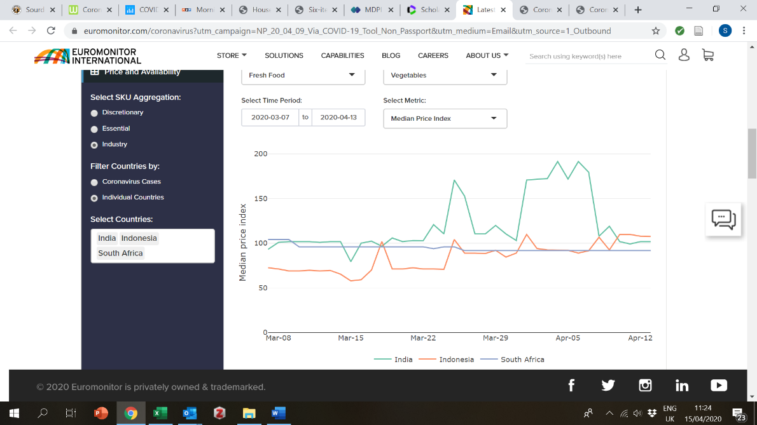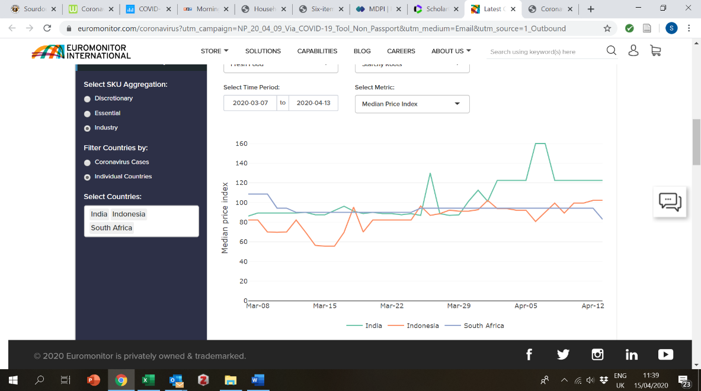

***Fig. A1 - Price Index for Fresh (Unprocessed) Vegetables (L) and Starchy Roots (R)***

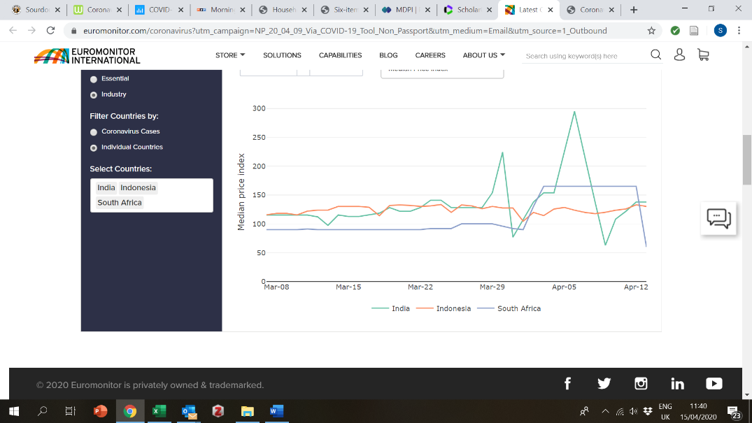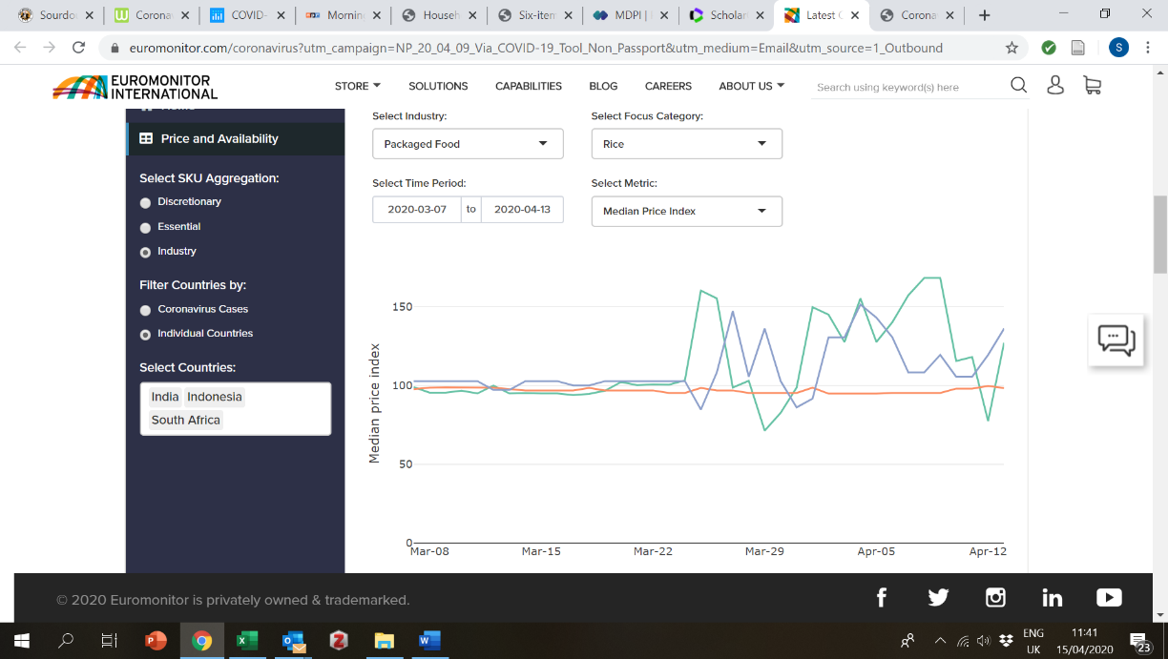

***Fig. A2 - Price index for eggs (L) and rice (R)***

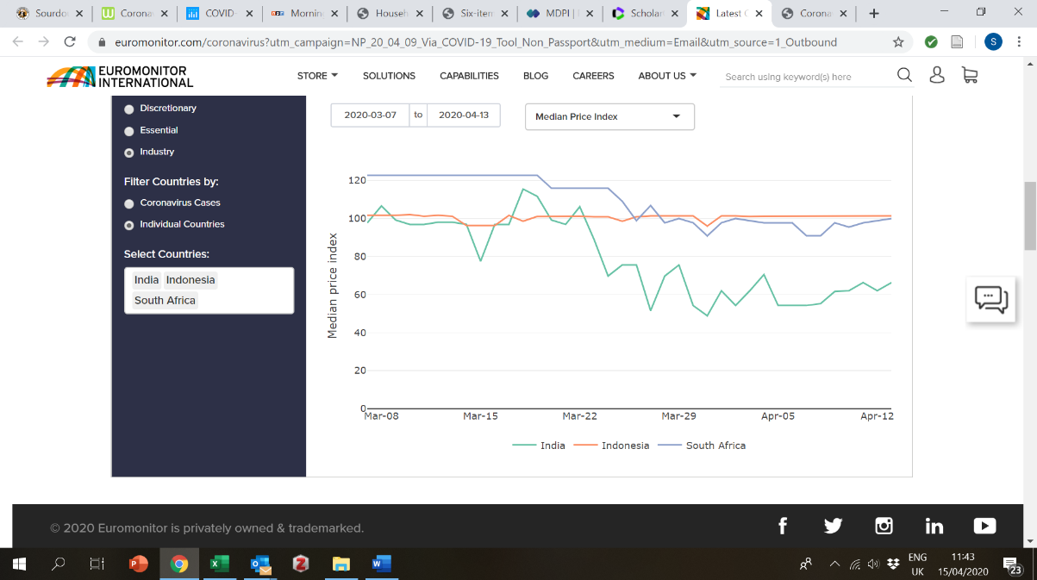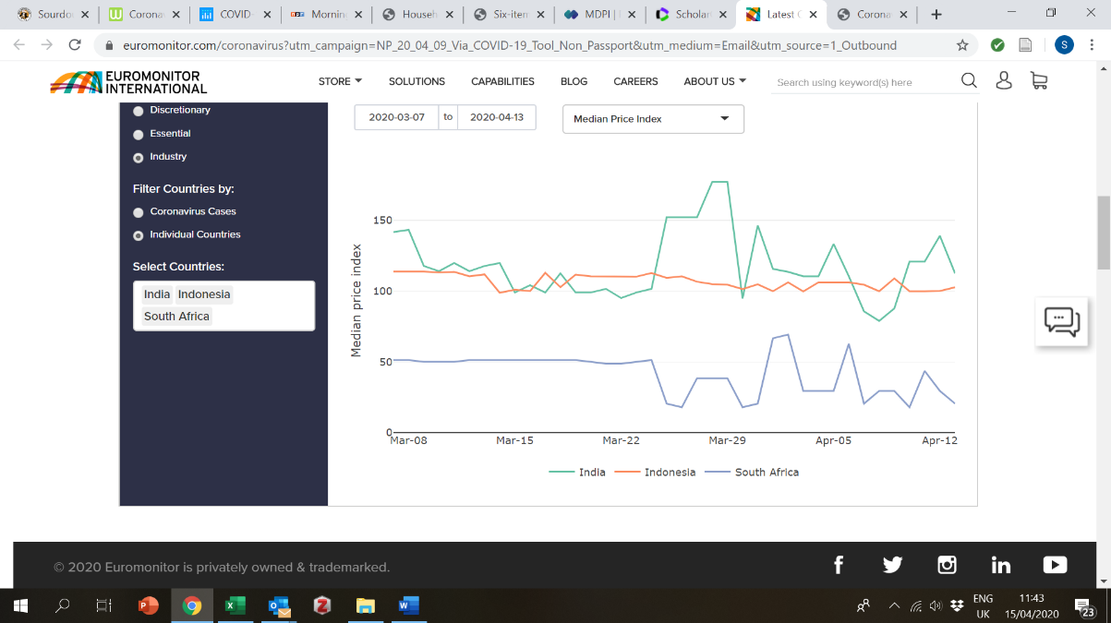

***Fig. A3 - Price Index for Dried Pasta (L) and Noodles (R)***

1. **Availability Data**

The graphs below show a one-week moving average of the number of SKUs available within each product category and each country over time. Data span from the first week of March to the week ending 14 April.

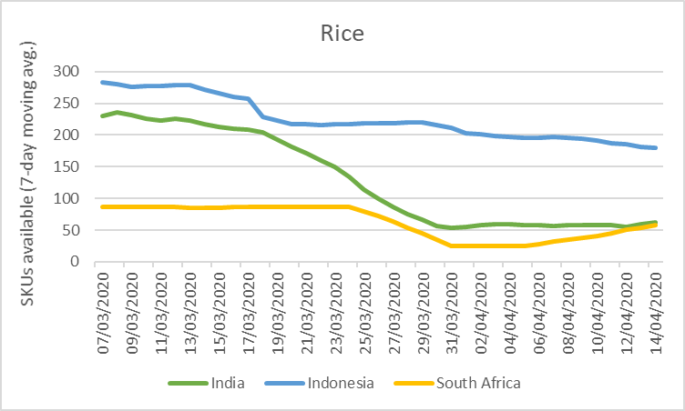

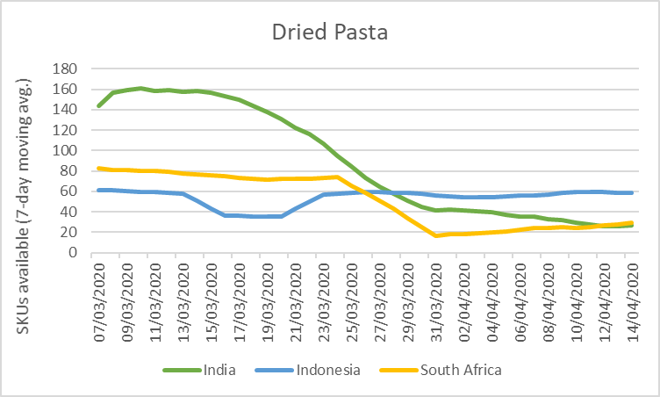

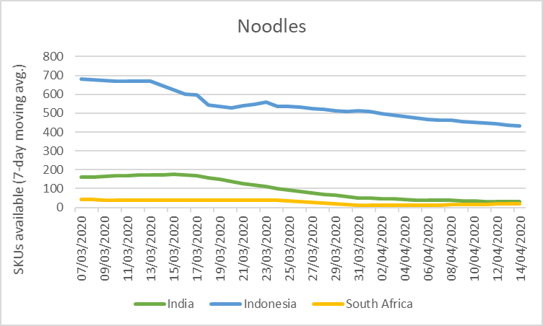

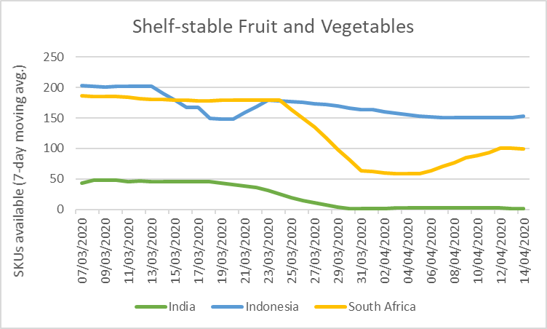

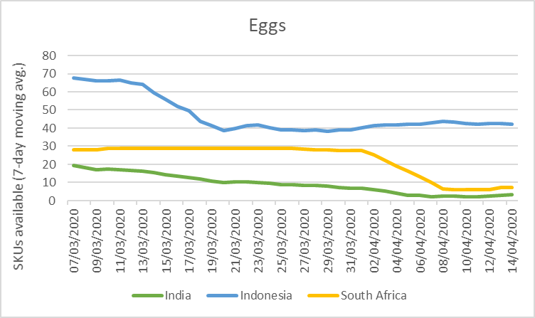

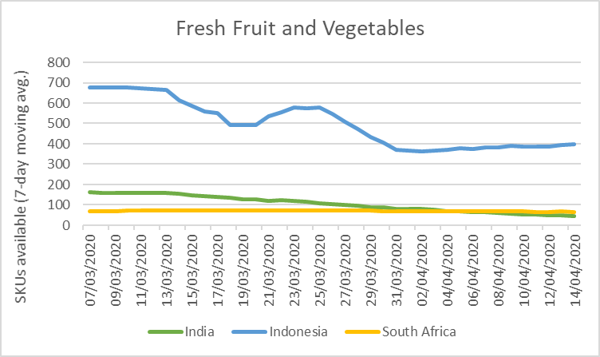

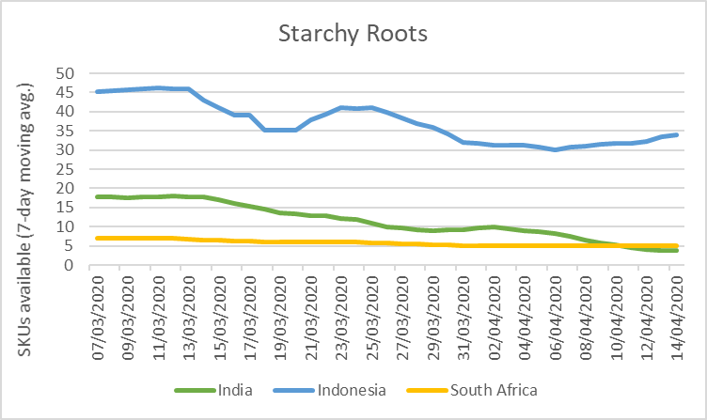

1. Technoserve, 2020. Africa’s Food Processors in the Face of COVID 19: A Survey of Impacts and Responses from the Sector. 15 April 2020.
2. The IPC and WFP VAM websites were also reviewed but did not have data reflecting COVID-19 impacts.
3. The focus here is on measures expected to impact the food system, but all countries also have some recommendations in place related to general social distancing – e.g., advising work from home or banning large events and/or religious services.
4. Lockdown measures had been in place for approximately 3-4.5 weeks at the time of this survey.
5. In Nigeria, a Dalberg analysis also notes less produce at market or produce reaching the market after its sell date (e.g., tomatoes), as well as insecurity and price hikes (Dalberg Consulting. 2020. Economic impact of covid-19 in Nigeria: April 2020.)
6. Euromonitor price and stock data are based on SKUs (Stock Keeping Units) and refers to the individual and discreet products that their system captures from retailers’ websites in each monitored country every day. As it draws only on ecommerce retailers, it is **non-representative of actual food systems** in GAIN countries, where most consumers buy from in-person, informal retail (e.g., informal markets, kiosks). However, it can provide an indication of trends.
7. The Print: [No regular income for 74% low-earning families in Ahmedabad since lockdown, finds IIM survey](https://theprint.in/india/no-regular-income-for-74-low-earning-families-in-ahmedabad-since-lockdown-finds-iim-survey/402187/)
8. [WFP](https://cdn.wfp.org/2020/school-feeding-map/) estimates that over 368 million children globally are missing school meals due to such closures.
9. <https://www.wto.org/english/tratop_e/covid19_e/sawdf_nepal_e.pdf>
10. <https://risingnepaldaily.com/opinion/tackling-economic-fallout-of-covid-19>
11. <https://kathmandupost.com/money/2020/03/22/small-and-medium-enterprises-feel-the-pinch-as-the-economy-flounders>