REPORT ON ASSESSMENT OF ESSENTIAL NUTRITION SERVICES IN CHHATTISGARH DURING SECOND WAVE OF COVID 19 PANDEMIC

Contents
1 Objective and Methodology 2
1.1 Background 2
1.2 Objectives. 3
1.3 Methodology 3
1.4 Limitations: 3
2 Key Abstract 4
3 Key Recommendations 5
4. Findings 6
4..1 Status of Anganwadi Centers functioning and Growth Monitoring 6
4.2 Status of THR distribution 7
4.3 Pradhan Mantri Matru Vandana Yojna (PMMVY) 8
4.4 IFA Supplementation 9
4.5 Services under Mothers’ Absolute Affection (MAA) and Home-Based Care for Young Child Programme (HBYC) Programmes and Status of VHSND 9
9
4.6 Status of Nutrition Rehabilitation Centers (NRCs) 10
4.7 Status of Public Distribution System (PDS) 10
4.8 Water Scarcity 10
4.9 Services for Maternal Nutrition 10
ANNEXURE 1.-distribution of districts 12
Annexure 2: MULTI DEPARTMENTAL ASSESSMENT OF NUTRITION SERVICES DURING COVID EMERGENCY-PHASE 8 13

Status of Essential Nutrition Services in Chhattisgarh

- Objective and Methodology

  - Background
India witnessed a “catastrophic" second wave of COVID 19 cases, with rapid replication of cases from February onwards, which paralyzed the Health system even more aggressively than the previous wave. The combination of reopening and lapses in infection prevention efforts adopted by people, led to a rapid spurt of cases throughout rural and urban parts of India and forced the states to impose stricter lockdowns in order to curb the rapid and violent spread of cases. Further the second wave also saw severe lack of oxygen beds and lifesaving drugs, as the Health system was already exhausted after battling of chain of COVID cases in the previous round, leading to a spate of COVID related morbidity and mortality.
Chhattisgarh was one of the worst hit states during the second wave of pandemic and accounted for more than 80 percent of the toll of COVID 19 cases in India in March ‘2021, along with Maharashtra, Kerala, Punjab and Tamil Nadu. As with the first wave in 2020, the greatest impact was seen to have affected the poor vulnerable households, because of negligible access to healthcare, nutrition services, education, jobs and income. Chhattisgarh continued to be vulnerable in the face of pandemic because of existing high prevalence of child malnutrition (37.6% stunting) and anemia among adolescent girls and children of age under five years (45.5% and 41.6% respectively).

The present report on status of essential nutrition services in Chhattisgarh during second wave guides for a more integrated approach to strengthen the community level service delivery and proposes crucial pointers towards actions and supports coverage and reach through alternate approaches and strategies. It is very important to know the status of essential health and nutrition services extended in the community to identify gaps and support to meet these gaps during COVID crisis. Further the report also aims to advocate with the government to issue guidelines for improving alternate delivery systems.
UNICEF-Chhattisgarh conducted eighth rounds of assessments to monitor the status of various nutrition and related services provided by the Government of Chhattisgarh since the first lockdown imposed in March 2020. The current report presents the findings from the eighth round of assessment since COVID began with lockdown in march’2020 (first wave) and it is the first assessment in the second done during the lockdown imposed during second wave of COVID, which peaked in March 2021.

1.2 Objectives.
- To understand the extent of service delivery by ICDS and health through anganwadi centres at community level.
- To study the challenges faced by service providers in delivery of services.
- To know the alternate approaches for services delivery
- To generate evidence for continuity of services for advocacy with the government.

  - Methodology
- The data was collected from 28th May to 8th June’ 2021 through telephonic interview. Data were collected by UNICEF’s four consultants from all the 28 districts by contacting the ICDS and Health field functionaries at district, block and sectors levels.
- For data collection, a questionnaire was developed covering the nutrition, health and hygiene services for children, women and adolescents. The key informants were largely ICDS District Program Officer, Child Development Project Officer and Sector Supervisors – all selected purposively.
- Most of the data collected were quantitative in nature – largely on the continuity of nutrition related services in districts. However, few questions were included to understand the challenges and mode of service delivery in field.
- Seven rounds of assessments had already been conducted during the previous wave of COVID pandemic, since the announcement of lockdown on 22-March 2020 - this report presents findings of the eighth round of assessment in the series since COVID emergency in 2020 and is the first assessment of COVID 19 in its second wave.
- Total respondents were eighty nine, which included 14 DPOs, 30 CDPOs and 45 Lady Supervisor’s.

  - Limitations:
- Due to the lock-down, data were collected partly from secondary sources and partly taken as word of the field functionaries.
- The method of selection of the respondents was purposive – the respondents were selected based on their accessibility over the telephone and those who were willing to spare time to respond over the telephone.
- The findings are therefore based solely on the perceived understanding of the ICDS Field team.
- The changes in figures over various rounds of assessments are indicative and should be used only for the purpose of programmatic measures.
- All data are collected from rural and tribal ICDS projects and thus, do not apply to ICDS program in urban areas(Projects).

- Key Abstract
The assessment results reveal the following:
- Majority of all Anganwadi centres were closed and were only providing essential nutrition services at the door step of the beneficiaries.
- All services like Take Home Ration, counseling, growth monitoring and ECCE activities were re strategized to be provided essential nutrition services at the door step of the beneficiary, while taking strict precautions to prevent spread of COVID 19.
- Weighing of children and pregnant women were carried out through door-to-door visit at the time of THR. However, 58 per cent respondents revealed that growth monitoring was carried out in the field both through home visit and also in VHSND.
- Counseling on nutrition, health, hygiene and COVID-19 related tips were extended in all 28 districts. Only 5 per cent of the respondents reported of challenges in counseling for IYCF because frontline workers were engaged in COVID surveillance and many households denied entry of grass root level workers due to fear of corona virus.
- THR was distributed to all 6-month to 6-year children including those from migrant families in all districts. Even pregnant women and lactating mothers from migrant families were taken as beneficiaries under supplementary nutrition program of ICDS and received THR. It was reported by 78 per cent of respondents that THR was given to pregnant women, which replaced one full meal (under Mahatari Jatan Yojna). Only 22 per cent of the respondents said that food entitlements for women under Mukhyamantri Suposhan Abhiyan – a state initiative was being provided to anemic women in reproductive age and malnourished and anemic children. Distribution of THR to migrant population was reported by 70 per cent of respondents.
- Majority of districts (94 per cent) continued to register pregnant women for cash benefits under PMMVY program and 89 per cent of respondents said that cash benefits were provided to registered beneficiaries.
- More than half the respondents stated that IFA tablets were distributed to adolescents and pre-school children, while only one fourth (28 per cent) said that primary school children received these tablets. Counseling related to anemia control and benefits of IFA was reported by 79 per cent respondents
- Availability and distribution of medicines for pregnant women was assessed during second wave and it was found that 63 per cent respondents reported distribution of albendazole, 72 per cent said that calcium tablets were given and 93 per cent reported of distribution of IFA to mothers.
- Counseling by mitanins (ASHA) on breast feeding and complementary feeding under MAA was reported by 90 per cent of the respondents, while 70 per cent of the respondents said that HBYC visits were taking place regularly by mitanin.
- VHSND resumed in all districts and all services like immunization, IFA distribution and ANC checkup were happening.
- NRC services were severely impacted in second wave of COVID pandemic and it was seen that only 27 per cent of respondents reported of opening of nearest NRCs for SAM management and 29 per cent reported of conduction of screening for SAM identification. Only 4 percent respondents said that referral of SAM children to NRCs was happening as the major challenge was restricted movement and fear of corona virus.
- PDS shops were open in all 28 districts and provided adequate ration to households, including free ration to migrant families through anaaj Bank set up at gram panchayat level.
- Nine per cent of respondents reported of water scarcity in their respective catchment areas in four districts (14 percent) of Mahasamund, Balrampur, Baloda Bazar and Sukma which had restricted access and availability of safe sources of water.
- During current round of assessment, 72 per cent respondents reported to conduct home visits for pregnant women and 92 per cent respondents reported said that they provided referral support to for high risk pregnant mothers.

3 Key Recommendations
- It is important that wajan tyohar (10 day weighing campaign) is considered immediately , to be undertaken in all 51,279 AWCs across 28 districts , to understand the impact of COVID 19 (second wave) on the nutritional status of preschool children, that needs immediate support.
- Ensuring timely processing of file for funds availability in districts, to continue feeding under Mukhyamantri Suposhan Abhiyan as only xx districts reported to continue its distribution at household level.
- Strengthening of COVID related counselling such as social distancing, hand hygiene, dietary diversity, consuming energy dense food by family at home must be done through issuing of guidelines and support to follow them.
- Strengthening service delivery at VHSND is critical to support and improve community level services including screening of SAM, health checkup, SAM related counseling and ANC checkup of pregnant women.
- Ensuring buffer stock of healthcare essentials supplies such as IFA Tablets for pregnant and lactating women, adolescents and children to be the top priority. This should be in line with the revised guidelines issued by Department of Health and Family welfare. PHC medical officers can guide for smooth supply of IFA, calcium and Albendazole at the community level.
- It is important that Department of Health and Family welfare (NHM) fully operationalizes NRCs with regular staff in place for children with SAM (children referred during COVID 19) for immediate management.
- Engagement of RBSK team in screening of children with SAM and providing referral will be the need of the time during COVID 19 pandemic.
- As the NRC staff is distributed between treatment of COVID patients and management of SAM in NRCs, it would be worthwhile to consider converting pediatric wards for treatment of SAM children in COVID emergency. PHCs and gram panchayats need to receive a joint order to support referral service of SAM with or without COVID to nearest NRCs/pediatric wards.

4. Findings

4..1 Status of Anganwadi Centers functioning and Growth Monitoring

- During Assessment, it was found that majority of all Anganwadi centres were closed and were only providing essential nutrition services at the door step of the beneficiaries such as Take Home Ration, counseling, growth monitoring and ECCE activities
- Most AWC had resumed functioning while adhering to precautions for containment of COVID 19, post release of guidelines for opening of AWC since 7th September from Department of Women and Child Development (DWCD). But since the state was battling with second rebound wave of COVID 19 pandemic, most of AWCs were ordered to shut down via Letter released from DWCD vide Letter no 3-29/2020/50 dated 22/3/2021 , with restrictions on all activities carried out from the center like Pre-school education, Hot cook Meal provision and conduction of beneficiary meetings. All services like Take Home Ration, counseling, growth monitoring and ECCE activities were re strategized to be provided essential nutrition services at the door step of the beneficiary, while taking strict precautions to prevent spread of COVID 19.

- DWCD had also restricted conduction of beneficiary meetings during the second wave, in order to contain the spread of infection during gatherings. It was revealed during assessment that only 7 per cent of respondents reported of holding of beneficiary meetings like suposhan chaupal, godbharai and annaprashan, which was done during home visits, instead of AWC.
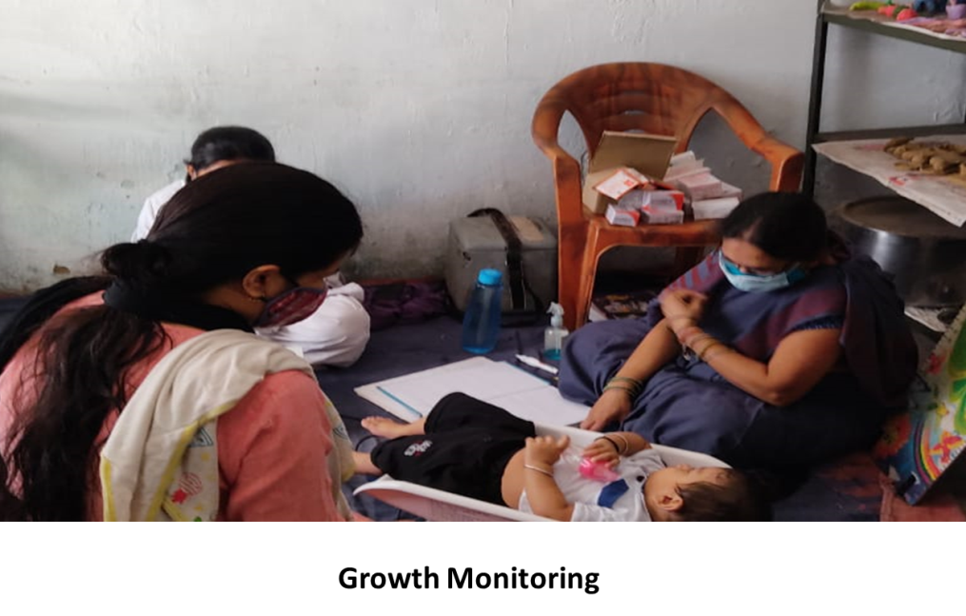
- Growth monitoring and promotion (GMP) is an essential nutrition services, which helps the workers to assess the indirect impact of pandemic. Weighing of children and pregnant women were carried out through door-to-door visit at the time of THR. However, 58 per cent respondents revealed that growth monitoring was carried out in the field both through home visit and also in VHSND.

- Further, it was revealed during assessment that acceptance for growth monitoring and counseling services was very low and beneficiaries resisted from entry of frontline workers into their houses, for the fear of spread of infection as the frontline workers were highly suspected to be exposed to infection. Further, many respondents revealed that many challenges were encountered during growth monitoring like unavailability of sanitizer and difficulty in carrying weight machines from home to home.
- Anganwadi workers in all 28 districts continue to provide essential nutrition services at the doorstep of the beneficiaries including migrant population, while adhering to norms of social distancing, hand and respiratory hygiene. Counseling on nutrition, health, hygiene and COVID-19 related tips were extended in all 28 districts. Only 5 per cent of the respondents reported of challenges in counseling for IYCF because frontline workers were engaged in COVID surveillance and many households denied entry of grass root level workers due to fear of corona virus.

  - Status of THR distribution

- DWCD had released guidelines for discontinuation of Hot Cooked Meal and provision of Take Home Ration for all beneficiaries of Supplementary Nutrition Program , Mahatari Jatan Yojna and Mukhyamantri Suposhan Abhiyan vide Letter no 3-29/2020/50 dated 22/3/2021.

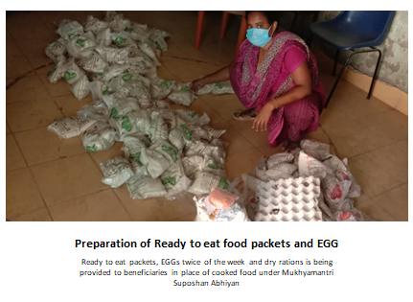
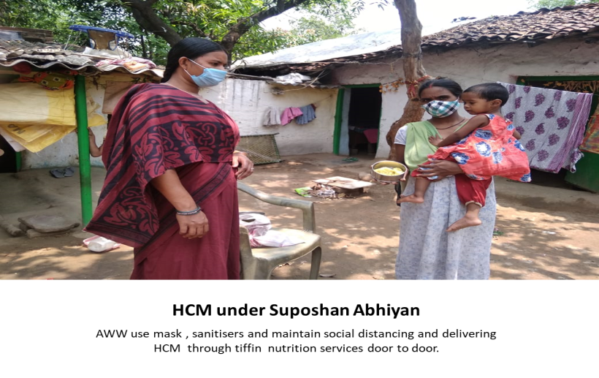
- THR was distributed to all 6-month to 6-year children including those from migrant families in all districts. Even pregnant women and lactating mothers from migrant families were taken as beneficiaries under supplementary nutrition program of ICDS and received THR. DWCD had guided districts to register and distribute the THR at doorstep to the children of migrant families who have returned from other parts of the country/ state It was reported by 78 per cent of respondents that THR was given to pregnant women, which replaced one full meal (under Mahatari Jatan Yojna). Only 22 per cent of the respondents said that food entitlements for women under Mukhyamantri Suposhan Abhiyan – a state initiative was being provided to anemic women in reproductive age and malnourished and anemic children. Distribution of THR to migrant population was reported by 70 per cent of respondents.
- Few Districts like Raigadh reported of innovative distribution of Hot cooked Meal for malnourished children registered under Mukhyamantri Suposhan Abhiyan through Tiffins purchased under District Mineral Fund for Mukhyamantri suposhan.

- Very few districts like Korba , Raigad and Balod reported of distribution of chikki and egg under Mukhyamantri suposhan abhiyan as the file for advancement of fund for program was under process.

  - Pradhan Mantri Matru Vandana Yojna (PMMVY)

- PMMVY is a centrally sponsored scheme with a cash transfer provision of INR 5,000/- for the first living child and the fund is transferred directly to the account of the pregnant women and lactating Mothers in three installments subject to certain conditions, e.g. institutional delivery.
- During the current round of assessment, majority of districts (94 per cent) continued to register pregnant women for cash benefits under PMMVY program and 89 per cent of respondents said that cash benefits were provided to registered beneficiaries.

  - IFA Supplementation

- Distribution and reporting of IFA Tablets was found to be skewed during previous rounds of assessment due to closure of schools and irregularity in reporting due to alternative mechanisms of distribution. After continuous advocacy with the Department of Health and family welfare and department of Education, guidelines were released during the previous wave of pandemic for redistribution of tablets from school to AWW. Simultaneously the Health department had revised guidelines for distribution of IFA tablets and ensuring smooth supply and timely reporting of IFA, thereby ensuring convergence at all levels. During the current round of assessment , more than half the respondents stated that IFA tablets were distributed to adolescents and pre-school children, while only one fourth (28 per cent) said that primary school children received these tablets. Counseling related to anemia control and benefits of IFA was reported by 79 per cent respondents

- Availability and distribution of medicines for pregnant women was assessed during second wave and it was found that 63 per cent respondents reported distribution of albendazole, 72 per cent said that calcium tablets were given and 93 per cent reported of distribution of IFA to mothers.

  - Services under Mothers’ Absolute Affection (MAA) and Home-Based Care for Young Child Programme (HBYC) Programmes and Status of VHSND

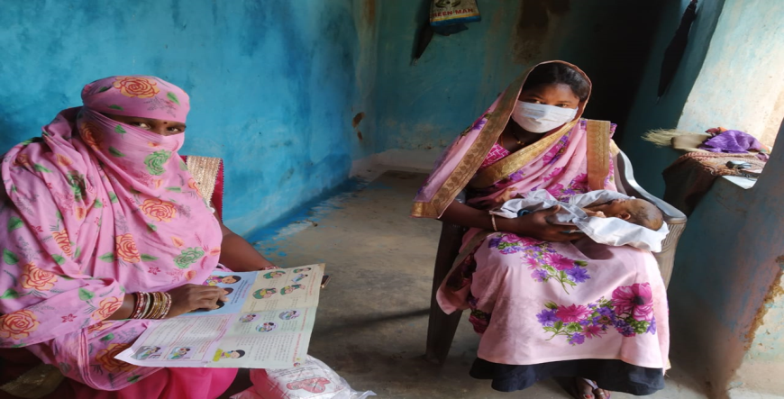
- It was observed during the current round of assessment that Counseling by mitanins (ASHA) on breast feeding and complementary feeding under MAA was reported by 90 per cent of the respondents, while 70 per cent of the respondents said that HBYC visits were taking place regularly by mitanin.
- Only 44 per cent of respondents reported of use of MCP card by mitanin as a tool for promotion of HBYC activities.
- VHSND resumed in all districts and all services like immunization, IFA distribution and ANC checkup were happening regularly.

  - Status of Nutrition Rehabilitation Centers (NRCs)

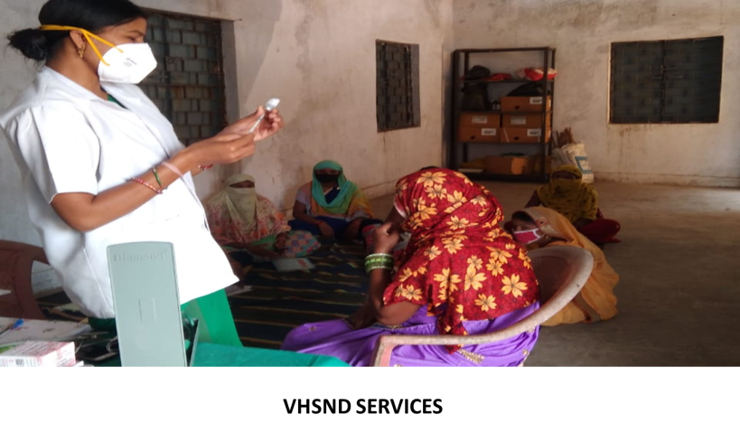
- The current round of assessment revealed that NRC services were severely impacted during second wave of COVID pandemic due to limited availability of staff, poor identification and referral from the field, along with limitations in transport services during lockdown. Since the availability of staff for NRC services kept fluctuating and transport services had been hampered due to recurrent lockdown, number of referrals to NRC had been seriously impacted.
- Only 27 per cent of respondents reported of opening of nearest NRCs for SAM management and 29 per cent reported of conduction of screening for SAM identification. Only 4 percent respondents said that referral of SAM children to NRCs was happening as the major challenge was restricted movement and fear of corona virus.

  - Status of Public Distribution System (PDS)

It was revealed during the current round of assessment by all respondents, that PDS shops were open in all 28 districts and provided adequate ration to households, including free ration to migrant families through anaaj Bank set up at gram panchayat level

  - Water Scarcity

- It was observed during the current round that nine per cent of respondents reported of water scarcity in their respective catchment areas in four districts (14 percent) of Mahasamund, Balrampur, Baloda Bazar and Sukma which had restricted access and availability of safe sources of water.

  - Services for Maternal Nutrition
- Various services are provided to pregnant women in community to ensure timely identification of complication in pregnant women and to ensure timely referral of high risk pregnant cases. It was revealed during current round of assessment, 72 per cent respondents reported to conduct home visits for pregnant women and 92 per cent respondents reported said that they provided referral support to for high risk pregnant mothers.

- Availability and distribution of medicines for pregnant women was assessed during second wave and it was found that 63 per cent respondents reported distribution of albendazole, 72 per cent said that calcium tablets were given and 93 per cent reported of distribution of IFA to mothers.

___________________________

ANNEXURE 1.-distribution of districts
Distribution of Districts for Data Collected by Consultants

 | I.N. Jha |  | Swami Vivekanand |  | Shruti Sachdeva |  | Neeraj
1. | Balrampur | 8. | Balod | 15. | Baloda Bazar | 22 | Bastar
2. | Bemetara | 9. | Bilaspur | 16. | Dhamtari | 23 | Bijapur
3. | Durg | 10. | Janjgir - Champa | 17. | Gariyaband | 24 | Dantewada
4. | Jashpur | 11. | Korba | 18. | Kabeerdham | 25 | Kanker
5. | Koriya | 12. | Mungeli | 19. | Mahasamund | 26 | Kondagaon
6. | Surajpur | 13. | Raigarh | 20. | Raipur | 27 | Narayanpur
7. | Surguja | 14. | Balod | 21. | Rajnandgaon | 28 | Sukma

Annexure 2: MULTI DEPARTMENTAL ASSESSMENT OF NUTRITION SERVICES DURING COVID EMERGENCY-PHASE 8
TOOL 8: QUESTIONNAIRE FOR COVID ASSESSMENT -DISTRICT/BLOCK /SECTOR/VILLAGE

sno | QUESTION | RESPONSE
1 | Username
2 | Name of Organisation
3 | Name of Surveyor
4 | Date of Survey
5 | Person contacted
6 | District
7 | Name of Block
8 | Name of Sector
9 | Name of Village
10 | Name of AWC
11 | Are Anganwadi centers currently open? | 1 YES 2 NO
12 | Is Growth Monitoring and Promotion conducted by AWW | 1AWC 2 HOME VISIT 3 VHSND 4 HEALTH SUBCENTRE  5 NOT HAPPENING
13 | Are Take Home Rations (THR) provided for Pregnent / Lactating Women | 1AWC 2 HOME VISIT 3 VHSND 4 HEALTH SUBCENTRE  5 NOT HAPPENING
14 | Are Take Home Rations (THR) provided for children | 1AWC 2 HOME VISIT 3 VHSND 4 HEALTH SUBCENTRE  5 NOT HAPPENING
15 | Are Pregnant women receiving full meal under the MJY program | 1AWC 2 HOME VISIT 3 VHSND 4 HEALTH SUBCENTRE  5 NOT HAPPENING
17 | [Are beneficiaries receiving food under Mukhyamantri Suposhan Abhiyan] | 1AWC 2 HOME VISIT 3 VHSND 4 HEALTH SUBCENTRE  5 NOT HAPPENING
18 | [Are annaprasan, and godh bharai are happening under CBE] | 1AWC 2 HOME VISIT 3 VHSND 4 HEALTH SUBCENTRE  5 NOT HAPPENING
19 | Are new beneficiaries get registered under PMMVY program | 1AWC 2 HOME VISIT 3 VHSND 4 HEALTH SUBCENTRE  5 NOT HAPPENING
20 | Are beneficiaries get registered CG Kaushalya Matritva Yojana | 1AWC 2 HOME VISIT 3 VHSND 4 HEALTH SUBCENTRE  5 NOT HAPPENING
21 | [Are children 6-59 months given IFA syrup by AWWs/Mitanin] | 1AWC 2 HOME VISIT 3 VHSND 4 HEALTH SUBCENTRE  5 NOT HAPPENING
23 | Are children 5-9 years receiving IFA tablet (Pink) | 1AWC 2 HOME VISIT 3 VHSND 4 HEALTH SUBCENTRE  5 NOT HAPPENING
24 | Are out of School going adolescent girls receiving IFA (Blue) tablets | 1AWC 2 HOME VISIT 3 VHSND 4 HEALTH SUBCENTRE  5 NOT HAPPENING
25 | Are adolescent beneficiaries counselled on IFA consumption and anaemia prevention | 1AWC 2 HOME VISIT 3 VHSND 4 HEALTH SUBCENTRE  5 NOT HAPPENING
26 | Is AWW/Mitanin proper counselling on exclusive breastfeeding during home visit | 1AWC 2 HOME VISIT 3 VHSND 4 HEALTH SUBCENTRE  5 NOT HAPPENING
27 | Is AWW / Mitanin providing proper counselling on Timely introduction of complementary feeding | 1AWC 2 HOME VISIT 3 VHSND 4 HEALTH SUBCENTRE  5 NOT HAPPENING
28 | Is the Home Based Young Child Care (HBYC) program delivering services during the child 3rd, 6th, 9th, 12th and 15th months of age] | 1AWC 2 HOME VISIT 3 VHSND 4 HEALTH SUBCENTRE  5 NOT HAPPENING
29 | Is Mitanin /AWW using MCP tool to promote HBYC activities | 1AWC 2 HOME VISIT 3 VHSND 4 HEALTH SUBCENTRE  5 NOT HAPPENING
30 | Is VHND happening in the villages | 1AWC 2 HOME VISIT 3 VHSND 4 HEALTH SUBCENTRE  5 NOT HAPPENING
31 | Are pregnant women weighed by any field functionary during home visi | 1AWC 2 HOME VISIT 3 VHSND 4 HEALTH SUBCENTRE  5 NOT HAPPENING
32 | Home visits of at risk mothers happening | 1AWC 2 HOME VISIT 3 VHSND 4 HEALTH SUBCENTRE  5 NOT HAPPENING
33 | Is referral service given to at risk pregnant mothers | 1AWC 2 HOME VISIT 3 VHSND 4 HEALTH SUBCENTRE  5 NOT HAPPENING
34 | [Is Iron & folic acid provided | 1AWC 2 HOME VISIT 3 VHSND 4 HEALTH SUBCENTRE  5 NOT HAPPENING
35 | [Is Calcium provided | 1AWC 2 HOME VISIT 3 VHSND 4 HEALTH SUBCENTRE  5 NOT HAPPENING
36 | Is Albendazole provided | 1AWC 2 HOME VISIT 3 VHSND 4 HEALTH SUBCENTRE  5 NOT HAPPENING
37 | Are beneficiaries receiving cash transfer under PMVVY program? (PW/LM shall receive as cash benefits of 5000/-in three installments) | 1 YES 2 NO
38 | Is the nearest NRC open for SAM management? | 1 YES 2 NO
39 | Is screening for SAM happening in AWCs? | 1 YES 2 NO
40 | Are children identified as SAM & being referred to NRCs | 1 YES 2 NO
41 | What all services are given in VHSND ? | 1 ANC 2 IMMUNIZATION 3 IFA DISTRIBUTION 4 GROWTH MONITROING AND PROMOTION 5 NOT HAPPENING
42 | Has there been Home delivery (new born) taken place in the last one month (during the period of local down)? | 1 YES 2 NO
43 | Total Home Deliveries | PLEASE MENTION THE NUMBER
44 | Trained Birth Attendant (numbers) | PLEASE MENTION THE NUMBER
45 | Any Relative (numbers) | PLEASE MENTION THE NUMBER
46 | Any other (neighbour) (numbers) | PLEASE MENTION THE NUMBER
47 | Number of Still Birth at Home delivery | PLEASE MENTION THE NUMBER
48 | Number of Neonatal death at Home delivery | PLEASE MENTION THE NUMBER
49 | Has there been Institutional delivery (new born) taken place in the last one month (during the period of local down)? | 1 YES 2 NO
50 | Total Institutional Deliveries | PLEASE MENTION THE NUMBER
51 | Number of Still Birth at Institutional delivery | PLEASE MENTION THE NUMBER
52 | Number of Neonatal death at Institutional delivery | PLEASE MENTION THE NUMBER
53 | Are the Rations shops open in your area | 1 YES 2 NO
54 | Is PDS providing adequate food commodities to people in the village in this lockdown, Including migrants ? | 1 YES 2 NO
55 | Is there water scarcity in your area or anywhere in your village? | 1 YES 2 NO
56 | Focus of Nutrition Counselling [IYCF] | 1 YES 2 NO
57 | Focus of Nutrition Counselling [Food safety] | 1 YES 2 NO
58 | Are the people following the appropriate covid related behaviour [Double Mask] | 1 YES 2 NO
59 | Are the people following the appropriate covid related behaviour [Hand washing] | 1 YES 2 NO
60 | Are the people following the appropriate covid related behaviour [Social distancing] | 1 YES 2 NO
61 | Was there any stock out of Maternal Micronutrient supplements and Deworming tablets during COVID 19, after April 2021? [IFA Red] | 1 YES 2 NO
62 | Was there any stock out of Maternal Micronutrient supplements and Deworming tablets during COVID 19, after April 2021? [Folic Acid] | 1 YES 2 NO
63 | Was there any stock out of Maternal Micronutrient supplements and Deworming tablets during COVID 19, after April 2021? [Calcium] | 1 YES 2 NO
64 | Was there any stock out of Maternal Micronutrient supplements and Deworming tablets during COVID 19, after April 2021? [Albendazole] | 1 YES 2 NO
65 | How each service is being delivered during covid lockdown | PLEASE MENTION THE STATUS OF DELIVERY OF SERVICE

NFHS-4
NFHS-4
The list of districts covered by each consultant is given in Annex 1.
The Format is attached for reference in Annexure 2.
Under the Anemia Mukt Bharat (launched in April 2018), prophylactic Iron folic acid supplementation is one of the six strategies used to combat the nutritional deficiency among children, adolescent girls and P&L women.

