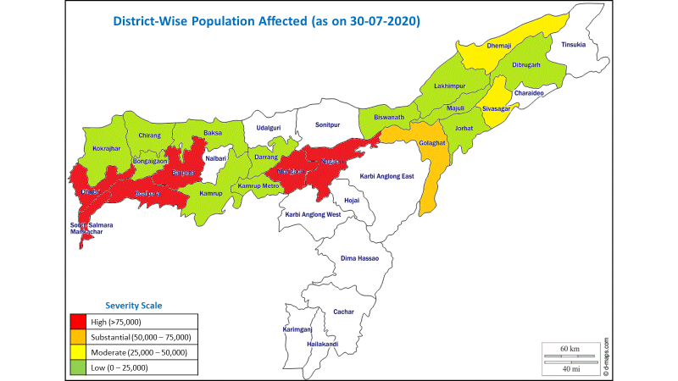
Assam, India

Floods 2020
Situation Report # 6

30 July 2020

- As of 29 July 2020, 1,654,984 people, including approximately 661,994 children, were affected by the floods in 21 of the 33 districts of Assam. Among the affected districts, Goalpara remains the worst hit with 419,300 (25.34 per cent) people affected.
- Cumulatively (May 22 - July 29), 5.67 million people including an estimated 2.27 million children have been affected in 30 of the 33 districts.
- A small percentage of people have taken shelter in relief camps (2.24 per cent of the affected population). Goalpara district has the highest number of people (18,374) living in government-operated relief camps followed by Chirang (3,969).
- In the past few days, the water levels in the Brahmaputra River had fallen. As forecasted by India Meteorological Department, heavy rainfall has been observed since 28th July. 18.70 mm rainfall has been reported on 29th July.
- UNICEF has supported timely issuance of COVID-19-adaptive relief camp management guidelines and Standard Operating Procedures by the Government of Assam before the onset of the floods. These are being used by the District Disaster Management Authorities (DDMAs) for operating and managing relief camps. So far (22 May to 29 July) 153,930 people have taken shelter in 617 flood relief camps. Presently, there are 208 relief camps in 13 districts catering to 37,012 people.
- UNICEF and ASDMA trained community volunteers (Pratirodhi Bandhu) in May 2020, who are currently deployed by DDMAs to support relief camp management in affected districts. Approximately, 112 UNICEF consultants and CSO partner staff have been trained in June 2020 on flood response. Based on this (despite of the lockdown and movement restrictions), UNICEF mobilized consultants (based in the affected districts) and CSO partner staff to assess relief camps. So far 43 relief camps in 11 districts have been assessed and preliminary findings have been shared with ASDMA.
- UNICEF in collaboration CSO partner, Rural Volunteer Centre, has supported DDMAs of Majuli (6) and Dhemaji (4) in establishing 10 model relief camps, as per guidelines. This has been documented and shared with all districts.
- Timely technical support has been provided in preparedness plans and in building the capacity of functionaries in Education, Social Welfare (Nutrition), and Public Health Engineering (WASH) departments to respond to floods, which has supported rapid response by these departments.
- UNICEF has supported in conducting a Joint Rapid Needs Assessment (JRNA) covering 146 villages from 12 affected districts. The JRNA report has been shared with Civil Society Members of the IAG, which is supporting them in planning for response and beyond.
5,801
Children in relief camps
(Source: Assam State Disaster Management Authority, Daily Flood SitRep, 29-07-2020. Total 6 of 13 districts with 11,013 of 37,012 inmates in 66 of 208 camps have not reported desegregated number of children in camps)

37,012
People in 208 relief camps in 13 of the 21 affected districts
(Source: Assam State Disaster Management Authority, Daily Flood SitRep, 29-07-2020)

661,994
Children affected by flood (estimated)
(Estimated as 40% of the affected population as children comprised 40% of the state’s population as per Census 2011)

1,654,984
People affected by flood in 21 Districts and 54 Revenue Circles
(Source: Assam State Disaster Management Authority, Daily Flood SitRep, 29-07-2020)

Situation Overview & Humanitarian Needs
Regional Rainfall Map (1st July – 29th July 2020)
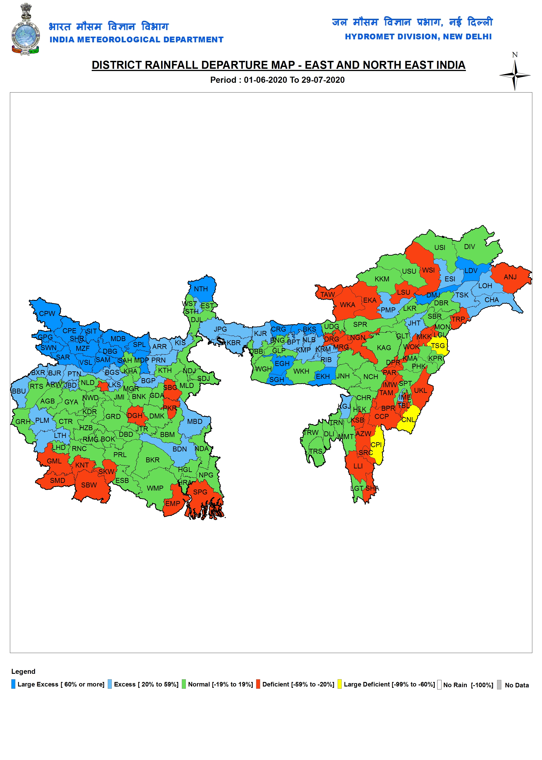
Source: Indian Meteorological Department, Government of India https://mausam.imd.gov.in/imd_latest/contents/rainfallinformation.php?msg=M#.
Two major waves of the flood have impacted the state since May 22, 2020. As per the Flood, Report dated 29 July 2020 by Assam State Disaster Management Authority (ASDMA), 1,654,984 people from 1,536 villages of 54 Revenue Circles (Taluks) across 21 districts remain affected. Based on the extrapolation of Census 2011 figures, it is estimated that 661,994 children are affected. Since 22 May (till 29 July), 5.67 million people including an estimated 2.27 million children from 30 districts have been affected due to floods. Over 133 deaths (Flood –107, Landslide –26) have been reported, while 1,53,930 people have taken shelter in 617 relief camps.
At present, 208 relief camps have been set up in 13 of the 21 affected districts. About 37,012 people have taken shelter in these relief camps out of which 14,805 (estimated) are children. About 36 people have been rescued so far by the National Disaster Response Force (NDRF) and the State Disaster Response Force (SDRF), as of 29 July 2020.
Though flooding in this period of the year is common, the scale of flooding in early July has not been usual. The COVID-19 pandemic has delayed certain conventional preparedness measures by the government as well as by communities, to be made during the pre-monsoon period. Therefore, coping with the current flood has proven to be difficult for many vulnerable communities. For children, the stress is multiplied. According to the Joint Rapid Needs Assessment (JRNA), respondents from 73 percent villages have indicated having food for less than a week, while 29 per cent reported a decrease in the quantity of food consumption. Respondents from 51 per cent assessed villages have limited/no access to safe drinking water, while open defecation has been reported in 49 per cent of the assessed villages. It has also been observed that a large number of affected people have not moved into relief camps and are taking shelter on roads, embankments, raised platforms, and other higher grounds without basic amenities and support services.
Presently, only 2.24 per cent of the affected people are in relief camps. Other than relief camps, local administration is also operating relief distribution centers to provide essential gratuitous relief to those who are beyond the coverage of relief camps. Many affected people are still either in their houses or have taken shelter on nearby higher grounds.
Humanitarian Leadership and Coordination
UNICEF is actively coordinating with ASDMA, Inter-Agency Group, and other sectoral CSO partners and networks to monitor specifically the situation of women and children in relief camps through direct assessment by consultants and CSO partner staff. The assessment covers 12 parameters and 71 indicators based on the relief camp SoPs. Approximately, 112 UNICEF consultants and CSO partner staff have been trained in June 2020 on flood response. Based on this (despite the lockdown and movement restrictions) UNICEF mobilized consultants (based in the affected districts) and CSO partner staff to assess relief camps. So far 43 relief camps from 11 districts have been assessed using this tool by the trained consultants and CSO partners.
UNICEF has supported IAG in revising the JRNA format in the context of COVID-19 and recent policy developments, by converting it into an e-tool using KoBo Toolbox, and oriented 64 representatives of IAG members on its usage. Based on the orientation, the IAG members have conducted the JRNA from 1 to 6 July 2020. This is the first JRNA in which the data collection process is fully digitized. The JRNA exercise covered 146 villages from 12 districts of Assam. UNICEF has coordinated the formation of a drafting committee and has contributed towards the drafting of the full report.
Before the onset of floods, UNICEF has led to advocating and ensuring policy level preparedness. UNICEF supported ASDMA in developing the Standard Operating Procedure (SOP) on Relief Camp Management and Guidelines for Child-Friendly Spaces (CFS) in 2020 for the COVID-19 context which is being followed by District Disaster Management Authorities (DDMA) in management of relief camps currently. UNICEF and ASDMA have also trained community volunteers (Pratirodhi Bandhu) in May 2020, they are currently deployed by DDMAs to support in relief camp management in affected districts.
Humanitarian Strategy
UNICEF’s response strategy has focused on improving services and facilities for children affected by floods particularly those in relief camps. The Emergency Management Team of Assam Field Office met on 28 May 2020, where sectoral anticipated response strategies were discussed and agreed. UNICEF sector specialists have been coordinating with government counterparts to provide technical support in executing their response actions for which preparedness activities such as capacity building and planning for response has done beforehand. Due to the partnership established before floods, CSO partner Rural Volunteer Centre (RVC) has worked with DDMAs of Majuli (6) and Dhemaji (4) to establish 10 model relief camps (all camps that came into existence in these two districts in the second wave of the flood). This experience has also been documented and shared widely through official social media handles of ASDMA. ASDMA has also shared the video documentation with all districts for replication (as feasible).
Currently one of these two districts has 3 camps with 183 people including 65 children. UNICEF’s technical assistance also guided DDMAs of many flood-affected districts to operate CFS in relief camps. Initial estimates by ASDMA suggest that around 141 relief camps operated Child-Friendly Spaces. Though the exact number of children benefiting from these spaces is yet to be reported, UNICEF estimates that around 14,100 children would have benefitted from the services provided in these child-friendly spaces. Child-Friendly Spaces are regarded as one of the core innovations in flood response this year by the Government of Assam.
Summary Analysis of Programme Response (by Government and technical assistance by UNICEF)
UNICEF Sector Specialists/Officers are working with department teams to assess the situation and respond as required. A brief overview of the initial observations is as follows:
Health
The sector is at the forefront of the response to COVID-19. The Health Department is continuing the COVID-19 response through the 2nd phase of the Community Surveillance Program and Infectious disease outbreak. The pre-positioning of ORS-Zinc tablets has been integrated into this surveillance activity. No major disease outbreak has been reported to date. There are reports of inundation of health facilities in the state, interrupting the essential services. 241 health facilities majorly the sub-centers have been affected so far. While the initial estimates by the department indicated damage to 18 Sub-Centres and 4 Primary Health Centers (damage assessment is still progress). Districts of Barpeta, Dibrugarh, Morigaon, Jorhat, and Majauli are worse hit. UNICEF Sector Specialist is coordinating with the National Health Mission to provide necessary technical support in ensuring health measures outlined in the SOP for Relief Camp Management and Guideline for CFS in the COVID-19 context. In coordination with the Health Department, the disease surveillance report is reviewed daily, and relevant actions discussed. The sector has also asked consultants and CSO partners to conduct an assessment of camps and support the health department in flood response activities
Nutrition
Anganwadi centers have been inundated although they are already closed due to ongoing COVID-19 related lockdown. Initial estimates by the department indicate that 3714 Anganwadi Centres have been affected/damaged while the detailed assessment is still in progress. Nutrition services were disrupted due to the COVID-19 outbreak which will be further affected. Gratuitous Relief (dry ration) has been distributed in relief camps and through relief distribution centers. Between May 22- July 29, 1,41,449.38 quintals of rice, 27,315.74 quintals of dal, 8,249.39 quintals of salt, 2,40,650 liters of mastered oil, other items such as baby food etc has been distributed to the flood-affected people by the government. Nutrition Sector in UNICEF is coordinating with the Social Welfare department to assess the situation at hand and explore the need and possibility for support. The sector is supporting the department in keeping track of any instances of the IMS Act violation and facilitating appropriate action by the department. To further prevent violation of the IMS act, UNICEF facilitated the issuance of advisories from both Dept of Social Welfare and NHM Assam. The advisories focus on reinforcing optimal Infant feeding practices during floods and reinforce the implementation of the IMS act during flood season and in the context of COVID19. Further, the sector has worked with the Department of Social Welfare and partner district administrations in supporting the capacity building of district and sub-district staff on flood response on 25th June 2020, which has helped in rolling out the response on the ground rapidly. In addition, the nutrition Sector has reached out to two partners, including academic and CSO partners to support monitoring of flood response in two districts.

WASH
As reported by Public Health Engineering Department on 27th July 2020 (initial estimates), 2645 Spot Sources (mainly hand tube well), 197 Piped Water Supply Schemes (PWSS) have been affected by floods. Public Health Engineering Department has so far installed 68 spot sources, 998 toilets, and has distributed 1,78,000 water pouches in relief camps and other areas where people are taking shelter. Though the department is striving hard to reach the affected, the JRNA has reflected issues related to the availability of safe drinking water as well as the practice of open defecation in areas affected by floods as water and sanitation infrastructure has been affected.
UNICEF is coordinating with the department to assess the situation. DRR and WASH sectors have worked with the PHED for building the capacity of district and sub-district staff on flood response on 5th and 12th June 2020 reaching 199 officials from district and sub-district level. Further support was also provided on the issuance of supporting GO compiling and synthesizing the roles and standards of the department as per different manuals and guidelines. The UNICEF sector specialist has worked with PHED to ensure WASH parameters/ standards as mentioned in the “Guidelines in the relief Camp Viz-a Viz flood and COVID-19” have been rolled out in the districts. Further, depending upon need support will be provided to PHED for relief camp management monitoring for WASH access. The sector will continue supporting the PHED, for accurate loss and damage reporting. The sector will also work with partners to address communications on safe WASH in the relief camps and CFS supplies to address water purification and disease control. Further, 365 master trainers were trained on COVID and Flood response on 9th July who will in-turn train Swachhagrahis (WASH frontline workers) in the district which will provide surge support to the department to deliver essential WASH services to flood-affected communities.
Education
Schools have been inundated in many districts. Initial estimates by the department indicate that around 967 elementary schools and 34 secondary schools have sustained damage due to floods (detailed assessment is in progress) As schools are already closed due to the COVID-19 related lockdown, there is no direct disruption of education services attributed to floods. However, school Mid-day Meal and e-learning services have been affected due to the floods. The department is proposing to assess the situation of schools to respond more efficiently. A review meeting has been conducted by the department including UNICEF to discuss the disruptions caused. Further, UNICEF was requested to support the monitoring of the situation and developing an appropriate response plan. As a response, an orientation was conducted of all district level heads of the department on flood preparedness and actions to be initiated. A strategic response plan for flood preparedness and response at the state level has been developed along with advocacy for teacher deployment in relief camps to support children. The response has been reviewed by the department Principal Secretary on 3rd July, including the sharing of initiatives and challenges by district-level education authorities. A follow-up meeting with the Education department took place on 8 July 2020, where UNICEF highlighted critical areas of focus for the department and pushed for teacher deployment in all relief camps as a mandatory measure. A letter has been issued to all Deputy Commissioners with approval from Chief Secretary on 13th July 2020 to address the deployment of teachers in relief camps for operating child-friendly spaces along with other areas as advocated by UNICEF. The department is in the process of appointing a Nodal officer to streamline the seamless collection of data. The Nodal Officer will be assisted by the Civil Engineering Department.
Child Protection
As families had to abandon their homes due to the sudden onset of the flood, their exposure to protection risks increased. Still, a large number of affected people are beyond the camp purview and hence beyond formal monitoring channels. Further safety and security monitoring have become difficult as roads are disrupted.
District Child Protection Unit Tezpur conducted a joint intervention with Police and local NGOs to rescue an abondonned child on banks of Morabharali river. More details in this news column (http://tezpurbuzz.com/news/tezpur-local-person-detects-abandoned-infant-on-banks-of-morabharali-river-rescued-successfully/)
So far, there are no reports of childcare institutions getting affected from the flood-affected districts. The Sector is coordinating with multiple CP related departments and agencies within the government. Further, the sector will work with Police Department to ensure security parameters as mentioned in the “Guidelines in the relief Camp Viz-a Viz COVID-19” and also for increased vigilance of the nearest transport points to identify the movement of both accompanied and unaccompanied children. The sector will also work with the office of Commissioner Disability and State Child Protection Society (SCPS) and relevant District Child Protection Unit (DCPU) to ensure Special arrangements for Children, women, physically challenged and elderly parameters of the relief camp guidelines.
Social Policy
The Social Policy Sector has started assessing the reach of the MGNREGA Scheme amongst vulnerable families in the select Gaon Panchayats in the flood-affected districts of Goalpara, Lakhimpur, and Biswanath Chariali districts. UNICEF has formalized the collaboration with P&RD in developing communication materials for demand generation with a focus on MGNREGA and the role of PRIS during COVID 19 and floods response and recovery. In areas where there has not been much flooding and/or water has started receding, the farmers are in the field as it is the season for sowing crops. The partner organizations have been reaching out to these farmers in the fields for increasing awareness on the social protection schemes particularly MGNREGA and job cards so that they can avail the benefits as soon as the sowing season is over
Safety and Security
With new forecasts for heavy rainfall for the next few days, water levels will again increase in places where water had started receding. Guwahati (the state capital city) has been locked down from 29th June till 19th July. Though some relaxation has been brought in (after July 19th) still restrictions have been kept on many activities till 31st July. A weekend lockdown has been imposed in all urban areas of the state (under Urban Local Bodies) and night curfew has been imposed throughout the state from 7 PM to 7 AM. Official Travel restrictions are in place for all UN personnel.

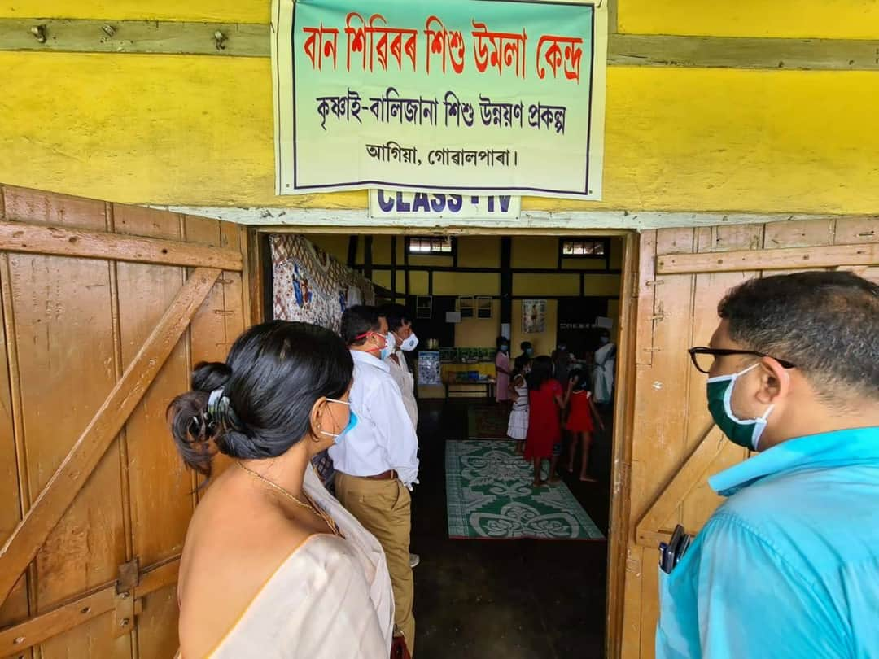 | 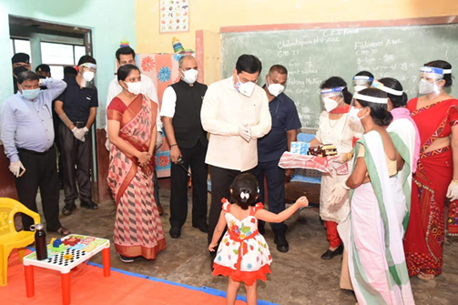
Image 3: Chief Secretary of Assam visiting a Child-Friendly Space in one of the relief camps in Barpeta (photo Source- ASDMA) | Image 4: CFS in a relief camp in Bongaigaon visited by the Chief Minister of Assam (Source: CMO Assam, Facebook Page)
UNICEF India: https://www.unicef.org/india/
Anand Kanoo
DRR Officer
UNICEF State Office for Assam
Mob: +91 6900524478
Email: akanoo@unicef.org
Purvi Malhotra
Communication Specialist
UNICEF State Office for Assam
Mob: +91 9810039283
Email: pmalhotra@unicef.org
Dr. Madhulika Jonathan
Chief of Field Office
UNICEF State Office for Assam
Mob: +9435049790
Email: mjonathan@unicef.org
Who to contact for further information:

Source: ASDMA (http://www.asdma.gov.in/pdf/flood_report/2020/Daily_Flood_Report_29.07.2020.pdf)
Source: ASDMA (http://www.asdma.gov.in/pdf/cumulative_flood_report/2020/Daily_cumulative_Flood_Report_29.07.2020.pdf)
Being estimated as 40% of the people taking shelter in relief camps as all districts have not reported children desegregated data for relief camps
Estimate has been derived by deviding the total population taking shelter in relief camps till date with the total number of relief camps to determine per camp population size, 40% of which are assumed as children
MHA (NEOC) situation report on 29th July (https://www.ndmindia.nic.in/images/gallery/Sitrep%20Report%20as%20on%2029.07.2020%20at%201900%20Hrs.pdf)

