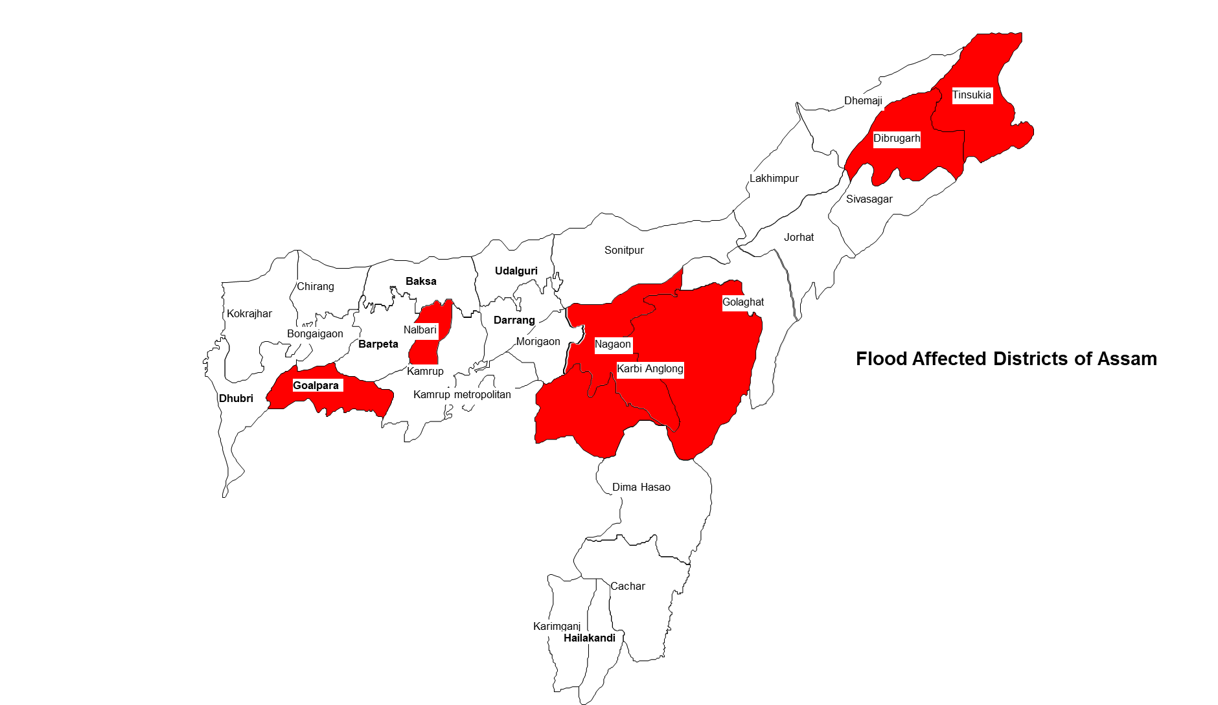
Assam (India)
Floods 2020
Situation Report # 2

- The 1st wave of flood in Assam which has started since 22nd May in the aftermath of ‘Super Cyclone Amphan’ is currently affecting 0.38 million people including 0.15 million children across 7 districts of Assam
- This flood has been caused by largely excess rainfall (IMD terminologies) which happened in parts of Meghalaya, Arunachal Pradesh and Assam.
- Goalpara has been the worst affected district with 0.19 million (52%) people affected by the current wave of flood. It is also housing the highest number of people displaced and taking shelter in relief camps (16,300 or 75% of the people currently in relief camps in the state)
- The Indian Meteorological Department has projected heavy rainfall in most of the districts of Assam till 31st May, 2020.
- Chief Minister of Assam chaired a flood review meeting with officials of the government at state level on 27th May and have also visited flood affected villages and camps in Goalpara on 29th May, 2020.
- The Revenue and Disaster Management Minister, Government of Assam has chaired a video conference with DDMAs from all 33 districts tor review preparedness/response to flood and has issued a 20-point preparedness checklist to DDMAs to respond to within 3 days
- UNICEF advocated for and supported timely issuance of relief camp management guidelines and Standard Operating Procedures by Government of Assam before the onset of the floods which are being adhered to for operating and managing relief camps.
- UNICEF has also supported training of more than 10000 Pratirodhi Bondhu volunteers who are supporting the DDMAs in COVID as well as flood response
- 1st Emergency Coordination meeting of the IAG Assam on the emerging flood situation has been convened by UNICEF on 16th May and field observations have been obtained from CSO partners
- UNICEF is coordinating with ASDMA to activate relief camp monitoring and assessment through UNICEF consultants and partners if the situation further worsens.
- All UNICEF sectors have been coordinating with respective government departments for providing necessary technical support as per need. A sectoral response strategy has been developed.
- UNICEF has also initiated internal surge mapping for providing technical assistance as per need adhering to COVID guidelines and procedures.

SITUATION IN NUMBERS
30 May 2020

5,065 children in relief camps
(Daily Situation Report of ASDMA, GoI for 29th May 2020, 1 district out of 3 having 31 camps with 5299 people has not reported number of children)

21,807
# of people estimated to be displaced due to floods and are taking shelter in 101 relief camps in Goalpara, Tinsukia and Hojai districts
(Source: Assam State Disaster Management Authority, Daily Flood SitRep, 29-05-2020)

3,81,320 (7 Districts, 11 Revenue Circle)
# of people affected by flood
(Source: Assam State Disaster Management Authority, Daily Flood SitRep, 29-05-2020)

1,52,528
Estimated # of children affected by flood
(being estimated as 40% of the affected population as children comprised 40% of the state’s population as per Census 2011)

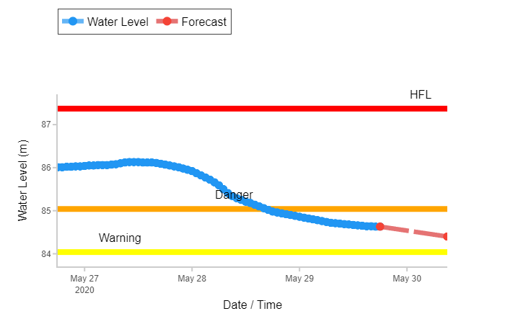
Hydrograph of River Brahmaputra at Neamatighat, Jorhat
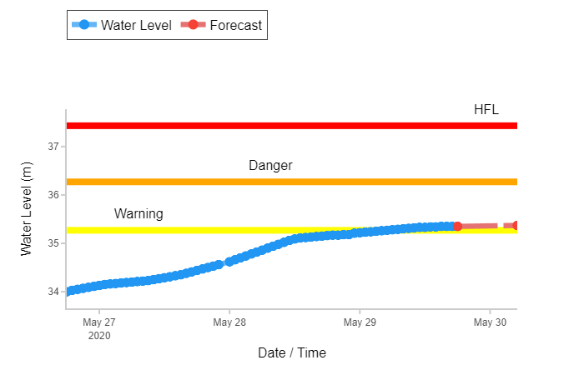
Hydrograph of River Brahmaputra at Goalpara

Karbianglong indicates West Karbi Anglong and Nagaon indicates both Nagaon and Hojai (as Hojai was a part of undivided Nagaon district)

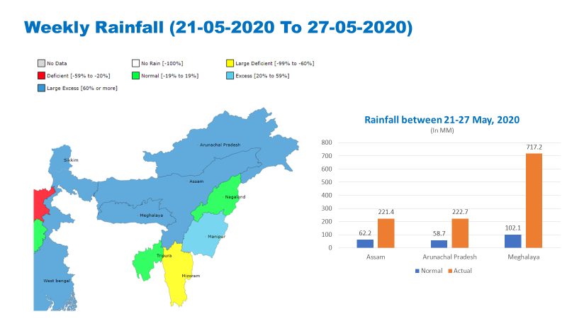
Situation Overview & Humanitarian Needs
Source- Indian Meteorological Department, Government of India
As anticipated, the secondary impact of the ‘Super Cyclone Amphan’ has led to incessant rainfall activities in North East India. After landfall in West Bengal, the cyclone moved through the North-eastern states of India causing widespread influence on the rainfall front. Between 21-27 May, 2020 Assam, Arunachal Pradesh and Meghalaya have received 221.4 mm (against 62.2 mm), 222.7 mm (against 58.7 mm) and 717.2 mm (against 102.1 mm) respectively. As due to the onset of COVID-19 situation, the restoration of embankments breached during 2019 floods could not be completed in certain locations, the inundation was rapid. Since the onset of floods on 22nd May where initially some of the major tributaries of Brahmaputra started flowing above danger level and caused inundation, the impact became widespread from 1 district on 22nd May to 11 districts by 27th May. Since last 2 days, the number of affected districts has reduced, however, the number of people affected continued to increase from 630 people on 22nd May to 0.38 million on 29th May. This flood also forced a good number of people to leave their houses which were getting inundated to take shelter on streets and other higher grounds and then gradually they were shifted to relief camps operated by government. There have been reports of embankments being breached in many locations, Impact on connectivity in many places primarily in Goalpara as well as in some parts of other affected districts as roads, bridges being washed away/damaged, heavy erosion in districts which are not yet affected by floods, landslides in different parts Dima Hasao and Kamrup metro districts and storms at many locations causing widespread damages.

Humanitarian Leadership and Coordination
UNICEF has initiated coordination with Assam State Disaster Management Authority and Inter Agency Group Assam to understand the situation and define possible response actions. An initiate meeting with ASDMA to jointly review the situation and support needed has been held on 29th May 2020. Detailed discussion on monitoring the implementation of camp management guidelines have been held. UNICEF will be requested to support in this regard by Government if the situations worsens further. UNICEF has also convened a meeting of Inter Agency Group particularly focusing on members from affected districts to take stock of the situation. UNICEF sectors have initiated coordination with respective line departments to understand the situation and accordingly arrange for support. An internal surge mapping exercise has been initiated to identify and train UNICEF consultants and partners to deliver technical assistance from their base locations if need arises.

Humanitarian Strategy
UNICEF will be prioritizing improved services to children affected by floods and taking shelter in relief camps through technical assistance. Preparedness in the form of issuance of guidelines and standard operating procedures for relief camp management including operationalization of child friendly spaces in such camps in the context of COVID-19 have already been done. A meeting of Emergency Management Team of Assam Field Office took place on 28th May, 2020 where the emerging situation has been discussed in detail and initial sectoral observations related to impact has been shared with sectors. Further, Programme specialists/Officers have also discussed and identified potential response actions to be taken if the situation warrants. A decision has also been taken to define a threshold for initiating field response as Assam witnesses flooding every year which is very widespread. The threshold of 0.5 million people and 10 districts affected has been agreed.

Summary Analysis of Programme Response (by Government and technical assistance by UNICEF)

UNICEF sector specialists/officers have initiated coordination with counterparts to assess the situation and plan for support if needed. Preparedness to deliver technical assistance has been initiated with mapping of sectoral consultants. The following provides a brief overview of initial observations related to sectoral impacts and actions initiated/planned by sectors to support government in the response to this and upcoming phases of floods:

Health
As per initial observations, health sub-centers have been inundated particularly in Goalpara district. Assessment of facilities will be initiated once there is a reduction in water levels. Further there were also instances of relocation of quarantine centres in Goalpara. Regular services have also been disrupted in some areas. However, the department has initiated special measures to continue COVID-19 response through the Community Surveillance Program in flood affected areas. As per the SoP and guideline notified by ASDMA, it was discussed during the meeting to ensure presence of health personal with adequate protective equipment in camps, pre-positioning of essential drugs in the camps, ensuring temporary shifting/relocation of health facilities that may get affected during floods. It was also decided by NHM to ensure pre-positioning of ORS and Zinc in all designated camps, implement infection prevention measures in camps for water borne diseases and mitigation measures (as per the notified SoP) related to COVID-19. UNICEF suggested about mandatory symptom screening of all inmates before they register into the camps, separate arrangements for people who are under quarantine (home/institutional) away from other category of flood affected population, providing masks to inmates and communication materials to be made available in camps, identification and special arrangements for vulnerable groups, food hygiene etc. Further, these actions have been initiated in affected districts by the health personal. UNICEF sector specialist is coordinating with NHM to provide necessary technical support in this regard. The sector has also identified consultants and partners who will be oriented to provide technical support in relief camp monitoring.

Nutrition
Anganwadi centres have been inundated although they are already closed due to ongoing lockdown due to COVID 19. Children with their families were taking shelter on street without sufficient food and nutrition support in certain areas till they were shifted to camps. Anganwadi Workers have been deployed in relief camps to support children taking shelter in those camps. Certain nutrition services were already disrupted due to COVID-19 outbreak which will be further affected. Gratuitous relief (dry ration) has been distributed in relief camps and through relief distribution centres as per the standards mentioned in the relief distribution centres. Nutrition Sector in UNICEF is coordinating with Social Welfare department to assess situation at hand and explore need and possibility of support. The sector will be supporting the department in keeping track of any instances of IMS act violation and will be facilitating appropriate action by the department. Further, sector is planning to work with Department of Social welfare and partner district administrations to support capacity building of district and sub-district staff on flood response and will also explore possibility of engaging with State NCARe Centre Tezpur University for remote monitoring of field situation in selected districts.

WASH
Piped Water Supply Schemes/Hand Pumps/Toilets inundated in affected areas. Temporary arrangements in camps and for affected population taking shelter on other higher grounds. Public Health Engineering Department is supplying water pouches and erecting temporary toilets. The Sector Specialist from UNICEF is coordinating with the department to assess the situation. Further, the sector will Work with PHED to ensure WASH parameters/standards as mentioned in the “Guidelines in the relief Camp Viz-a Viz flood and Covid” .Further, depending upon need support will be provided to PHED for relief camp management monitoring w.r.t WASH access (child friendly spaces).The sector will continue supporting the PHED, for accurate loss and damage reporting. The sector will also work with partners to address communications on safe WASH within the CFS context, supplies to address water purification and disease control.

Education
Schools have been inundated in many affected places. As schools are already closed due to lockdown, there is no direct disruption of education services attributed to floods. However, Mid-day Meals services, e-learning services might have been affected due to the floods. Knowing the actual numbers of schools inundated/damaged will take some time for the department to assess and share. Further, the schools which are not inundated are preferred camp sites. The Sector Specialist has taken part in a review meeting with department and have discussed about the disruptions caused. Further, UNICEF was requested to support proper monitoring of the situation and developing appropriate response plan. The same will be initiated to cater to this as well as coming phases of flood in the state.

Child Protection
As families were on street due to sudden onset of flood in certain areas, their exposure to protection risks increased. Still large number of affected people are beyond camp purview and hence beyond formal monitoring channels. Further safety and security monitoring have become difficult as roads are disrupted. So far there are no reports of childcare institutions getting affected from the flood affected districts. The Sector is coordinating with multiple CP related departments and agencies within government. Further the sector will work with Police Department to ensure security parameters as mentioned in the “Guidelines in the relief Camp Viz-a Viz Covid” and also for increased vigilance of the nearest transport points to identify movement of both accompanied and unaccompanied children. The sector will also work with the office of Commissioner Disability and State Child Protection Society (SCPS) and relevant District Child Protection Unit (DCPU) to ensure Special arrangements for Children, women, physically challenged and elderly parameters of the relief camp guidelines.

Safety and Security
Some roads have submerged due to flood, the accessibility will remain a challenge till the water recedes. In the current situation of COVID and the lock down measures, restrictions on travel will impact field movement. No security threats have been reported so far.

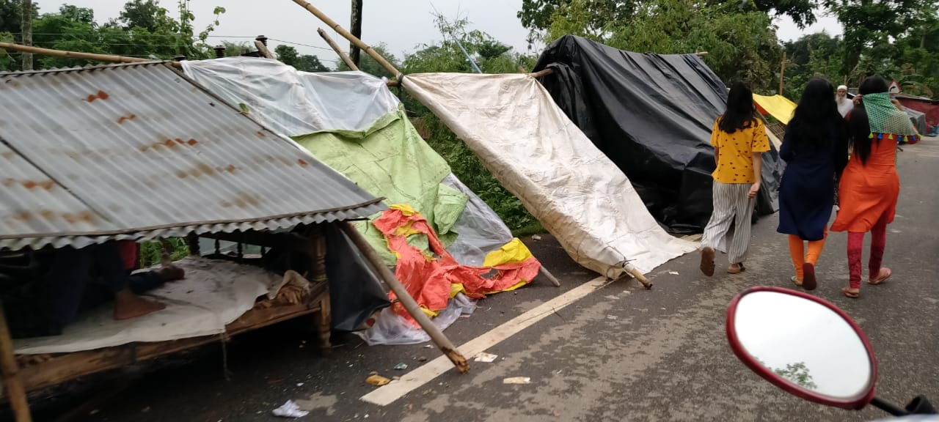
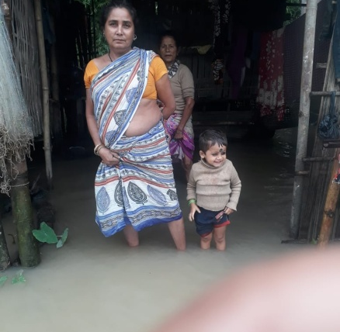
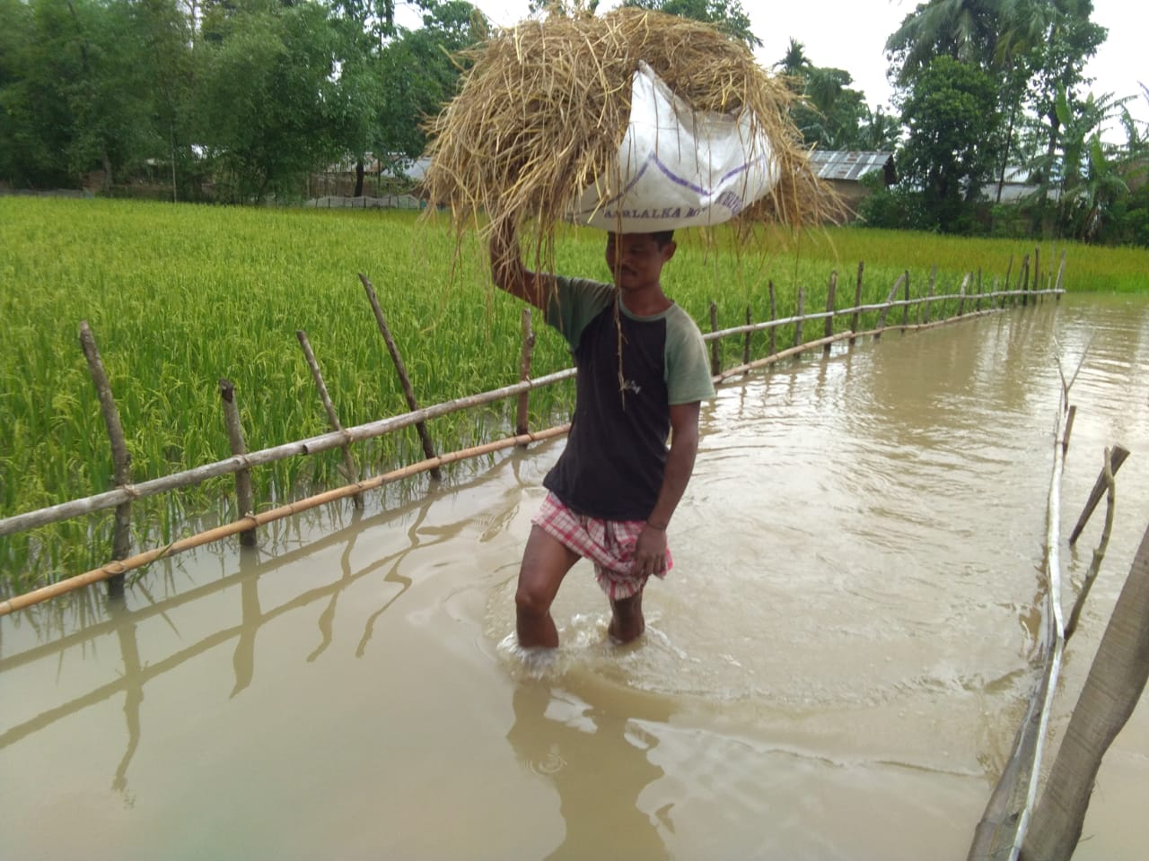
From Left 1. Makeshift shelter on streets in Goalpara (Picture-IAG). 2. A person crossing inundated road with paddy in Goalpara (Picture-IAG). 3. A mother with her child in her house which is getting inundated with flood water in Dhemaji (Picture- Rural Volunteer Centre)
Chief Minister of Assam visiting flood affected areas and relief camps (Child Friendly Spaces) in Goalpara and interacting with children on 29th Mat, 2020 (Picture-CM’s Social Media Page)
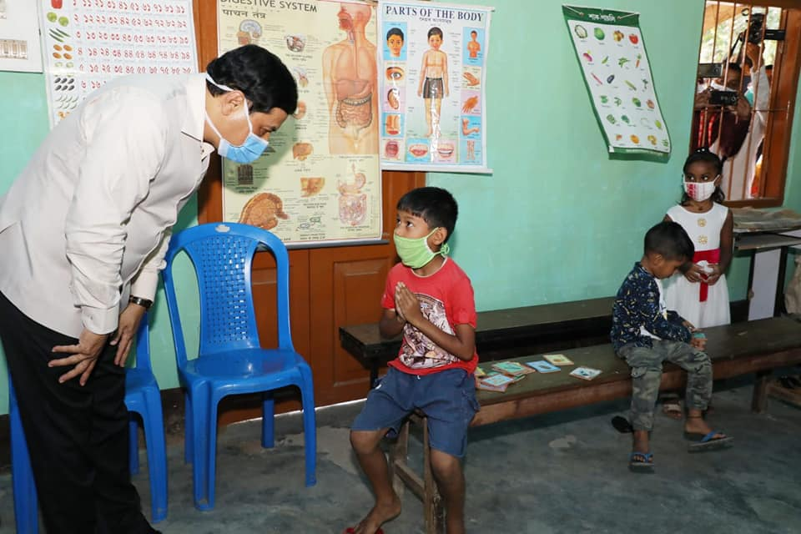
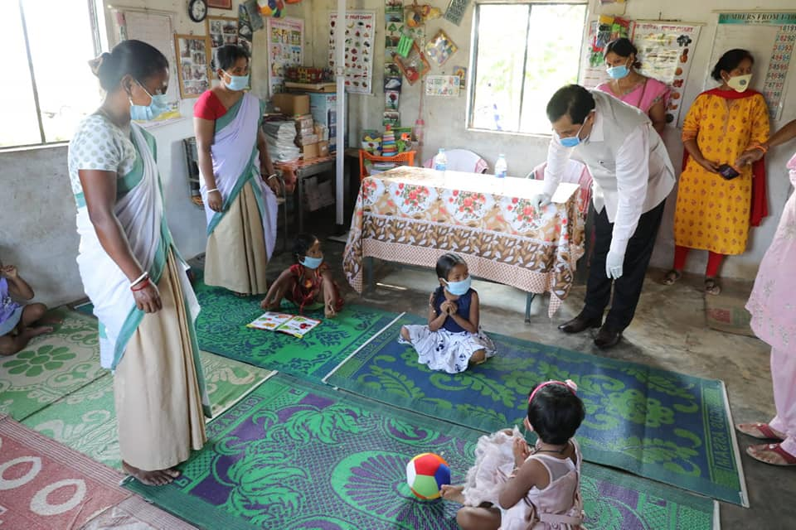
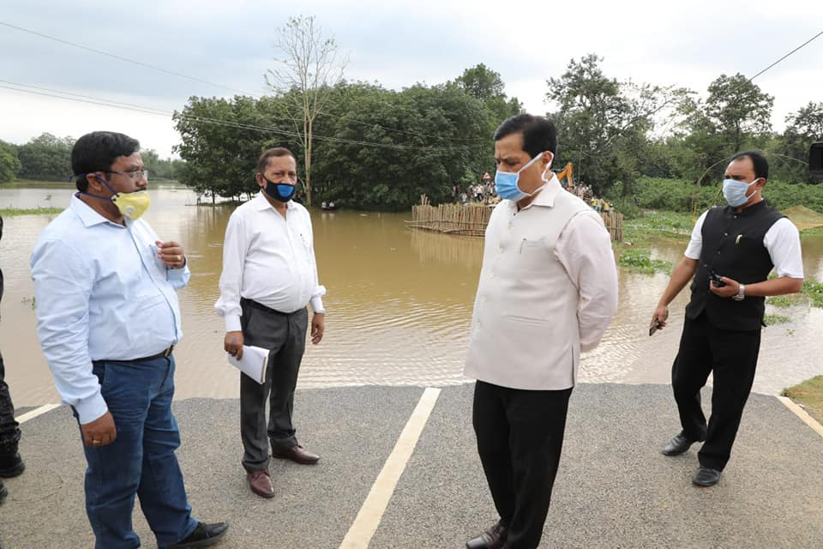
UNICEF India: http://unicef.in/
Dr. Madhulika Jonathan
Chief of Field Office
UNICEF State Office for Assam
Mob: +9435049790
Email: mjonathan@unicef.org
Who to contact for further information:
Purvi Malhotra
Communications Specialist
UNICEF State Office for Assam
Mob: +91 9810039283
Email: pmalhotra@unicef.org
Anand Kanoo
DRR Officer
UNICEF State Office for Assam
Mob: +91 6900524478
Email: akanoo@unicef.org
Sweta Patnaik
WASH Specialist & Emergency Focal Point
UNICEF State Office for Assam
Mob: 91 9717894435
Email: spatnaik@unicef.org

