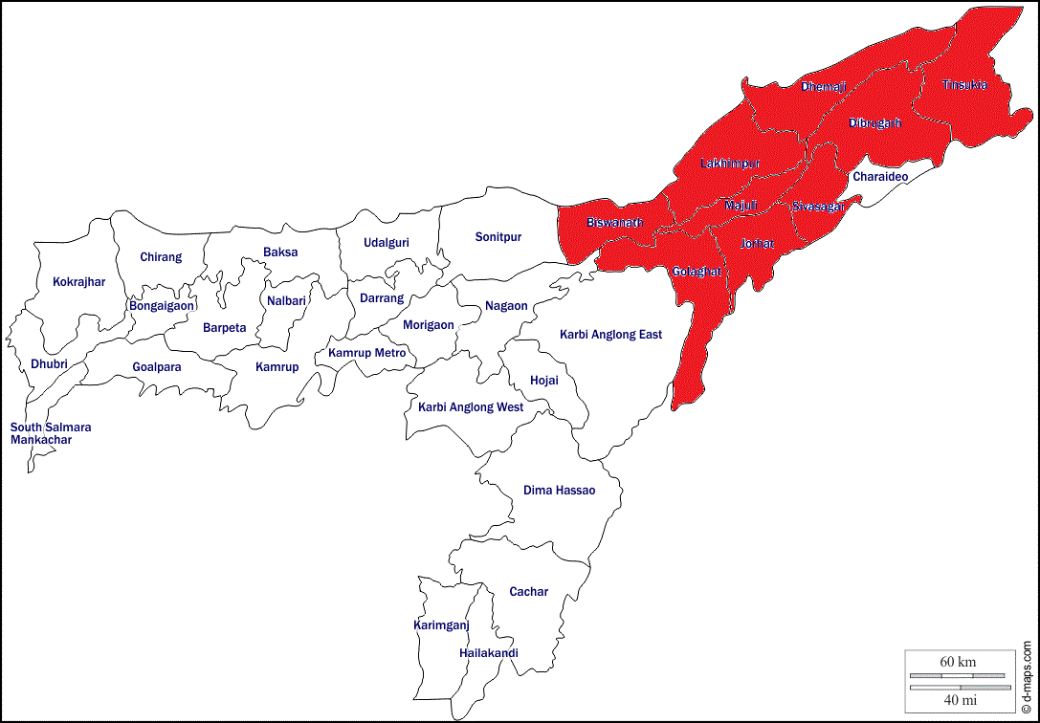
Assam (India)
Floods 2020
Situation Report # 3

26 June 2020

4587 children in relief camps
(being estimated as 40% of the affected population as children comprised 40% of the state’s population as per Census 2011)

11,468
# of people estimated to be displaced due to floods and are taking shelter in 44 relief camps
(Source: Assam State Disaster Management Authority, Daily Flood SitRep, 25-06-2020)

189,314 (9 Districts, 23 Revenue Circles)
# of people affected by flood
(Source: Assam State Disaster Management Authority, Daily Flood SitRep, 25-06-2020)

75,725
Estimated # of children affected by flood
(being estimated as 40% of the affected population as children comprised 40% of the state’s population as per Census 2011)

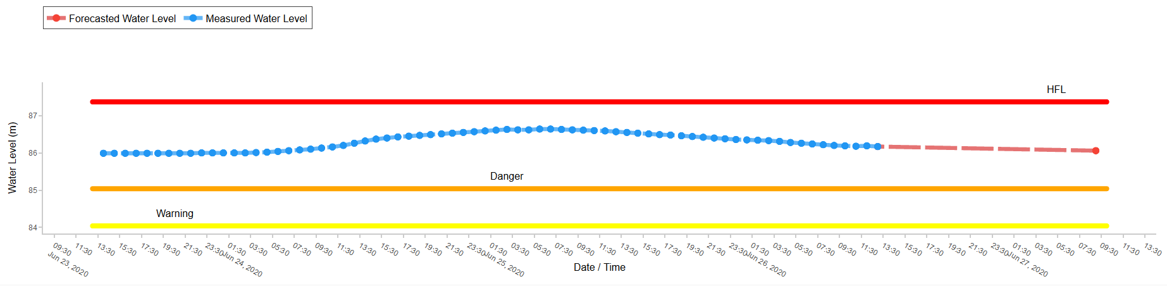
Hydrograph of River Brahmaputra at Neamatighat, Jorhat

- The 1st wave of flood in Assam which has started since 22nd May in the aftermath of ‘Super Cyclone Amphan’. Currently, the 2nd wave of flood is affecting 0.18 million people including 75,725 million children across 9 districts of Assam.
- Dhemaji district has been the worst affected district with 91,009 (48%) people affected by the current wave of flood.
- UNICEF advocated for and supported timely issuance of relief camp management guidelines and Standard Operating Procedures by Government of Assam before the onset of the floods which are being adhered to for operating and managing relief camps.
- UNICEF CSO partner RVC is working to set up model relief camps in Dhemaji and has established one in Jonai Revenue Circle
- UNICEF has supported training of more than 10000 Community Volunteers (Pratirodhi Bondhu) who are supporting the DDMAs in COVID as well as flood response.
- UNICEF has supported capacity building of staff from Social Welfare, Public Health Engineering and Education Department on emergency assessment and response in the context of flood and COVID-19.
- UNICEF is coordinating with ASDMA to activate relief camp monitoring and assessment through UNICEF consultants and partners if the situation further worsens.
- All UNICEF sectors have been coordinating with respective government departments for providing necessary technical support as per need. A sectoral response strategy has been developed.
- UNICEF has also initiated internal surge mapping for providing technical assistance as per need adhering to COVID-19 guidelines and procedures.
SITUATION IN NUMBERS
Situation Overview & Humanitarian Needs
Statewise Rainfall Information (as on 25/06/2020)
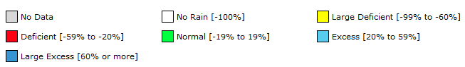
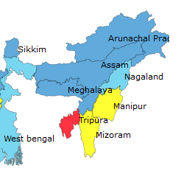
Source: Indian Meteorological Department, Government of India
Due to the heavy rainfall in the past 72 hours, the water level in the tributary of River Brahmaputra, River Dikhow was flowing above danger level and eventually breached the weak spots of the embankments in Sivasagar district on 22nd June 2020. Embankments in the Dhemaji, Lakhimpur, Biswanath, Golaghat, Jorhat, Majuli, Dibrugarh & Tinsukia districts were also breached causing floods in these districts. As per Assam State Disaster Management Authority’s (ASDMA) Flood Report dated 25th June 2020, 189314 people from 492 villages of 23 Revenue Circle are affected by the floods. Based on the Census 2011 figures, it is estimated that 75,725 children are affected among the 189,314 people.

At present, 44 relief camps have been set up in the 09 affected districts. 11,468 people have taken shelter in these relief camps out of which 4587 (estimated) are children. Over 300 people were rescued by the National Disaster Response Force (NDRF) and State Disaster Response Force (SDRF) teams as they were stranded in the flood. 15 deaths have been reported so far out of which 04 were in second wave.

Humanitarian Leadership and Coordination
UNICEF is actively coordinating with ASDMA, IAG and a local NGO Rural Volunteers Centre (RVC - DRR Partner) in Dhemaji for updates on the situation. UNICEF supported ASDMA in developing the Standard Operating Procedure (SOP) on Relief Camp Management and Guidelines for Child Friendly Spaces (CFS) in 2020 for the COVID-19 context. UNICEF and ASDMA have also trained community volunteers (Pratirodhi Bandhu) in May 2020, and UNICEF sector consultants in June 2020 on various aspects of technical assistance that can be provided in flood response including relief camp assessment using the e-scorecard. Depending upon the scale of the flood, this roster of trained personnel can be activated. A decision will be jointly taken by ASDMA and UNICEF in this regard if the situation further escalates.

Humanitarian Strategy
UNICEF will be prioritizing improved services to children affected by floods and taking shelter in relief camps through technical assistance. Preparedness in the form of issuance of guidelines and standard operating procedures for relief camp management including operationalization of Child Friendly Spaces (CFS) in such camps in the context of COVID-19 have already been done. A meeting of Emergency Management Team of Assam Field Office took place on 28th May, 2020 where the emerging situation has been discussed in detail and initial sectoral observations related to impact has been shared with sectors. Further, Programme Specialists/Officers have also discussed and identified potential response actions to be taken if the situation warrants. A decision has also been taken to define a threshold for initiating field response as Assam witnesses flooding every year which is very widespread. The threshold of 0.5 million people and 10 districts affected has been agreed. A CSO partnership has been established to support creating model relief camps as per revised SoP and guidelines and accordingly CSO partner RVC is supporting DDMA, Dhamaji in running relief camps

Summary Analysis of Programme Response (by Government and technical assistance by UNICEF)
UNICEF Sector Specialists/Officers are coordinating with their Government counterparts to assess the situation and plan for support, if needed. Preparedness to deliver technical assistance has been initiated with mapping of sectoral consultants. The following provides a brief overview of initial observations related to sectoral impacts and actions initiated/planned by sectors to support government in the response to this and upcoming phases of floods:

Health
The sector is already under tremendous stress fighting with COVID. So far there are no specific information on health cetres affected by floods. However, Dibrugarh city has multiple wards under inundation. The Health Department is continuing the COVID-19 response through the 2nd phase of the Community Surveillance Program. UNICEF Sector Specialist is coordinating with NHM to provide necessary technical support in ensuring health measures outlined in the SOP for Relief Camp Management and Guideline for CFS in the COVID-19 context. The sector has also identified consultants and partners who will be oriented to provide technical support in relief camp monitoring.

Nutrition
Anganwadi centres have been inundated although they are already closed due to ongoing lockdown due to COVID 19. As per ASDMA’s flood report, 14 Anganwadi Centres in Sivasagar district have been reported to be affected. Certain nutrition services were already disrupted due to COVID-19 outbreak which will be further affected. Gratuitous Relief (dry ration) has been distributed in relief camps and through relief distribution centres. As per ASDMA’s flood report, over 2 quintals of beaten rice (chira), 46.7 kgs of jaggery (gur), 06 litres of milk and 20 packets of biscuits have been distributed by the district administration to the flood affected people. Nutrition Sector in UNICEF is coordinating with Social Welfare department to assess situation at hand and explore need and possibility of support. The sector will be supporting the department in keeping track of any instances of IMS Act violation and will be facilitating appropriate action by the department. In order to further prevent violation of IMS act, UNICEF facilitated issuance of advisories from both Dept of Social Welfare and NHM Assam. The advisories focus on reinforcing optimal Infant feeding practices during floods and reinforce implementation of IMS act during flood season and in context of COVID19. Further, sector has worked with the Department of Social Welfare and partner district administrations in supporting the capacity building of district and sub-district staff on flood response on 25th June 2020.

WASH
Hand Pumps and Toilets inundated in affected areas. Public Health Engineering Department is supplying water pouches. As per ASDMA’s flood report, over 2650 litres of drinking water has been provided in relief camp. 33,850 halogen tablets and 2650 chemical packets have also been distributed to the people to treat water for drinking purpose. As of now, people are using the toilets of the schools where they have taken shelter. 20 mosquito nets and mosquito repellent coils have also been provided. The Sector Specialist from UNICEF is coordinating with the department to assess the situation. DRR and WASH sectors have worked with the PHED for building capacity of district and sub-district staff on flood response on 5th and 12th June 2020 covering 199 officials from district and sub-district level. Further support was also provided on issuance of supporting GO compiling and synthesizing the roles and standards of the department as per different manuals and guidelines. The sector is working with PHED to ensure WASH parameters/standards as mentioned in the “Guidelines in the relief Camp Viz-a Viz flood and COVID-19”. Further, depending upon need support will be provided to PHED for relief camp management monitoring with respect to WASH access. The sector will continue supporting the PHED, for accurate loss and damage reporting. The sector will also work with partners to address communications on safe WASH in the relief camps and CFS, supplies to address water purification and disease control. Further,

Education
Schools have been inundated in many affected places. As schools are already closed due to lockdown, there is no direct disruption of education services attributed to floods. However, Mid-day Meals services, e-learning services might have been affected due to the floods. Knowing the actual numbers of schools inundated/damaged will take some time for the department to assess and share. Further, the schools which are not inundated are preferred camp sites. The Sector Specialist has taken part in a review meeting with department and have discussed about the disruptions caused. Further, UNICEF was requested to support proper monitoring of the situation and developing appropriate response plan. The same will be initiated to cater to this as well as coming phases of flood in the state. Responding to the request an orientation was conducted of all district level heads of the department on flood preparedness and actions to be initiated. This was further supported by development of a strategic response plan for flood preparedness and response at state level.

Child Protection
As families had to abandon their homes due to sudden onset of flood, their exposure to protection risks increased. Still large number of affected people are beyond camp purview and hence beyond formal monitoring channels. Further safety and security monitoring have become difficult as roads are disrupted. So far, there are no reports of childcare institutions getting affected from the flood affected districts. The Sector is coordinating with multiple CP related departments and agencies within government. Further the sector will work with Police Department to ensure security parameters as mentioned in the “Guidelines in the relief Camp Viz-a Viz COVID-19” and also for increased vigilance of the nearest transport points to identify movement of both accompanied and unaccompanied children. The sector will also work with the office of Commissioner Disability and State Child Protection Society (SCPS) and relevant District Child Protection Unit (DCPU) to ensure Special arrangements for Children, women, physically challenged and elderly parameters of the relief camp guidelines.

Safety and Security
As per the media reports, several rivers are flowing above their danger level such as the Brahmaputra in Neamatighat, Dhubri, and Sonitpur, Disang at Nanglamuraghat in Sivasagar, Dhansiri at Numaligarh, and Jia Bharali at NT Road Crossing. There is forecast of heavy rainfall for next 2 days as well. No security threats have been reported so far.

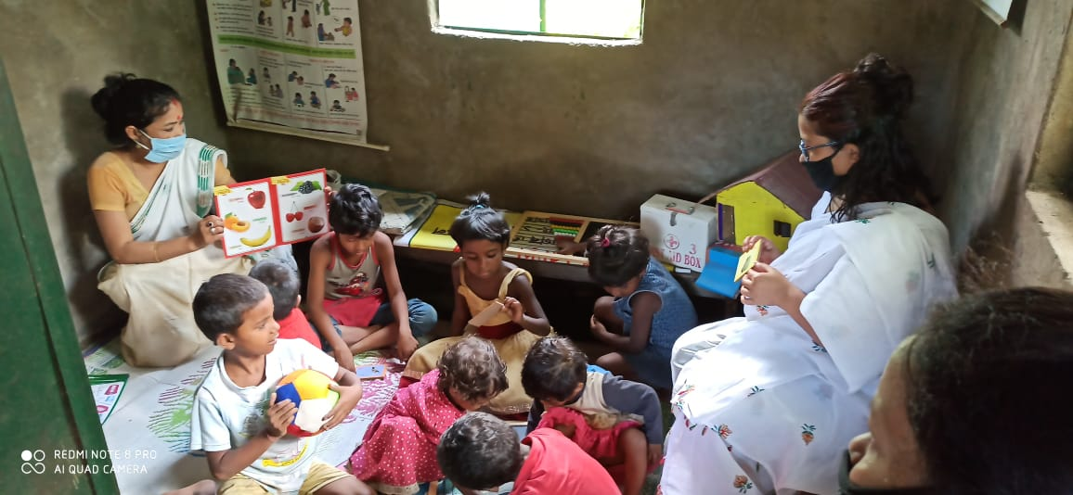 | 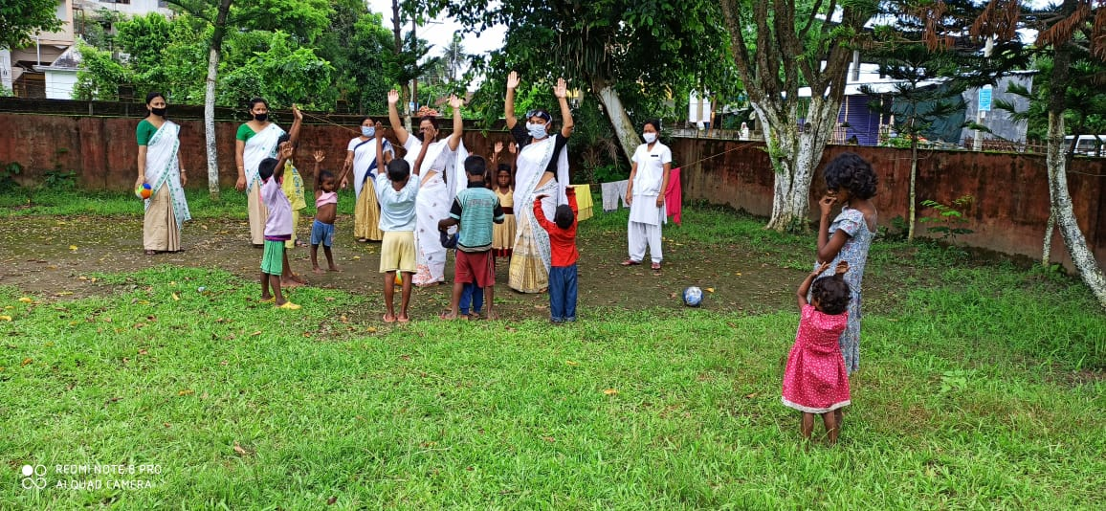
Image 1: Teachers conducting learning activities with children in a CFS in Sivasagar district. (Source: ASDMA) | Image 2: Teachers conducting recreational activities with children in a CFS in Sivasagar district. (Source: ASDMA)

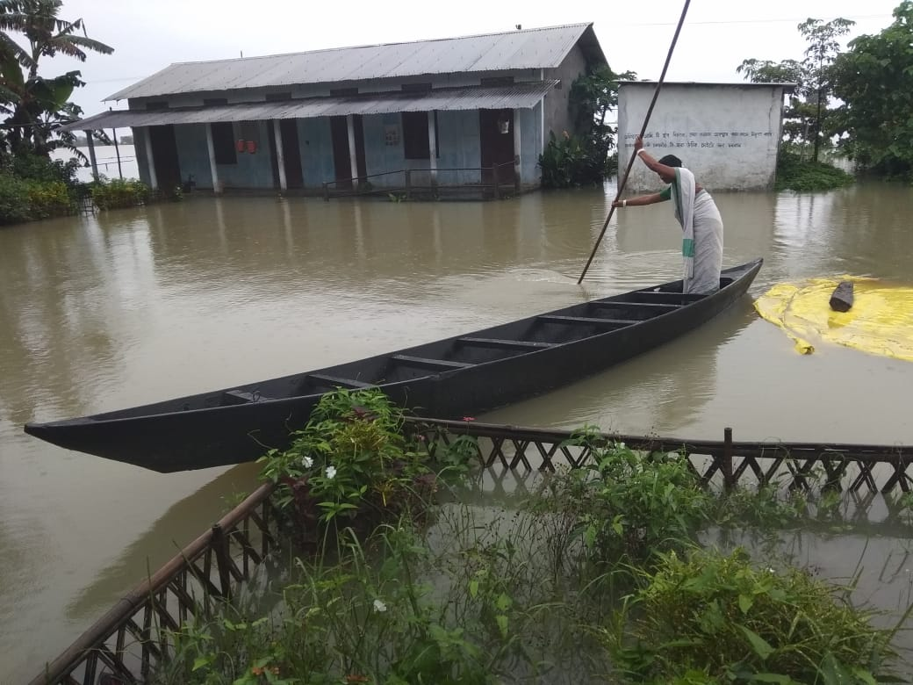 | 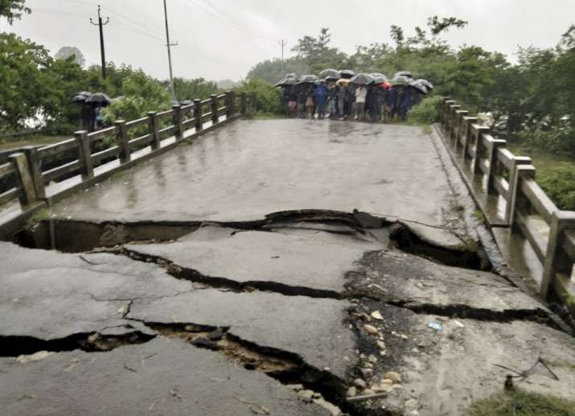
Image 3: A woman rowing a boat in front of an nundated school in Dhemaji district (Source: RVC) | Image 4: People look at a portion of a bridge damaged due to heavy rain in Tinsukia district (Source: India TV)

UNICEF India: http://unicef.in/
Anand Kanoo
DRR Officer
UNICEF State Office for Assam
Mob: +91 6900524478
Email: akanoo@unicef.org
Sweta Patnaik
WASH Specialist & Emergency Focal Point
UNICEF State Office for Assam
Mob: 91 9717894435
Email: spatnaik@unicef.org
Dr. Madhulika Jonathan
Chief of Field Office
UNICEF State Office for Assam
Mob: +9435049790
Email: mjonathan@unicef.org
Who to contact for further information:
Purvi Malhotra
Communications Specialist
UNICEF State Office for Assam
Mob: +91 9810039283
Email: pmalhotra@unicef.org

Source: ASDMA (http://www.asdma.gov.in/pdf/flood_report/2020/Daily_Flood_Report_25.06.2020.pdf).
Source: The Sentinel (https://www.sentinelassam.com/north-east-india-news/assam-news/assam-flood-1-more-dead-in-dhemaji-over-1-lakh-affected-484903)
Source: NDTV (https://www.ndtv.com/india-news/monsoon-news-heavy-rain-alert-in-bihar-assam-meghalaya-flood-situation-in-assam-grim-2252254)

