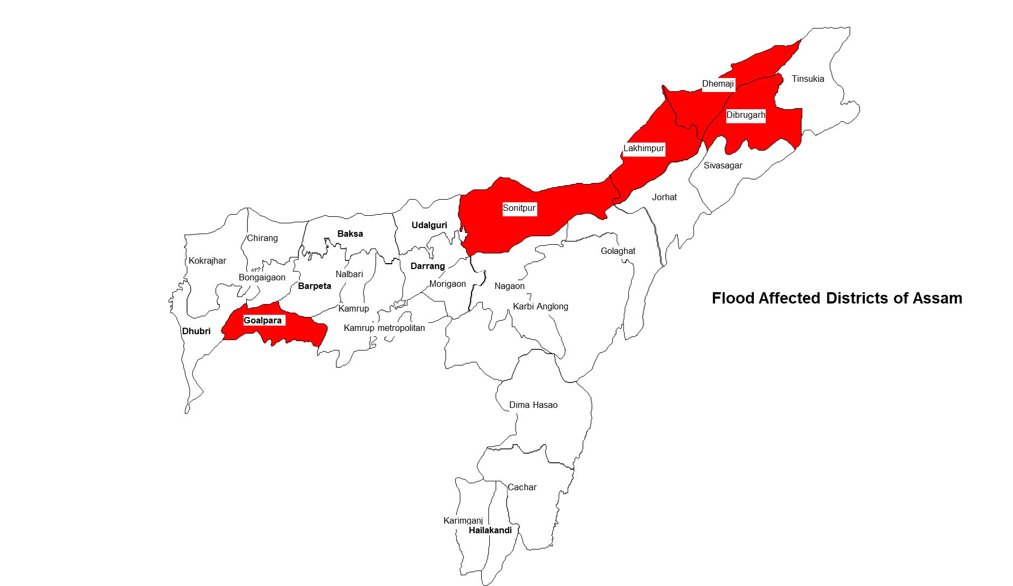
Assam (India)
Floods 2020
Situation Report # 1

- Assam is experiencing its 1st phase of flood which has started gradually since 22nd May due to incessant rainfall brought in by Super Cyclone Amphan
- Currently, 8941 people of which 2,281 are children, are taking shelter in 16 relief camps setup by the District Disaster Management Authority of Goalpara. Lakhimpur DDMA has also operationalized 17 relief camps the data regarding inmates is yet to be updated.
- 30701 people including an estimated 12280 children from 127 villages across 5 districts have been affected while 579 hectares of crop area have also been inundated.
- Cyclone Amphan has led to largely excess rainfall in the last couple of days. On 25th May, the departure from daily normal rainfall has been largely visible in the Assam (283%), Meghalaya (703%) and Arunachal Pradesh (525%).
- The worst affected districts (Lakhimpur and Goalpara) are linked to the heavy rainfall occurring in Arunachal Pradesh and Meghalaya. Flood in Lakhimpur is again attributed to release of water from Ranganadi Hydro Electric Plant (RHEP) at Yazali in Arunachal Pradesh
- On 25th, two major tributaries of Brahmaputra namely Jia Bharali (Sonitpur) and Puthimari (Karmup rural) were flowing above danger level (Source- ASDMA). While the main river is maintaining a rising trend at multiple locations.
- Regional Meteorological Centre, Guwahati has issued warning for extremely heavy rainfall for 25th and 26th May for certain districts in Assam and Arunachal Pradesh while heavy to very heavy rainfall is predicted upto 29th May which may contribute to deterioration of the situation.
- DDMAs of affected districts have already initiated response actions and both NDRF (1st Battalion) and SDRF teams have been deployed to undertake evacuation exercises
- As a preparedness to the current context of COVID-19 outbreak, ASDMA has already issued guidelines and SoPs for relief camp management developed with technical support of UNICEF which have been activated.
- Field observations from Goalpara by IAG members indicate that people have shifted to roadsides and other higher grounds. These people have now been taken government run relief camps.
- Field observations also indicate that the inundation was rapid in certain areas as embankments breached during 2019 floods were yet to be fully restored.
- UNICEF has initiated coordination with Government of Assam (ASDMA) and Inter Agency Group Assam to assess the situation and initiate appropriate action
SITUATION IN NUMBERS

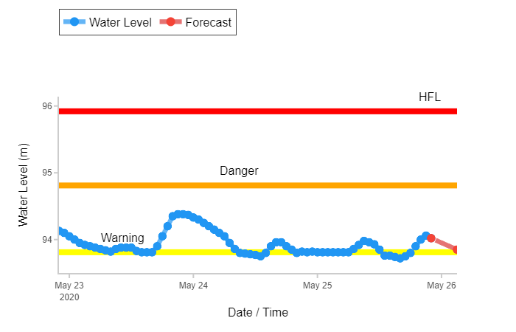
26 May 2020

2281 children in relief camps
(Daily Situation Report of ASDMA, GoI for 25th May, 2020)

8941
# of people estimated to be displaced due to floods and are taking shelter in 16 relief camps in Goalpara
(# Figures for 17 relief camps operated by DDMA Lakhimpur are not available. Source: Assam State Disaster Management Authority, Daily Flood SitRep, 25-07-2020)

30,701 (5 Districts, 8 Revenue Circle)
# of people affected by flood
(Source: Assam State Disaster Management Authority, Daily Flood SitRep, 25-05-2020)

12,280
Estimated # of children affected by flood
(being estimated as 40% of the affected population as children comprised 40% of the state’s population as per Census 2011)

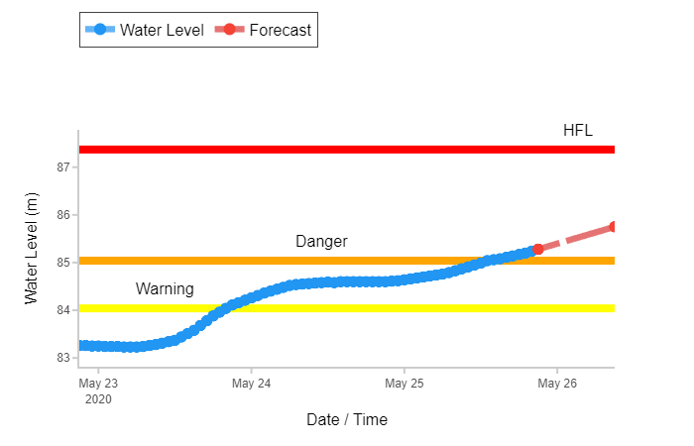
Hydrograph for Brahmaputra River at Neamatighat, Jorhat, Assam generated on 25th May, 2020 (Source CWC)

Hydrograph of Ranganadi river at NT Road crossing (Level) station on 25th May, 2020 (Source CWC)

Situation Overview & Humanitarian Needs
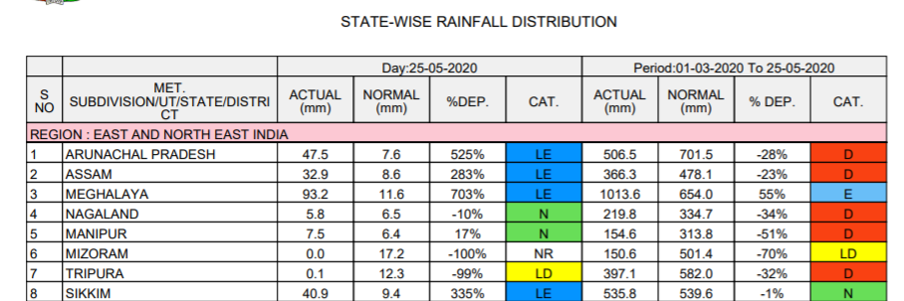
As anticipated, the secondary impact of the ‘Super Cyclone Amphan’ has led to incessant rainfall activities in North East India. After landfall in West Bengal, the cyclone moved through the North-eastern states of India causing widespread influence on the rainfall front. While meteorological observations indicated rainfall deficient May in NE India in 2020, the influence of the cyclone changed the equation and states like Meghalaya have received largely excess rainfall while in the last couple of days Assam and Arunachal Pradesh have also received and are projected to receive increased rainfall. With increased rainfall activities, few major tributaries of Brahmaputra river started flowing above danger mark. As due to the onset of COVID-19 situation, the restoration of embankments breached during 2019 floods could not be completed in certain locations, the inundation was rapid. Goalpara is the worst affected district with 22593 people affected. The characteristics of the flooding in Goalpara and Lakhimpur has been that of flash flood due to incessant rainfall in Meghalaya and Arunachal Pradesh respectively. Initially, with increasing water and inundation, people moved to nearby higher grounds on roads (highways) who have now been taken to government run relief camps. Currently Lakhimpir (17) and Goalpara (16) are the districts who are operating relief camps. Further, evacuation operation has been launched by NDRF and SDRF who have evacuated 400 people in Goalpara. Roads, bridges and embankments have been damaged at multiple places and the routine road communications have been affected. The challenges have increased manifold as the response to this flood is different from other years due to the COVID-19 outbreak and increased number of cases in the state.
Source- Indian Meteorological Department

Humanitarian Leadership and Coordination
UNICEF has initiated coordination with Assam State Disaster Management Authority and Inter Agency Group Assam to understand the situation and define possible response actions. Though IAG members located in affected districts, UNICEF is also getting field observations. Considering the situation as it unfolds, joint assessments may be planned. UNICEF has also initiated discussion with ASDMA to support in monitoring implementation of the revised guidelines on relief camp management including operationalization of child friendly spaces where integrated service delivery to children has been emphasized in line with the CCCs.

Humanitarian Strategy
UNICEF will be prioritizing improved services to children affected by floods and taking shelter in relief camps through technical assistance. Preparedness in the form of issuance of guidelines and standard operating procedures for relief camp management including operationalization of child friendly spaces in such camps in the context of COVID-19 have already been done. Further, as per the revised MPSs under Emergency Preparedness Procedure, UNICEF core sectors have started assessing the sectoral priorities which will further define the response strategy as the situation unfolds.

Summary Analysis of Programme Response (by Government and technical assistance by UNICEF)

UNICEF sectoral response will be activated based on the situation, need and request from government. UNICEF sector specialists are coordinating with respective departments and counterparts as well as partners to understand sectoral situations. Technical assistance will be provided to meet the needs of affected children.

Safety & Security
Some roads have submerged due to flood, the accessibility will remain a challenge till the water recedes. In the current situation of COVID and the lock down measures, restrictions on travel will impact field movement. No security threats have been reported so far.

UNICEF India: http://unicef.in/
Dr. Madhulika Jonathan
Chief of Field Office
UNICEF State Office for Assam
Mob: +9435049790
Email: mjonathan@unicef.org
Who to contact for further information:
Purvi Malhotra
Communications Specialist
UNICEF State Office for Assam
Mob: +91 9810039283
Email: pmalhotra@unicef.org
Anand Kanoo
DRR Officer
UNICEF State Office for Assam
Mob: +91 6900524478
Email: akanoo@unicef.org
Sweta Patnaik
WASH Specialist & Emergency Focal Point
UNICEF State Office for Assam
Mob: 91 9717894435
Email: spatnaik@unicef.org

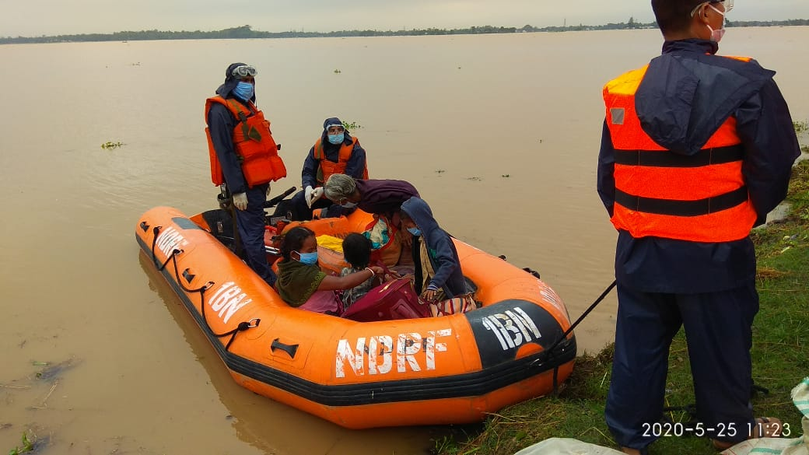
Evacuations carried out by NDRF in Goalpara. (Photo Source- Ajagar Social Circle, Goalpara, Inter Agency Group, Assam)

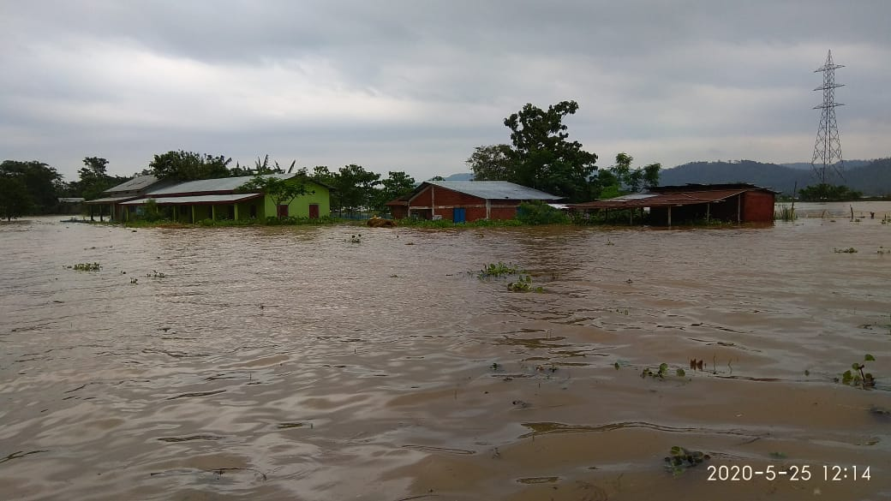
Schools and Anganwadi Centres inundated in Goalpara. (Photo Source- Ajagar Social Circle, Goalpara, Inter Agency Group, Assam)

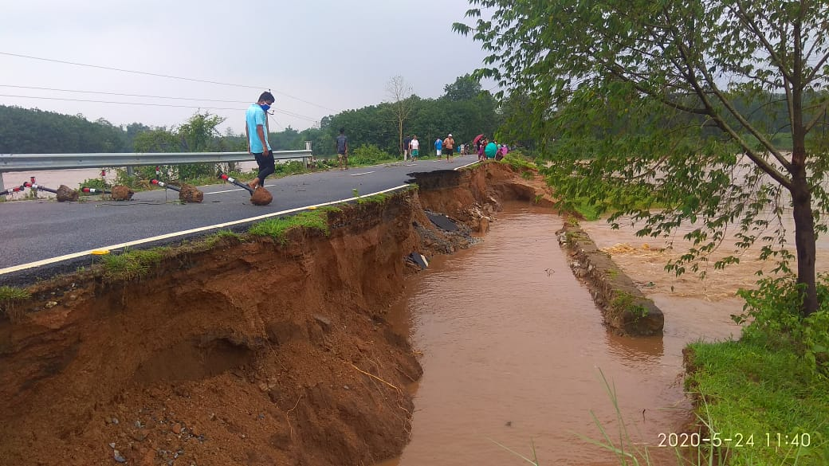
Roads being washed away in Goalpara. (Photo Source- Ajagar Social Circle, Goalpara, Inter Agency Group, Assam)
People taking shelter on the national highway in Goalpara district. (Photo Source- Ajagar Social Circle, Goalpara, Inter Agency Group, Assam)

